Video Study Guide
Writing Systems of Linear Inequalities Using a Graph
1. Write the system of linear inequalities shown on the graph.
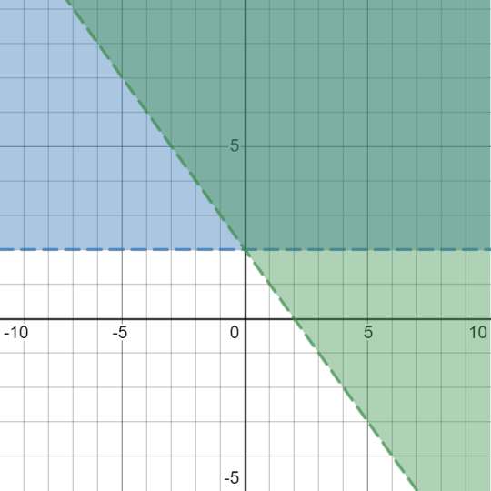

2. Write the system of linear inequalities shown on the graph.
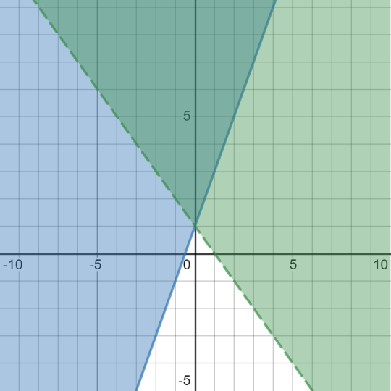
3. Write the system of linear inequalities shown on the graph.
