Using the Coordinate Plane to Write Equations

Directions: Watch the video to see an instructor demonstrate a process you can use to solve this problem. Make sure you follow along with the instructor by writing down the steps they use. This will help you learn and remember how to solve each question.

1. Use the graph shown to create a table of values. Then use the table of values to write the related linear equation.

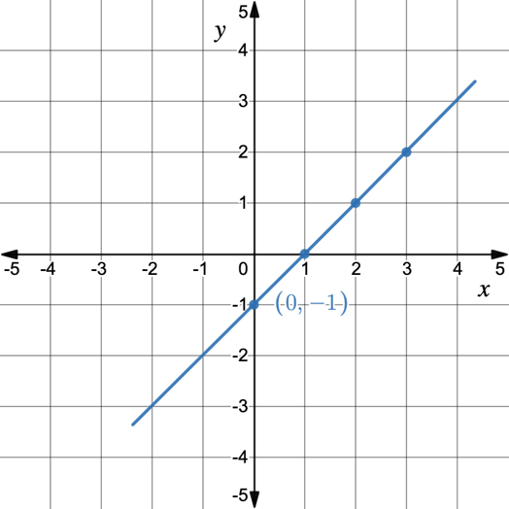
  $$x$$ | Operation | $$y$$

