Student Name: Enter Name Here
Esperanza Rising Plot Diagram

The Plot
Pam Muñoz Ryan’s Esperanza Rising follows Esperanza on her journey from life as a sheltered, pampered child on a ranch in Mexico to life as a farm worker in California. As she adjusts to her new world and to life without Papa, Esperanza comes to understand herself and others better. As you finish reading the novel, fill in the boxes for each element of the novel’s plot.

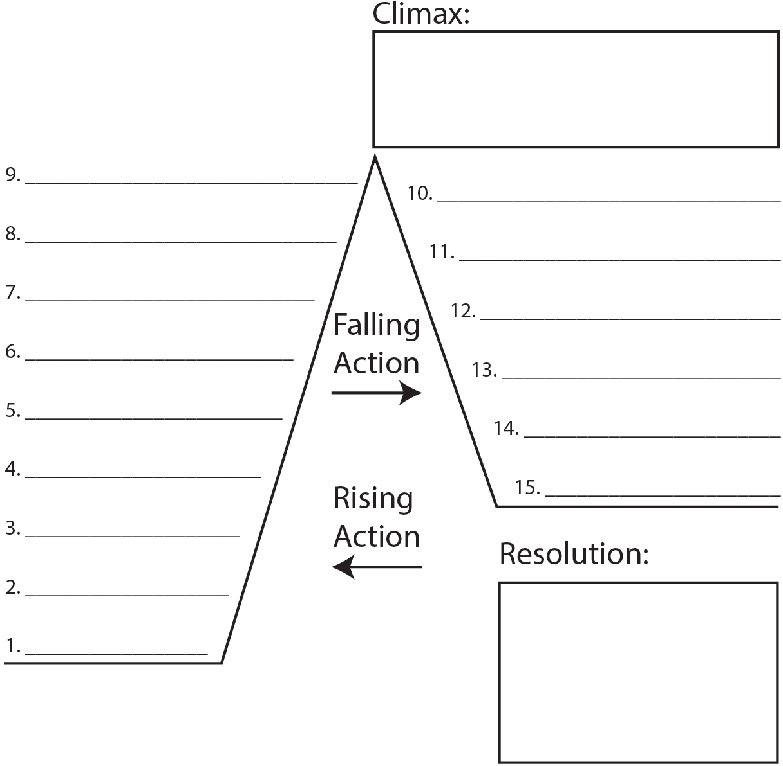
Enter Text Here

Enter Text Here Enter Text Here Enter Text Here Enter Text Here Enter Text Here Enter Text Here Enter Text Here

Enter Text Here Enter Text Here
Enter Text Here Enter Text Here
Enter Text Here

Enter Text Here

Enter Text Here

Enter Text Here

Enter Text Here

