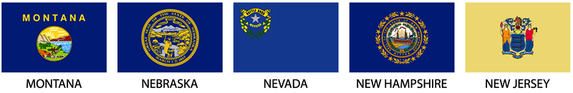

Student Name:

Who (state, district, or territory) are you designing a flag for?

What is the geography of this area?

What is the population like?

What is the culture like?

What is the history of the area that is significant?

What natural resources exist?

What are the famous landmarks?

What is special about this area?

What symbols are you considering? Why?

What colors are you considering? Why?

