Module 8, Probability Assignment
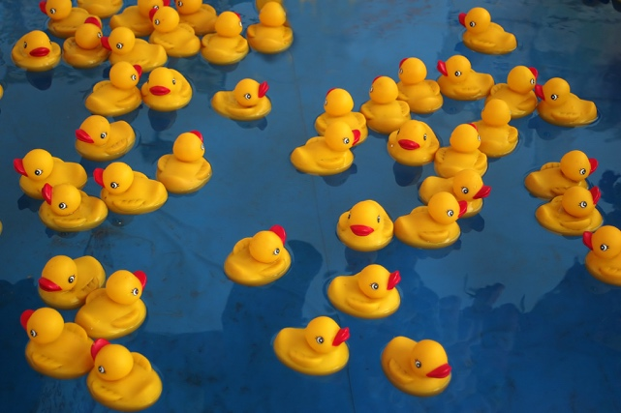
Kiara and her friends are playing The Duck Game at a local fair. In this game, the player selects one of 50 identical plastic ducks from a pool. The bottom of each duck is each numbered 1, 2, or 3. If you draw a duck with a 1, you win a small prize, a duck with a 2 will win you a medium prize, and a duck with a 3 will win a large prize. According to the game operator, there are 25 ducks with a number 1 on the bottom, 20 ducks with the number 2, and 5 ducks with the number 3.

Use the information given to explore some of the mathematical concepts you have practiced so far by answering the questions below.

1. Suppose that Kiara plays The Duck Game once. What is the probability that she draws a duck with the number 3 on the bottom? Explain the process you used to solve this question.

2. Kiara draws a duck with a 1 on her first try and decides to play the game again. This time her friends Denny and Rayanna play the game with her. Each friend takes a turn drawing a duck from the pond. Once all three friends have drawn a duck, they turn them over to reveal their prizes. Is each friend’s draw an independent or dependent event? Explain.

3. When the three friends play The Duck Game together, Kiara draws first, then Denny, and then Rayanna. What is the probability that Denny draws a 2, given that Kiara drew a 1? Show your work.

4. After winning a second small prize at The Duck Game, Kiara decides that she’d like to play a different game. She narrows her choices down to Spin the Wheel, and The Goblet Game. Kiara estimates that she has a 5% chance of winning a large prize on the Spin the Wheel Game, and a 2% chance of winning a large prize on The Goblet Game. If Kiara plays both games, what is the probability that she wins a large prize on one of these games? Explain how you determined your answer.

5. While Kiara is deciding which game to play, Denny and Rayanna play Spin the Wheel. In this game, the player spins a wheel that is divided into 15 equal sections. The player is awarded the prize indicated by the section in which the wheel stops. Each section of the wheel contains a different prize. What is the probability that Rayanna lands on the section marked “win a second spin” given that Denny landed on the section marked “win 10 tickets”? Explain your answer.

After watching her friends play Spin the Wheel, Kiara decides to play The Goblet Game. This game has an array of different colored goblets that are arranged in a square. To play the game, you roll a large ball that is roughly the diameter of a goblet’s mouth into the arrangement. If the ball lands on top of a white goblet, you win a small prize. If the ball lands on top of a yellow goblet, you win a large prize.

The operator of The Goblet Game has a mixed box of large prizes. The partial distribution of prizes in the box is shown.

 | Red | Blue | Total
Plush Cat | 38
Plush Dog |  | 43 | 68
Total |  | 114 | 177

6. Complete the blanks in the two-way table above. Use the space below to show any needed work.

7. Kiara plays The Goblet Game twice and she wins two large prizes! She likes all the prizes in the box, so she reaches into the box and randomly selects two prizes.

a. What is the probability that her prize is a plush cat given that it is red? Show your work.

b. What is the probability that her prize is blue given that it is a plush dog? Show your work.

