Module 5, Exponential Decay Assignment

Exponential decay occurs when the quantity of something decreases at a rate that is proportional to its current value. For example, a population of animals might decay as their habitat is slowly eroded by human encroachment, or the amount of radiation that is emitted from a radioactive substance could decrease as time passes.

Suppose that your friend Rhyley has saved $5,000 toward the cost of a car and her parents have agreed to match that amount, dollar for dollar. You learned in your algebra 2 class that the value of a car decreases as time passes. You want to use your knowledge to help your friend buy the best car that she can with the money she has available. Rhyley has narrowed the options down to two different cars, both of which have similar features:

Car A | Car B
Cost: $8,750  Mileage: 89,325  Year of Manufacture: 2015  Decay Factor (average): 12% | Cost: $9,995  Mileage: 73,498  Year of Manufacture: 2017  Decay Factor (average): 18%

Use the information given and your knowledge of exponential decay to help your friend Rhyley by answering the questions below.

1. Write an exponential decay function in the form $f(x)=ab^{x}$ for each of Car A and Car B. Explain how you determined the value of b for each function.

2. Use the Desmos graphing utility to create two graphs; one for each function that you wrote in question 1. Explain what each axis represents and why you choose the scale you did. You may also plot these graphs by hand, if you prefer.

3. Look at your graphs from question 2. Explain the value of each y-intercept in context of the scenario.

4. What are the domains and ranges of the functions you graphed? Explain.

5. Rhyley is unsure how long she will own the car she chooses. The graph below shows the exponential decay functions for Car A (in green) and Car B (in purple). Interpret the value of the marked point in relation to the value of each car as time passes.
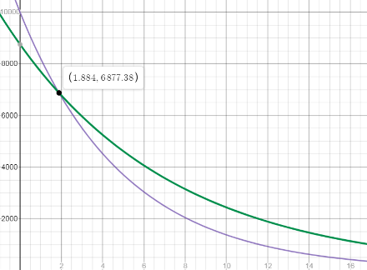

6. After some consideration, Rhyley’s best guess is that she will own the car she chooses for 5 years. Explain two different ways you could determine the value of each car in the fifth year Rhyley owns it.

7. Rhyley still cannot decide which car she really wants. Beyond the cost, mileage, and how the value of the car decreases, what are some other factors Rhyley might consider when making her decision?

