Module 2, Quadratic Functions & Parabolas Assignment
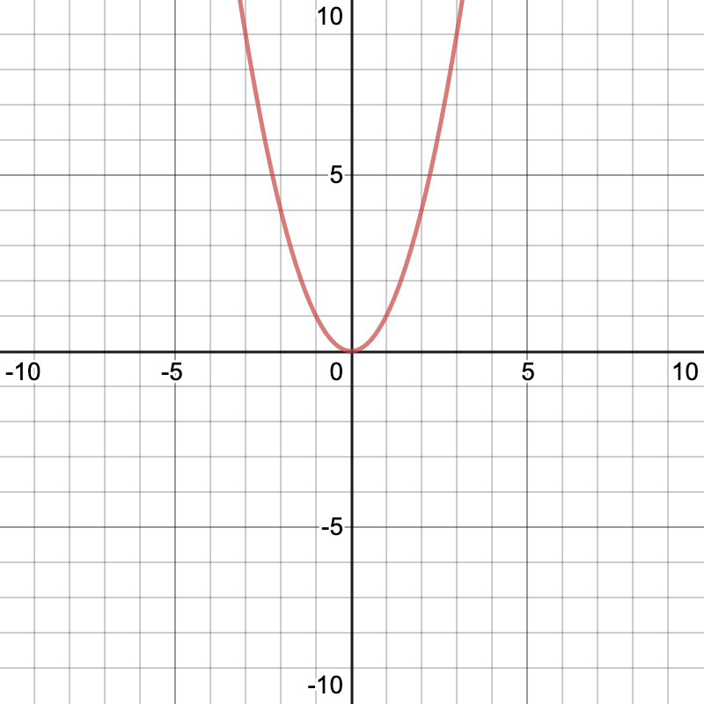
The function $f(x)=x^{2}$ is the parent quadratic function. It is the simplest function in the quadratic function family and its curve is shown. Remember that the curve created by a quadratic function is called a parabola.
There is only 1 parent function, but there are an infinite number of “child” functions in the quadratic function family. You can express all quadratic functions in either standard form or in vertex form.

Standard Form | Vertex Form
$$ax^{2} +bx + c=0$$ | $$a(x-h)^{2} + k = 0$$
- You can read the values of a, b, and c directly from the equation.  - You can use this form for factoring, or for solving by the quadratic equation. | - You can read the values of a, h, and k directly from the equation.  - You can use this form for sketching a quick graph of the parabola.  - You can read the vertex directly from the equation.  - You can use this form to easily compare how a parabola is transformed from the parent function, or from another quadratic function.

Use this information as well as your knowledge of quadratic functions and their related parabolas to work through the following scenario.
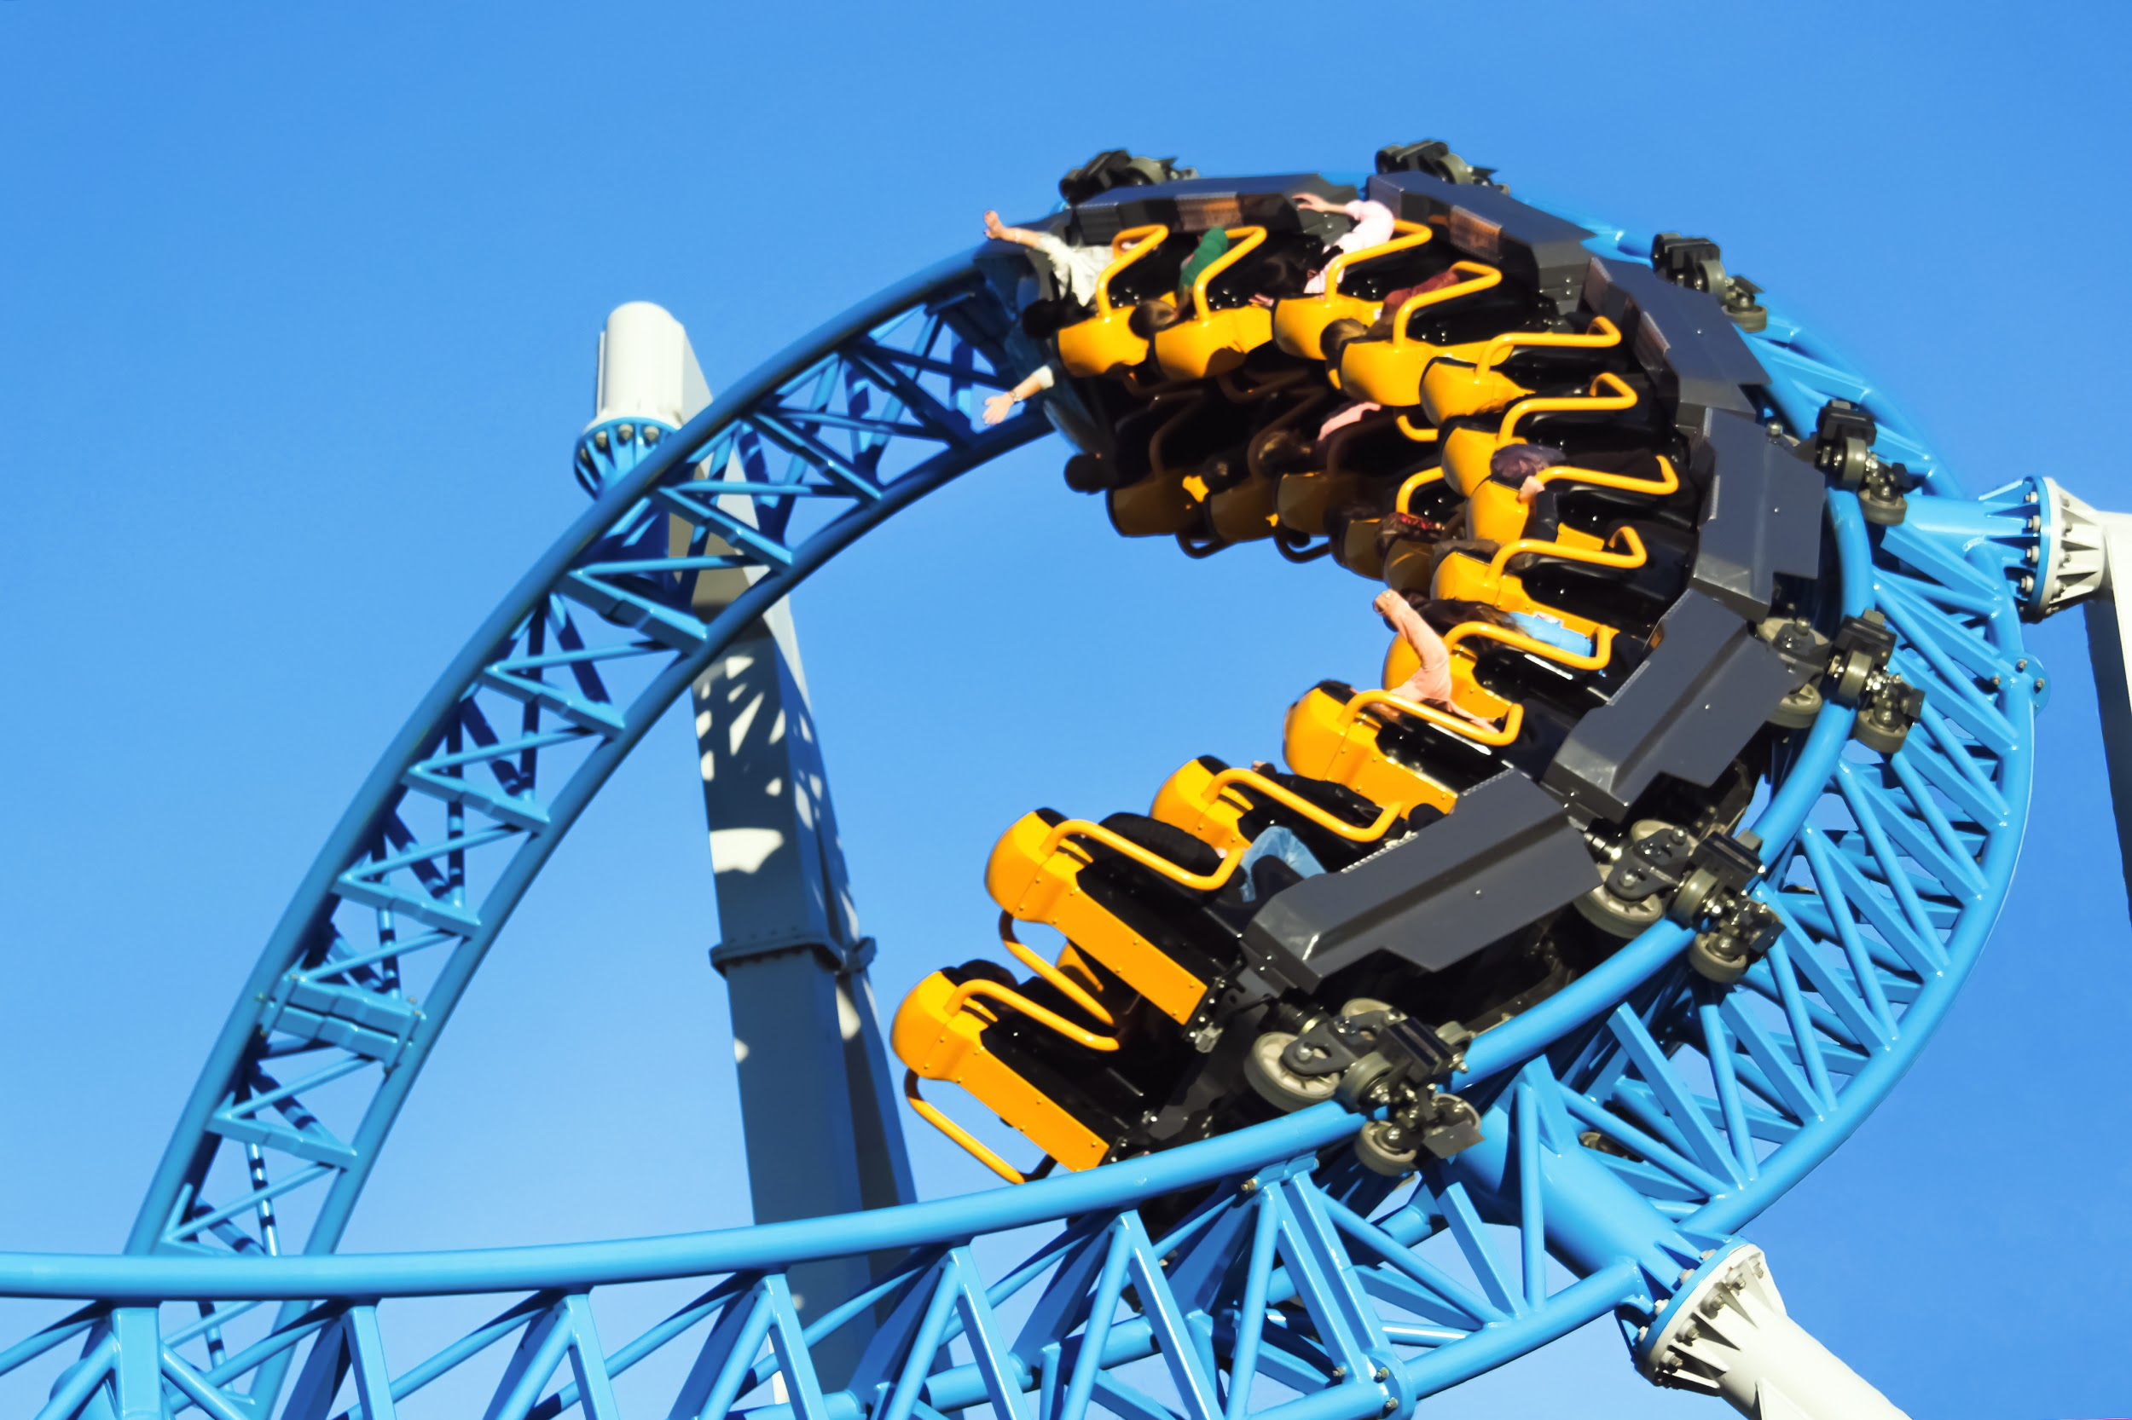
Last year, the Galaxy Fair Amusement Park installed a family roller coaster they named The Twist. This coaster was designed to accommodate riders from age 4 to adult and features a tall climb hill and several banking turns. Overall, the park has been disappointed in the reception of The Twist, and very few families are riding the coaster this season. After some research, they discovered that park guests think the climb hill is too tall and fast for younger riders.
Galaxy Fair Amusement Park has asked a roller coaster design firm to help them redesign The Twist during the coming off season. The quadratic function that represents the current climb hill is $f(x)=-0.10x^{2}+3.6x-2.4$ and the quadratic function that represents the proposed redesign of the climb hill is $g(x)=-0.03x^{2}+1.62x-6.87$. In these functions, the value of x represents the time, in seconds, since the roller coaster train cars have left the station, and the output variable is the height of the roller coaster track, in feet, above the ground.
1. Rewrite both $f(x)$ and $g(x)$ from standard form into vertex form. Explain your process. HINT: Each function has a common factor. Start by dividing it out.

2. State the vertex of each function. What does each vertex represent in context of The Twist?

3. Compare the a-value of $f(x)$ to the a-value of the parent quadratic function. What effect does this value have on a parabola?

4. Sketch both of the functions $f(x)$ and $g(x)$ on a single xy-plane. Describe the steps you took to create your sketch.

5. Use the vertex forms of $f(x)$and $g(x)$ and the sketch you created in question 4 to describe the track changes that occur when the function that represents the climb hill is altered from $f(x)$ to $g(x)$. Do you think these changes will help younger riders better enjoy The Twist? Explain.

