Module 11, Trigonometric Identities Assignment

In mathematics, an identity is an equation that is always true. When you learned how to factor expressions and equations, you worked with several algebraic identities, including ${\left(a+b\right)}^{2}=a^{2}+2ab+b^{2}$ and ${\left(a-b\right)}^{3}=(a-b)(a^{2}+ab+b^{2})$. These identities helped you to rewrite and simplify more complex expressions or equations. This, in turn, allowed you to more easily solve problems.

In this module you were introduced to trigonometric identities, including reciprocal identities, quotient identities, Pythagorean identities, and others. Like algebraic identities, you can use trigonometric identities to help you rewrite and simplify more complex expressions or equations in order to more easily solve problems. You can also use these identities to verify whether trigonometric equations represent identities. There are several ways to show an equation may be an identity, but to prove it is an identity, you must verify it.

Use what you know about trigonometric identities to explore the questions below.

1. Amna needs to decide if the equation $\frac{\sin^{2}{θ}}{1+\cos{θ}}=1-\cos{θ}$ is an identity. Choose 3 possible values for $θ$, substitute them into this equation, and simplify. What do your results indicate about the equation $\frac{\sin^{2}{θ}}{1+\cos{θ}}=1-\cos{θ}$? Show all your work.

2. The graphs of $\frac{\sin^{2}{θ}}{1+\cos{θ}}$ , in red, and $1-\cos{θ}$, in blue, are shown below. What do these graphs and your answer to question 1 indicate about the equation $\frac{\sin^{2}{θ}}{1+\cos{θ}}=1-\cos{θ}$? Explain.

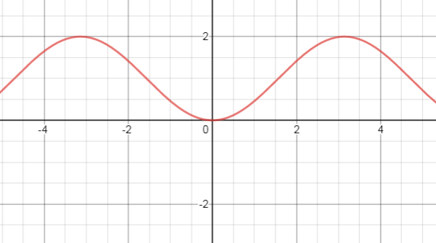 | 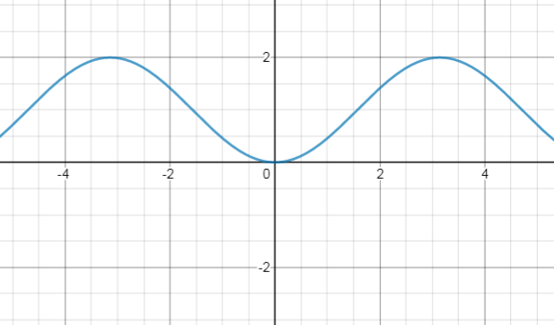

3. If possible, verify $\frac{\sin^{2}{θ}}{1+\cos{θ}}=1-\cos{θ}$ is true by rewriting the left-hand side of the equation to match the right-hand side of the equation. Show all your steps. If not possible, explain why.

4. If possible, algebraically verify $\frac{\sin^{2}{θ}}{1+\cos{θ}}=1-\cos{θ}$ in a different way. Show all your steps. If not possible, explain why.

5. Is the equation $\cos{θ-\sin{θ=1}}$ an identity? If so, verify it. If not, explain why.

