  Back Panel Header
  TEXT
  America’s Neighbors
  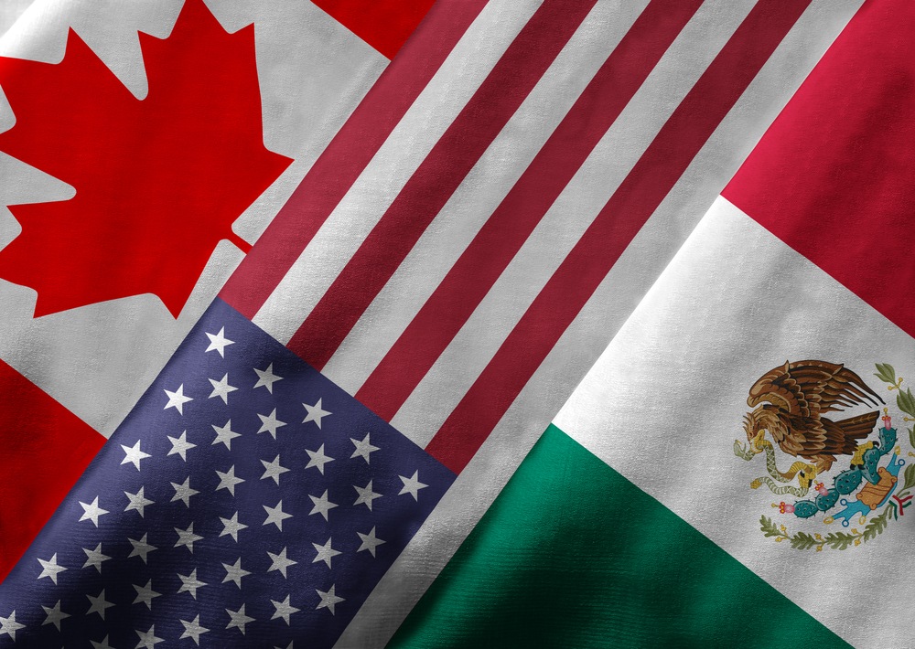
  NAME
Inside Left Header  TEXT |  |  | Inside Right Header  TEXT

