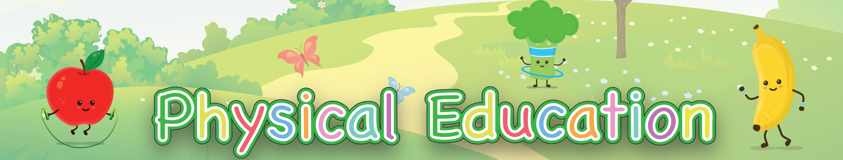

Hula Hoop Skills Practice
Review each of these skills activities. You will need to practice all the activities over the next few weeks. You can count the time you practice on your weekly Activity Log.

Print off this page to help you keep track of the skills you need to practice. You can print off a new one each week.

Hula Hoop | SU | M | Tu | W | Th | F | Sa
Waist (5+ times)
Neck (5+ times) Try to spin on knees Try to Tread Water
Try to spin on the arm

Try to switch from one arm to the other
Balance and run through

