Physical Education

Weekly Activity Log
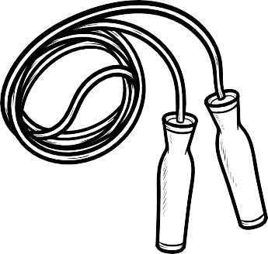
Please provide the requested information below. This will help your teacher. Student Name:
Supervising Adult: Email Address: Phone Number:

What is your age:
What is your approximate height:

and weight:

Activity Log #

Date | Activity Detail | Time Spent | Total Steps
Monday
Tuesday
Wednesday
Thursday
Friday
Saturday
Sunday
*If using a pedometer

Answer the following questions:

- What was your favorite thing about your activities this week?

- What was your least favorite thing about the activities this week?

- What can you do to make your physical activities better next week?

