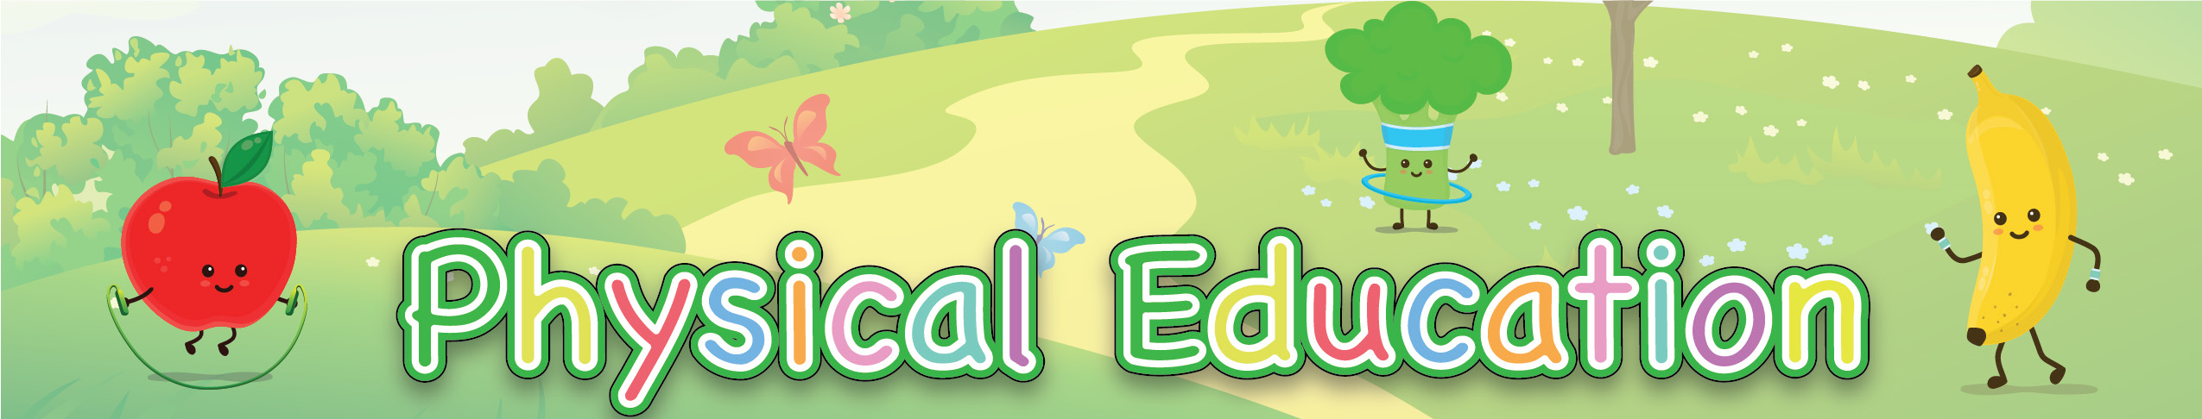


Basketball Dribble Skills Practice
Review each of these skills activities. You will need to practice all the activities over the next few weeks. You can count the time you practice on your weekly Activity Log.
Print off this page to help you keep track of the skills you need to practice. You can print off a new one each week.

Basketball Skills | Su | M | Tu | W | Th | F | Sa
Dribble with right or left hand
Dribble and switch between hands
Jog/Run while dribbling
Dribble in a zig-zag pattern
Passing | Su | M | Tu | W | Th | F | Sa
Bounce pass
Chest pass
Offense | Su | M | Tu | W | Th | F | Sa
Dribble and keep defender from stealing the ball
Pass to another player while being defended

