Designing Data Visualizations to Promote Mathematics Learning and Identity Development

Michelle Wilkerson-Jerde
Tufts University, Department of Education, Medford, MA

Elsa Head
Cambridge Public Schools, Cambridge, MA

Designing Data Visualizations to Promote Mathematics Learning and Identity Development

Abstract. A researcher and teacher at a diverse urban school partnered to enact a unit where 7th graders analyzed and designed visualizations of public city data. We analyze students’ engagement with math content and mathematical agency, and identify supports that promoted mathematical depth. The talk will include classroom video and student work.

Designing Data Visualizations to Promote Mathematics Learning and Identity Development
Data visualizations and infographics uncover and communicate quantitative patterns using novel and appealing visual methods. Their proliferation (McGhee, 2010) reflects both a challenge and an opportunity for mathematics educators. They eschew conventional representational forms, and can be misinterpreted or misleading. However, they also highlight the power of mathematics as a way to understand the world, and as a way to make arguments (Friendly, 2008). We conjecture that designing data visualizations offers a way for educators to support learners in developing data literacy, engaging in mathematical exploration, and using mathematics as a means for personal expression.
There is growing evidence that it is not enough to simply learn mathematics as a collection of representational forms (equations, line graph, or bar charts). Instead, learners must identify and navigate the connections across mathematical representations (Janvier, 1987; Kaput, 1994; Superfine, et al. 2009), learn to construct and critique representations (diSessa, 2004; Terwel, et al. 2009), and understand whether, how, and for what purposes representations are used in practice (Greeno & Hall, 1997). It is also important that learners see themselves as mathematical agents who can use mathematics a way to communicate about and investigate personally meaningful situations (Boaler, 2002; Cobb, Gresalfi & Hodge, 2009). These theories are the motivation for our work, and align with practices highlighted in NCTM’s Principles to Actions: Ensuring Mathematics for All, such as using and connecting representations, facilitating meaningful mathematical discourse, and posing purposeful questions.
There is a history of research on data modeling, technology-mediated data inquiry, and invented representation in mathematics education (McClain & Cobb, 2001; Hammerman & Rubin, 2004; Lehrer & Schauble, 2004; Brizuela & Gravel, 2013). This study builds on these literatures, with a specific focus on using city data. City data embody deeply interdependent relationships among the people and places students see every day. However, learners designing their own visualizations run a risk of only shallowly engaging in mathematical investigation. Or, merely applying mathematical procedures to subsets of data, without leveraging their existing knowledge to guide or enrich their investigation. In this paper, we explore these tensions and interactions.
Methods
Classroom Activity. “Designing Data Visuals” is a unit designed by Elsa (second author), a middle school mathematics teacher, in consultation with Michelle (first author), a researcher interested in mathematics learning with technology. Students worked in pairs to explore novel infographics from popular media and public non profit organizations, learn technological tools such as Google Spreadsheets and online graphics tools, formulate questions that could be answered by analyzing publicly available city data, write summaries of their findings, and construct, share, and critique visualizations intended to communicate the results of their analyses.
Participants. We enacted this two-week unit in five seventh-grade mathematics classes at an urban middle school in Greater Boston. The school is diverse in terms of socioeconomic status (50% low income), home language(s) (16% limited English proficient), and special education status (28%). This was reflected in our sample, which included students receiving special education services and/or sheltered english instruction. Students selected a variety of topics to explore, ranging from racial composition and poverty to public zoning and transportation use.
Research Question. Given our theoretical focus on learning mathematics through invented representation and students’ development of mathematical agency, we will explore:
(1) To what extent did students engage in core mathematical content and exercise mathematical agency during the unit?
Data Sources
We collected video recordings of small group activity and classroom-level instruction, and students’ written work and sketches from each day of class. We also used Camtasia (TechSmith, n.d.) to record on-screen activity and discussion when participating students used laptops to analyze data and design visualizations. Across the five classes, we have data for a total of 27 students (12 groups) for which all group members completed assent and consent documents and permitted collection of video data, screen capture, and written work.
To answer our research questions, we analyze video and written work from each day of these episodes using a coding scheme developed to explore, at a broad level, the quality of each group’s engagement with mathematical content or building connections to personal knowledge of or experience in the city. The scheme is described in more detail in Figure 1.
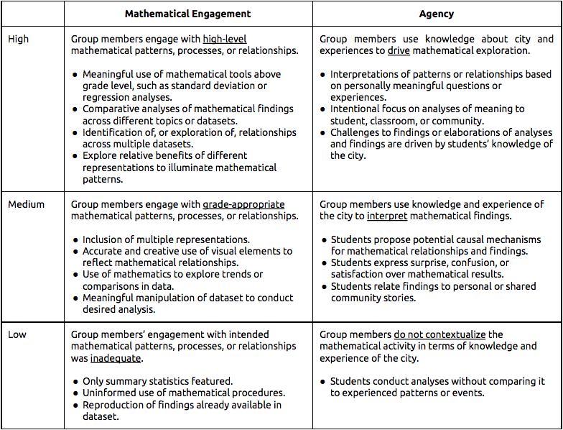
Figure 1. Codes used to analyze students’ engagement with mathematical content and agency.
Results
Here we share preliminary results from ongoing analysis of students’ final visualization artifacts, written project reports, and oral presentations. Should this proposal be accepted, we will also present a more in-depth analysis of each group’s trajectory of mathematical and personal engagement over time, which will allow us to draw stronger links between quality of engagement and particular instructional, curricular, or material supports.
Across all our data, we are finding that there is a broad diversity in the quality of mathematical depth and agency in student’s final products (see Figure 2 for an example). Low mathematical engagement was more common than low agency across our sample, this manifested in our analyses data (Table 1) as well as in our experiences of the lesson with all students. The work that included evidence of high student agency did not include evidence of low-mathematics products. This corresponds to our experiences as facilitators that personal agency over a student group’s exploration - in particular, expressing surprise at unexpected results, or using personal experience as a driver for an investigation, encourages students to engage in a mathematically richer activity. This is because often, the questions students pose involve more than descriptive statistics, but rather are embedded in city dynamics and relationships. In one case, students interested in the population of K-8 students enrolled in Cambridge Public Schools wanted to compare their findings with nearby cities, which in turn encouraged them to question the role of private schools and citizen’s income on school enrollment. In another, students who observed comparatively low poverty rates in 1990 asked questions about public policy and housing patterns, although they unfortunately did not have time to pursue these questions in class.

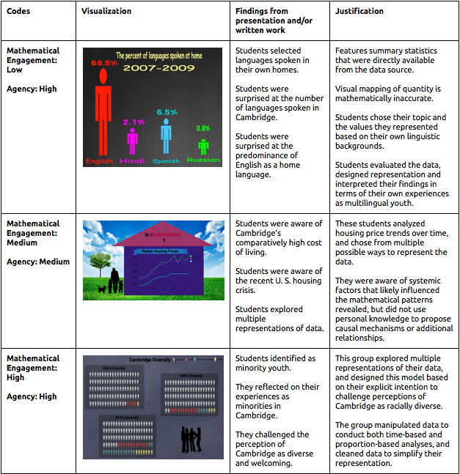
Figure 1. Examples of analyses using final artifacts, written work, and video evidence.
We are also finding patterns in which instructional, material, and curricular supports were especially important contributors to students’ mathematical engagement and sense of agency. For example, use of the Google Spreadsheets tool allowed students the ease and flexibility of engaging with multiple forms of data analysis - and hence, with multiple forms of mathematical content as they worked to correctly execute and make sense of those analyses. In planning for and designing the visualization itself, students constructed more connections to personal and community experiences, partly because of the requirement that they contextualize their findings using visual elements, color, and space which by their nature require interpretation and value judgements. At the time of presentation, we will have completed a full analysis of how these dynamics unfold across the entire curricular activity in terms of our coding scheme.

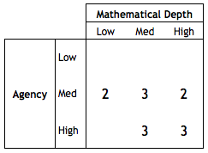
Table 1. Summary of mathematical depth and agency in students’ final products.

More generally, our findings suggest that the data visualization activity holds potential to engage students in deep and meaningful mathematical exploration. However, more work needs to be done to identify what curricular supports, materials, and facilitator moves can help those student groups who fail to engage in deep mathematical exploration. Our findings also have implications for the broader context of data analyses and modeling education. Specifically, they suggest that not just student interest, but deep, participatory knowledge of situations -- in our case, knowledge of a city as a citizen within in, or perhaps knowledge of scientific data as a participant in its generation -- can play an important role in how students’ sense of agency can drive deeper mathematical engagement.

Scientific Importance
There is growing concern that we must prepare students for an age of data . However, still little is known about how to design for and support learners in developing the skills and practices needed to be critical data literate citizens (Finzer & Parvate, 2008). This work is revealing new, research-based and practical methods to engage students in making sense of and creating their own data visualizations in ways that also support other mathematical goals such as deeply engaging with core mathematical content, and becoming agentive users of mathematics to explore and communicate about the people and places they see every day.
References

Brizuela, B. & Gravel, B. (2013). “Show me what you know”: Exploring Student Representations Across STEM Disciplines. New York: Teachers College Press.

Boaler, J. (2002). The development of disciplinary relationships: Knowledge, practice, and identity in mathematics classrooms. For the Learning of Mathematics, 22(1), 42-47.

Cobb, P., Gresalfi, M. & Hodge, L. L. (2009). An interpretive scheme for analyzing the identities that students develop in mathematics classrooms. Journal for Research in Mathematics Education, 40(1), 40-68.

diSessa, A. (2004). Metarepresentation: Native competence and targets for instruction. Cognition and Instruction, 22(3), 293-331.

Finzer, W. & Parvate, V. (2008). Who will teach them about data?: The responsibility of mathematics and statistics educators to support the integration of data analysis across all subjects. In Proceedings of the International Congress of Mathematical Education (ICME 11), Morelia, Mexico.

Friendly, M. (2008). A brief history of data visualization. In Handbook of data visualization (pp. 15-56). Springer Berlin Heidelberg.

Greeno, J. & Hall, R. (1997). Practicing representation. Phi Delta Kappan, 78(5), 361-367.

Hammerman, J. K., & Rubin, A. (2004). Strategies for managing statistical complexity with new software tools. Statistics Education Research Journal, 3(2), 17-41.

Lehrer, R., & Schauble, L. (2004). Modeling natural variation through distribution. American Educational Research Journal, 41(3), 635-679.

McClain, K., & Cobb, P. (2001). Supporting students' ability to reason about data. Educational Studies in Mathematics, 45(1-3), 103-129.

McGhee, G. (2009/2010). Journalism in the age of data. A video report on data visualizations as a storytelling medium. http://datajournalism.stanford.edu/ (retrieved July 10, 2013).

Superfine, A. C., Canty, R. S., Marshall, A. M. (2009). Translation between external representation systems in mathematics: All-or-none or skill conglomerate? The Journal of Mathematical Behavior, 28(4), 217-236.

TechSmith Corporation. Camtasia: Mac. [Computer Software]. Available from http://www.camtasia.com.

Terwel, J, van Oers, B., van Dijk, I., & van den Eden, P. (2009). Are representations to be provided or generated in primary mathematics education? Effects on transfer. Educational Research and Evaluation: An International Journal on Theory and Practice, 15(1), 25-44.

