Beyond Numbers: Evaluating Novices' Orientations to Teaching Mathematics

William Zahner
San Diego State University
bzahner@mail.sdsu.edu

Robert Afonso
Boston University
rafonso@bu.edu

Suzanne Chapin
Boston University
schapin@bu.edu

Abstract: This paper presents initial findings from a longitudinal study investigating the career pathways subject matter orientation of secondary mathematics teachers who entered the field through two distinct programs at the same university between 2009 and 2013. One program was a traditional certification program with scholarship support for STEM majors, and the other was an alternative certification program with a university partnership. Program inputs and outcomes for two groups of teachers are compared. In order to go beyond documenting years of teaching, we used a survey with representations of practice to investigate teachers’ orientations to mathematics. The mixed-methods analysis of survey responses highlights different subject-matter orientations across the two groups. In future work we plan to investigate what implications these different subject matter orientations might have for students of these teachers.

Introduction

In response to the relatively tight labor market for mathematics and science teachers (Guarino, Santibanez, & Daley, 2006; Ingersoll & Perda, 2010), policy makers and mathematics educators have collaborated on expanding undergraduate and graduate scholarship programs and developed alternative certification pathways. Much of this work is included under the umbrella network 100K in 10, named after the call to recruit and train 100,000 qualified STEM teachers in ten years (President’s Council of Advisors on Science and Technology, 2010). While these various teacher recruitment initiatives have distinct missions and philosophies, one overarching focus is recruiting qualified teachers to work in “high need” schools. One common metric for a teacher’s qualification is an academic background in the content area. There is support in the literature that a teacher’s content area preparation matters (Darling-Hammond, 2000), and in general more content preparation is associated with better student outcomes (Monk, 1994). However, mathematics educators have also invested considerable effort unpacking this association and investigating what kinds of content knowledge are most important for teaching (Ball, Hill, & Bass, 2005; Ball, Phelps, & Thames 2008).
Given the focus on recruiting and retaining qualified mathematics teachers in particular schools and districts, most evaluations of programs designed to meet this need focus on counting the number of teachers recruited, the characteristics of these teachers, and the retention rate of teachers who enter the field through various pathways. Some studies also include data on student outcomes, usually measured with standardized test scores (Boyd et al., 2012; Papay, West, Fullerton, & Kane, 2012). However, one critical element missing from much of the evaluation literature is an examination of novice teachers’ pedagogical practices and orientation to teaching mathematics. Many students in high need schools experience a form of pedagogy focused on development of routine procedures (Gándara & Contreras, 2009) and the NCTM’s Principles to Actions describes an overemphasis on procedures in teaching and too much weight placed on high stakes assessments (NCTM, 2014). The scarcity of data on teaching practices in these evaluation studies and the emphasis on assessment results reflects the challenge of measuring teaching practices at scale and across grade levels. This study, growing from an evaluation of the mathematics education program at one university represents the start of our efforts to address this lacuna through examining novice teachers’ reactions to representations of practice. Through investigating teachers’ reactions to representations of classroom situations we can gain insights into how teachers orient to the content of school mathematics (Herbst & Chazan, 2006) as well as how they describe their intended actions in response to these representations of classroom situations.
Perspectives for the Research
Most large-scale studies of teacher requirement and retention draw on a labor market framework focused on supply and demand (Guarino et al., 2006; Ingersoll & Perda, 2010). This study uses some constructs from these studies such as examining teachers’ content area background, the characteristics of the schools where they teach, and teachers’ job satisfaction and perceptions of their working conditions. In order to delve deeper into teachers’ orientation to mathematics and to gain some insight into their teaching practices, this study also draws on perspectives from the mathematics education literature that have examined teachers’ knowledge of mathematics for teaching (Ball, Hill, & Bass, 2005; Ball, Phelps, & Thames 2008), as well as how teachers orient to and use instructional tasks (Boston & Smith, 2009; Matsumura, Garnier, Slater, & Boston, 2008; Stein, Grover, & Henningsen, 1996). We also use elements of Herbst and Chazan’s (2006) investigations of the “practical rationality” of teaching, querying the assumptions teachers make about content and students.
Setting, Data and Methods
This study was situated at a university that sponsored both traditional and alternative pathways into teaching mathematics. The traditional pathway was a one-year master’s and certification program. During the time of this study the university had scholarship funds to support individuals with undergraduate STEM majors during their year of study in the master’s program. In return for receiving the scholarship, teachers committed to teaching mathematics in “high need” schools for two to four years. High need schools were identified as those with a high percentage of low-SES students, a high rate of teacher turnover, or a high percentage of “out of field” teachers. In addition to receiving financial support during their studies, fellowship recipients also participated in professional development meetings during their first years in the classroom. Across the time period from 2009 to 2013, 38 mathematics teachers were prepared in the traditional program.
The alternative pathway recruited high achieving undergraduates from a wider range of majors to teach for two years in high need schools. The alternative program recruited teachers for all subject areas, but this evaluation focuses on the subset of teachers in that group whose primary responsibility was teaching middle school and secondary mathematics. In contrast with the traditional program’s focus on recruiting STEM majors, the mathematics teachers in the alternative program were not necessarily STEM majors (in fact, STEM majors were in the minority). However, teachers in the alternative program who taught middle school and secondary mathematics did express interest in and capability for teaching mathematics. The pre-service preparation in the alternative program included a five week summer training. After participants in the alternative program started teaching, they took additional coursework through the university partner and participated in professional development. The university partner provided the coursework for the alternative program, but did not endorse the teachers for certification. From 2009 to 2013 there were 92 mathematics teachers in the local area who started teaching through the alternative program and who took classes at the university.
The primary data source for this study was a longitudinal survey administered to teachers from each program in spring 2013 and spring 2014. The survey included a series of questions that tracked program alumni’s academic background, teaching placements, course loads, perceptions of working conditions, sense of efficacy, and satisfaction with teaching. Most of these questions were adopted from prior evaluations of teachers’ career pathways (e.g., Boyd et al., 2012). In order to probe teachers’ orientations to mathematics and teaching mathematics, we also developed a series of three open-response questions based on classroom vignettes. The vignettes were presented as scenarios of classroom interaction where the students and teachers in the scenario encountered a problematic issue. For example, in one situation (Figure 1) two characters solved a linear equation in different ways (one algebraically and the other graphically) and the characters could not reconcile their solutions. The survey takers were asked to (a) reflect on and discuss the mathematical issues in the vignette, (b) write a list alternative responses a teacher could make along with advantages of different moves, and (c) then select one teacher response that they would use in their classroom. The three scenarios were designed to represent a range of content, from middle school algebra (solving linear equations) to geometry (proofs and area/perimeter) and advanced algebra (introducing logarithms and inverse functions).

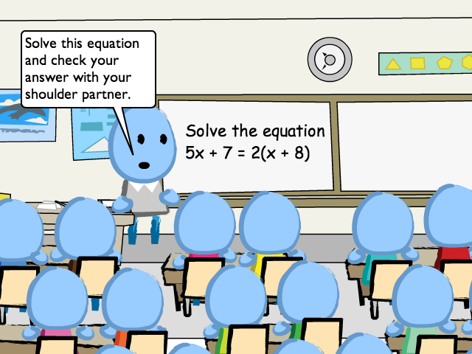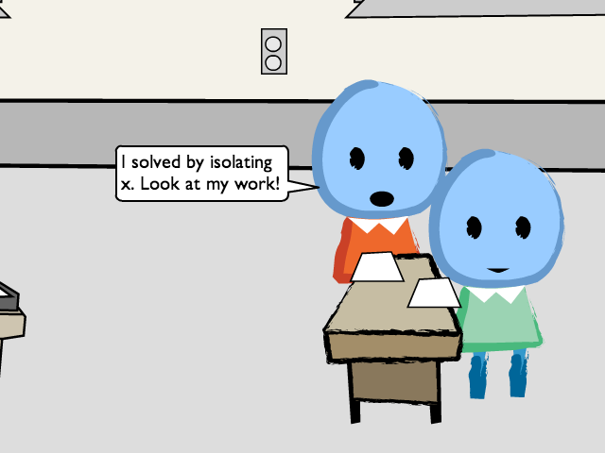

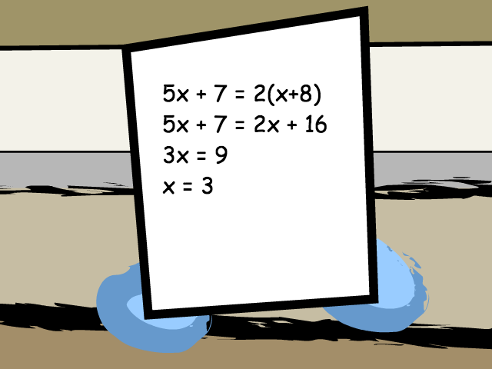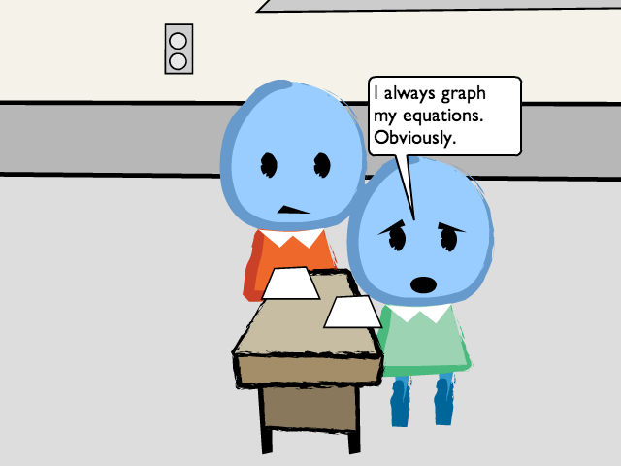

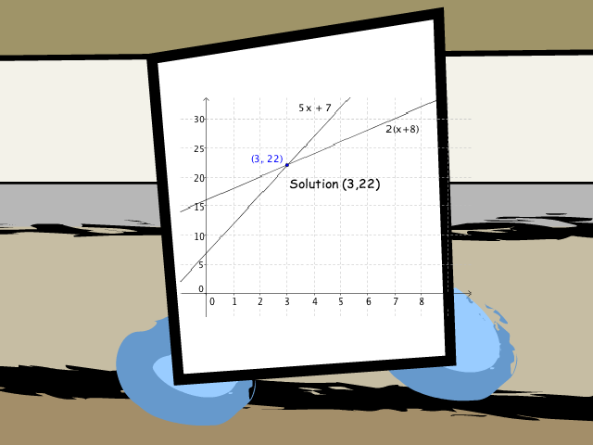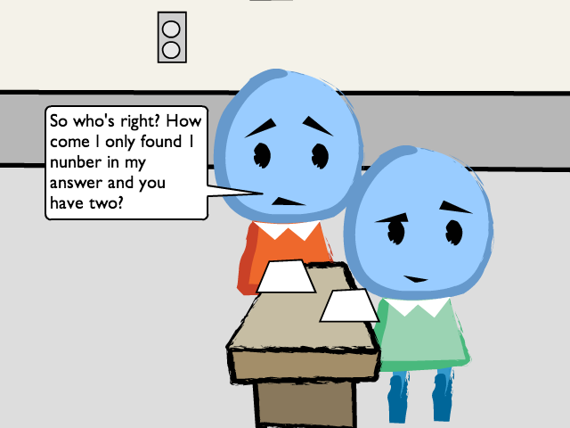

Figure 1. A representation from middle school algebra. These depictions were created using LessonSketch (www.lessonskectch.org) with partial support from the NSF.

Responses were coded using a four-level coding scheme derived from the categories for academic rigor of tasks in the Instructional Quality Assessment (Boston & Smith, 2009; Matsumura et al., 2008). For example, a code of 1 corresponded to an orientation dominated by following rules and procedures without making connections, while a code of 4 indicated that a respondent made mathematical connections within and beyond the given representation.
Results
Complete surveys were collected from 25 (64%) of the traditional and 27 (28%) of the alternative pathway teachers. For the purpose of the evaluation, missing data about teacher placement and satisfaction of service requirements were gathered by contacting program administrators and following up with individual teachers. The demographic and career satisfaction questions from the longitudinal survey revealed important commonalities and differences across the two pathways. Some highlights from the survey include the following:
- Mathematics teachers in the traditional pathway were far more likely to have a STEM major, reflecting the selection criteria for each program.
- Teachers in the alternative pathway were placed in schools that had a higher percentage of low-SES students.
- The participants from both programs expressed similar levels of job satisfaction and access to resources.
- Traditional pathway teachers were more likely to remain classroom teachers beyond their required two-year term of service.
The survey items that focused on the teachers’ teaching practices and orientation to teaching mathematics also revealed interesting contrasts between the teachers from each program. The research team developed a coding rubric for each item focused on the depth of the mathematical interpretation of the situation. A score of 1 indicated an orientation dominated by application of rules and procedures, while a score of 4 reflected a response that extended the description of the mathematical situation beyond the situation.
Level | Descriptor | Code Rubric
0 | NOMATH | No Math OR Skip
1 | Rule Dominated, Non-conceptual | Describe the situation in terms of rules (e.g. “student simplified by using distributive property”), no mention of equivalence of solutions, or says grapher did it incorrectly or inefficiently.
2 | Superficial Conceptual | General statement about multiple representations, did not explicitly show how 22 connects to 5x+7 = 2(x+8)
3 | Conceptual | Specific statement about the connection between the two solutions. For example, shows that 5(3) + 7 = 22 and that is where the y-coordinate comes from.  OR  Shows some evidence of more sophisticated mathematical understanding such as describing how graphing transformed two sides of the equation into functions, or noticing that nature of the variable shifts in each solution. However, this does not make specific connection with x = 3 and y = 22.
4 | Extending beyond present problem | Does one of the two descriptors in level 3 AND shows evidence of more sophisticated mathematical understanding such as transforming two expressions into functions, or noticing that nature of the variable shifts in each solution.

The participants’ responses to the algebra problem were similar across the two programs, but the participants in the traditional program provided significantly higher-level responses to the question about advanced algebra. Table 1 contains a summary of the data.
This difference may reflect the mediation of the effects of both undergraduate preparation in the content area and their teacher education experiences focusing on pedagogical content knowledge of teachers from the traditional program. Follow up analysis will examine qualitative features of the teachers’ responses such as how they indicate they would respond to the problematic situations.

Table 1. Summary of coded responses to depictions of practice.
 |  | n | mean | SD
Solve Equations | Traditional | 28.000 | 2.679 | 0.819
 | Alternative | 27.000 | 2.556 | 0.847
"Proof" | Traditional | 27.000 | 2.52* | 1.051
 | Alternative | 22.000 | 1.82* | 0.958
Introduce Logs | Traditional | 28.000 | 2.393* | 0.786
 | Alternative | 23.000 | 1.826* | 0.778
* Significant at the p<0.05 level using independent samples t test.

Significance
This study presents one attempt to add to evaluation of mathematics teacher education programs by tracking the teaching practices and orientation toward mathematics exhibited by program alumni. This more nuanced view of teachers and teaching contributes to ongoing efforts to recruit and retain highly qualified teachers for high need schools, aligning with the teaching practices highlighted in in Principles to Actions (NCTM, 2014). In future work we plan to investigate further the implications these different subject matter orientations might have for students of these teachers. For example, do different level responses to this instrument align with different classroom practices? These are some of the critical questions that remain as we seek to move beyond numbers and investigate how to recruit, prepare, and support highly qualified mathematics teachers in “high-need” schools.

Authors Note
Support for this work was provided by the National Science Foundation's Robert Noyce Teacher Scholarship Program under Award No. 1240057. Any opinions, findings, and conclusions or recommendations expressed in this material are those of the author(s) and do not necessarily reflect the views of the National Science Foundation. The items created with LessonSketch were created with support from the National Science Foundation to grant (Award #1316241).

References
Ball, D.L., Hill, H., & Bass, H. (2005). Knowing mathematics for teaching: Who knows mathematics well enough to teach third grade, and how can we decide? American Educator, 29(3), 14-17, 20-22, 43-46.
Ball, D. L., Thames, M. H., & Phelps, G. (2008). Content knowledge for teaching: What makes it special? Journal of Teacher Education, 59 (5), 389-407.
Cuoco, A. (2001). Mathematics for teaching. Notices of the American Mathematical Society, 28(2), 168-174.
Darling-Hammond, L. (2000). Teacher quality and student achievement: A review of state policy evidence. Education Policy Analysis Archives, 8:1.
Guarino, C. M., Santibanez, L., & Daley, G. A. (2006). Teacher recruitment and retention: A review of the recent empirical literature. Review of Educational Research, 76(2), 173-208.
Herbst, P., & Chazan, D. (2006). Producing a viable story of geometry instruction: What kind of representation calls forth teachers’ practical rationality. In Proc. of the 28 th PME-NA Conference (Vol. 2, pp. 213-220).
Hiebert, J., & Carpenter, T. P. (1992). Learning and teaching with understanding. In D. Grouws (Ed.), Hanbook of research in mathematics teaching and learning (pp. 65-97). New York: Macmillan.
Ingersoll, R. M., & Perda, D. (2010). Is the Supply of Mathematics and Science Teachers Sufficient? American Educational Research Journal, 47(3), 563-594. doi: 10.3102/0002831210370711
Matsumura, L. C., Garnier, H. E., Slater, S. C., & Boston, M. D. (2008). Toward measuring instructional interactions “at-scale”. Educational Assessment, 13(4), 267-300.
Monk, D. H. (1994). Subject area preparation of secondary mathematics and science teachers and student achievement. Economics of Education Review, 13(2), 125-145.
National Council of Teachers of Mathematics. (2014). Principles to Actions. Reston, VA: Author.
Stein, M. K., Grover, B. W., & Henningsen, M. (1996). Building student capacity for mathematical thinking and reasoning: An analysis of mathematical tasks used in reform classrooms. American Educational Research Journal, 33(2), 455-488.

