Eclass 7:
Steps to Self-Managing your Commercial Property
You need to make a decision before settlement of your commercial property if you are going to self-manage your commercial property or not. You can always change this later on by writing to the tenant but to start with you need to first make a decision if you want to self-manage the property or get an agent to manage it for you.
If you choose to get an agent to manage the property for you then you can ask local agents or the agent that sold you the property to refer someone. An agent will give you a management proposal which will list their fees and responsibilities. There are samples of these in the modules on a separate document. The fees for an agent to manage the property is usually between 5% to 7% plus GST.
If you chose to self-manage your property, then the steps are below:
(There are also templates for managing your property included in this module)
- Before settlement ask your solicitor to draft a letter to be sent out to your tenants upon settlement. This letter will detail to your tenant you are now the new landlord and that you are going to manage the property going forward. It should detail your contact details and bank account details for rent and inform the tenant when the rent is due per the lease
- After settlement email or call the tenant directly to introduce yourself and let them know how to contact you in case of any issues in the property and if you have a preferred tradespeople they can call in case of an emergency. Ask you tenant for the following details if you don’t have them already:
  - Name of the business the invoice to be made out to (if it is not the business name they are operating under currently)
  - The Tenant’s ABN
  - Email address (if you don’t already have it)
- Set up an invoice for your tenant (a template you can amend each month) with the following details:
  - Invoice Date
  - Invoice number (you can start with 001 or the year/001 – whichever format suits)
  - Your name or business details
  - Your ABN or CAN
  - Your contact details
  - Your tenant’s business details, contact details
  - Write out the month the rent is for (usually a month in advance)
  - The amount for the rent without GST
  - Add GST to the amount
  - The total that is due for the rent inclusive of GST
  - Your bank details
  - Due date for the rent (per the lease – the lease will say when the rent is due each month or week)
- Email the invoice to your tenant at the 1st of the month/first working day of the month and save a copy of the invoice in a special folder set up for your tenant under their name (this helps with tax at the end of financial year)
- You can ask your tenant to confirm receipt of invoice by replying to your email or you can just wait to see if they deposit the rent into your account by the due date or not. (some tenants do automatic direct deposits)
- For the first payment that the tenant pays me I like to confirm with them via email that I have received the rent because it means all systems are now set up
- Put a reminder in your diary to send your tenant an invoice beginning of every month
- Every 6 or 12 months you may want to send them a statement which just details the rent they have paid over the last 6 or 12 months. This just helps both you and the tenant to know that they have not missed any rent payments (also helps you at tax time)
Recovery of Outgoings
- You need to send your tenant a separate invoice for any outgoings they are responsible for.
- You need to setup an invoice template for this (sample included in the module)
- You need to put on the invoice the following:
  - Invoice Date
  - Invoice number (just follow the number sequence you have for your rent invoices)
  - Your name or business details
  - Your ABN or CAN
  - Your contact details
  - Your tenant’s business details, contact details
  - The outgoing (strata, water, rates, etc)
  - The amount due (separate GST from the total amount if possible)
  - Due Date
  - Your bank details
- You need to attach with your invoice a copy of the notice (rates, strata, etc) with the invoice (scanned copy attached to the email is enough)
- Email the invoice with the attachments to the tenant and ask for confirmation
- Wait to see payment of outgoing and respond to tenant to confirm receipt of payment
- Add any outgoing amount to any statements you send to the tenant
- Save a copy of the invoice in your tenant folder for future reference
Rent Increases
For rental increase each year, it is at the anniversary of the date of the lease. Each lease varies depending on the date the lease was drawn up so please refer to your lease for the exact date and make a note of it in your diary and write to your tenant about it 30 days before the rental increase
If your tenant is on an existing lease the rental review will be stated in the lease and it can be anything from CPI, 3% to 5% increase per year. You just times the percentage by the current rent which will give you an amount to be added to the current rent to make the new rent
For Example:
$50,000 (Current rent) x 0.03 (3%) = $1500 (rental increase)
$50,000 + $1500 = $51,000 (new rent)
$51,500 / 12 (months) = $4,291.67 plus GST (new month rent for the tenant)
If your rental increase is by CPI then you will have the find out how much the CPI is and times that by the current rent to get the new rent due
An example of a CPI is below:
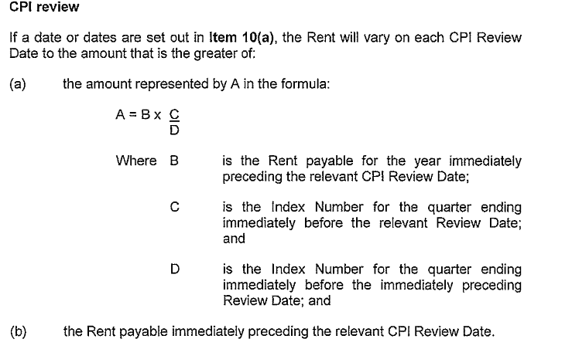
Below is a screenshot takeout out of the ABS CPI report for June 2016.

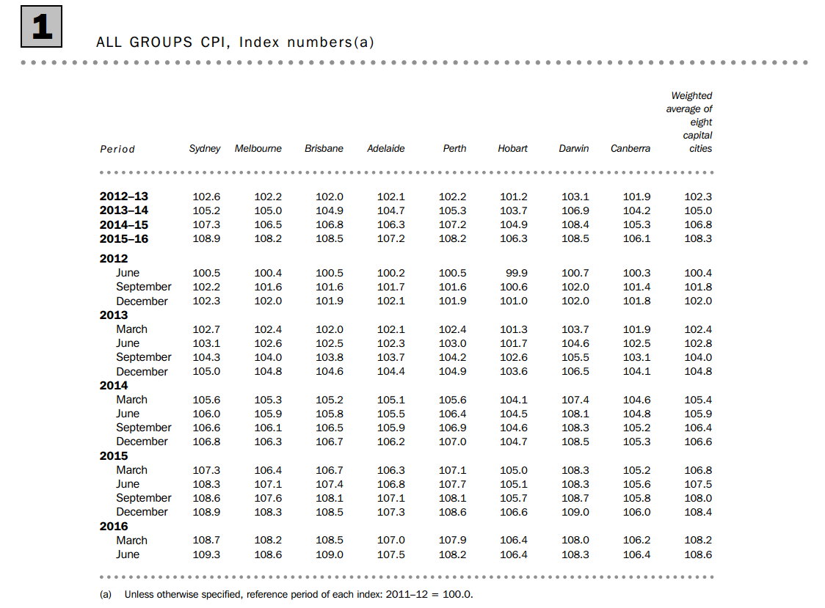
The Australian Bureau of Statistics (ABS) puts out different CPIs for different cities and also for different industries. The CPI for each commercial property will be specified in the lease in the definitions section. Please check to make sure which one you need to use
For Example:
If the lease specifies that the Sydney CPI is to be used, then you need to use the Sydney CPI column in the above screen shot.
Below is the same screenshot but with the CPI circled
In the second screenshot you can see the one circled in black is the CPI for June 2016 and one circled in red is June 2015. So applying the equation above the CPI of 109.3 (circled in black) is C (in the equation) and the CPI of 108.3 (circled in red) is D (in the equation)

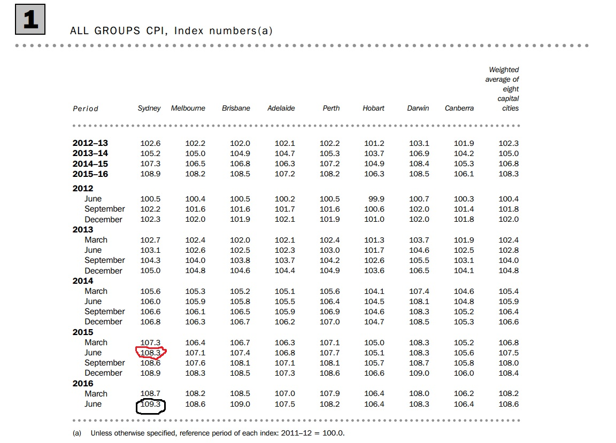
The rental increase for your tenant is calculated yearly so using the equation set out above you are comparing the CPI from the quarter that has just finished (for this example – June 2016) to the same quarter last year (June 2015) to get the change in CPI. You do that by dividing this year’s CPI (109.3) by last year’s CPI (108.3).

Applying the Equation:
A = B x C Adjusted Rent = Current Rent x CPI (quarter just gone)
D CPI (same quarter last year)

For Example:
Adjusted Rent = $50, 000 x 109.3 Adjusted Rent = $50,461.68
108.3
So the new adjusted rent for the next year is $50,461.68
The Year After:
The following year you would use $50,461.68 as your current rent and 109.3 would become the CPI from last year (the D in the equation). You will need to then find the latest CPI figures from the ABS to complete your equation.
To find the latest ABS figures for a particular city – the easiest way is to google
“ABS CPI “and it will take you to the latest CPI figures or go to the link below
http://www.abs.gov.au/ausstats/abs@.nsf/mf/6401.0
and it will take you to the page below – I have circled the tab you need to press to find the different capital city CPI
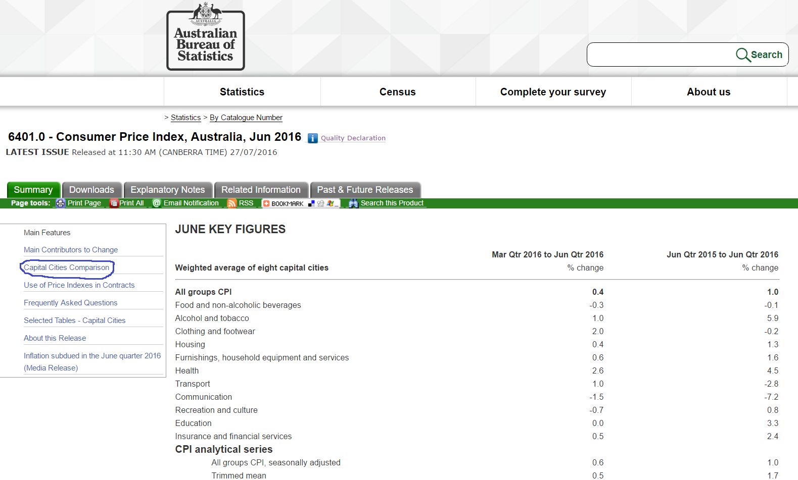
Once you click on the tab above – it will take you to the screen below
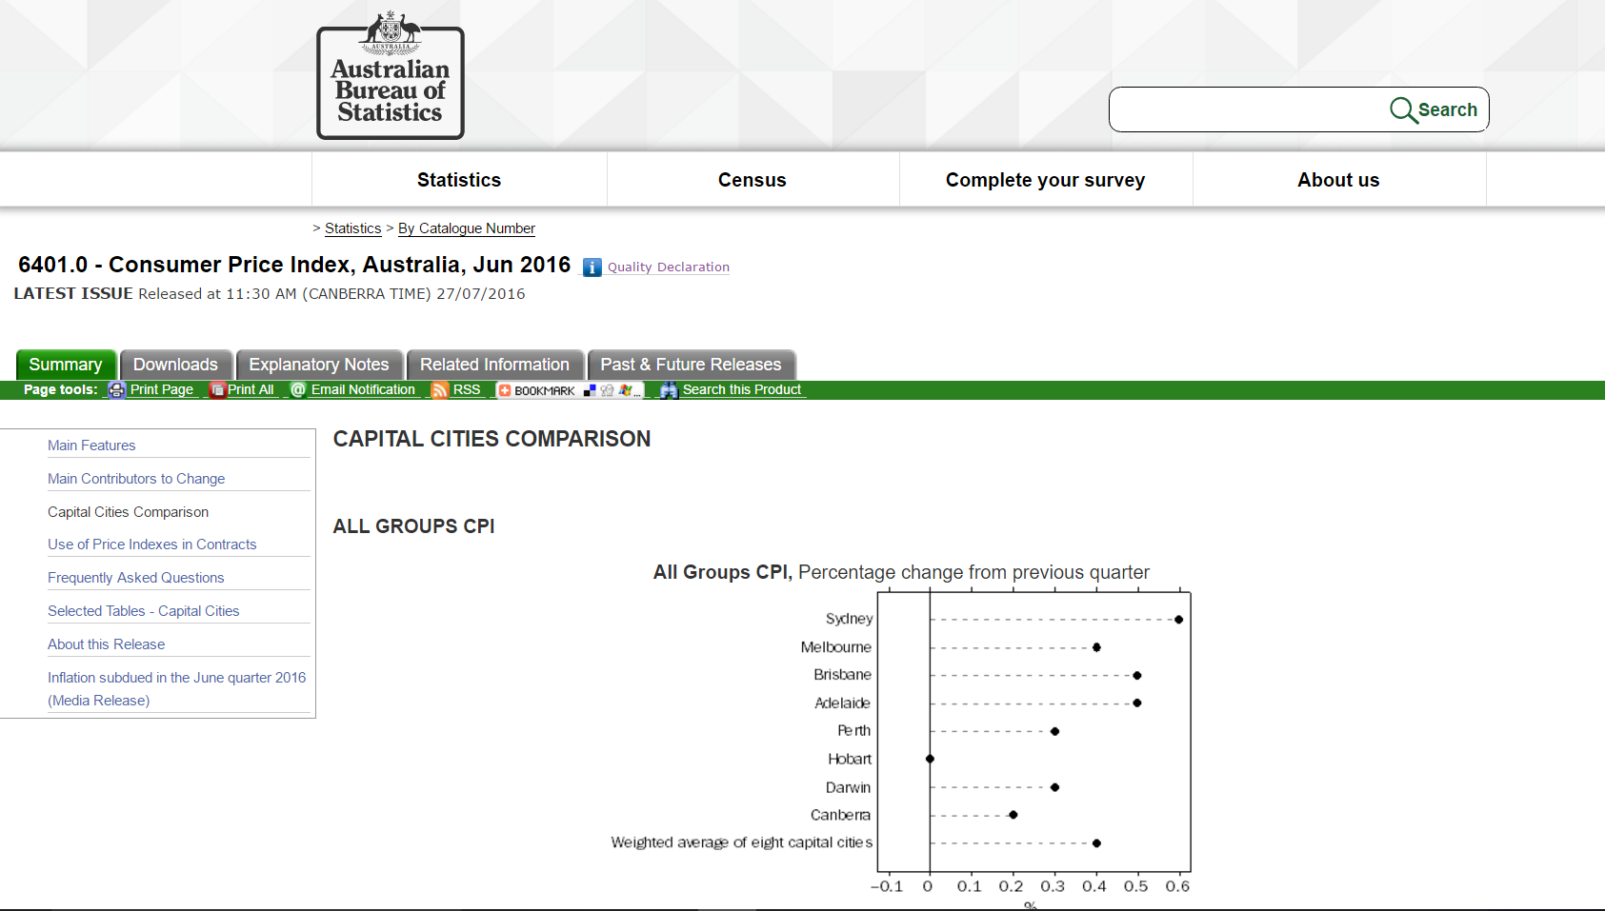
If you scroll down the webpage to about a third of a way down, you will see the following table which lists all the CPI changes for each capital city. You can just take the CPI figures from last column of the table titled “Jun Qtr 2015 to June Qtr 2016 and times that by your current rent to work out the new rent.
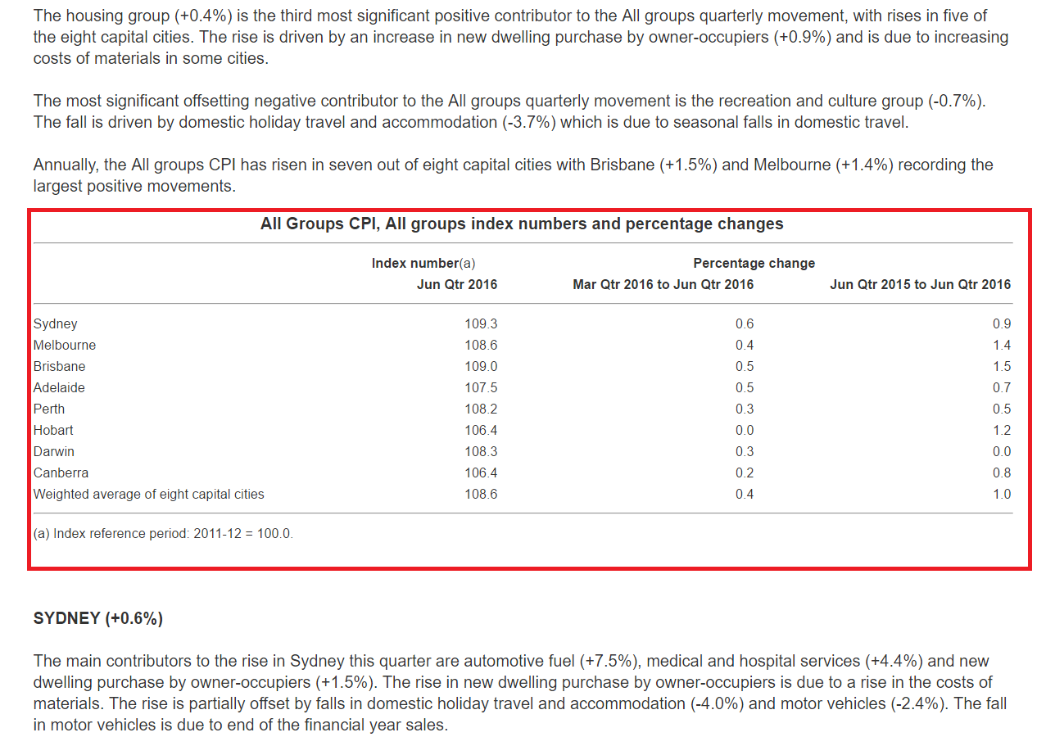
OR
You can download a document which lists all the CPI changes for each quarter for each city. In the screen shot below I have circled in red the tab you need to click to download the CPI document
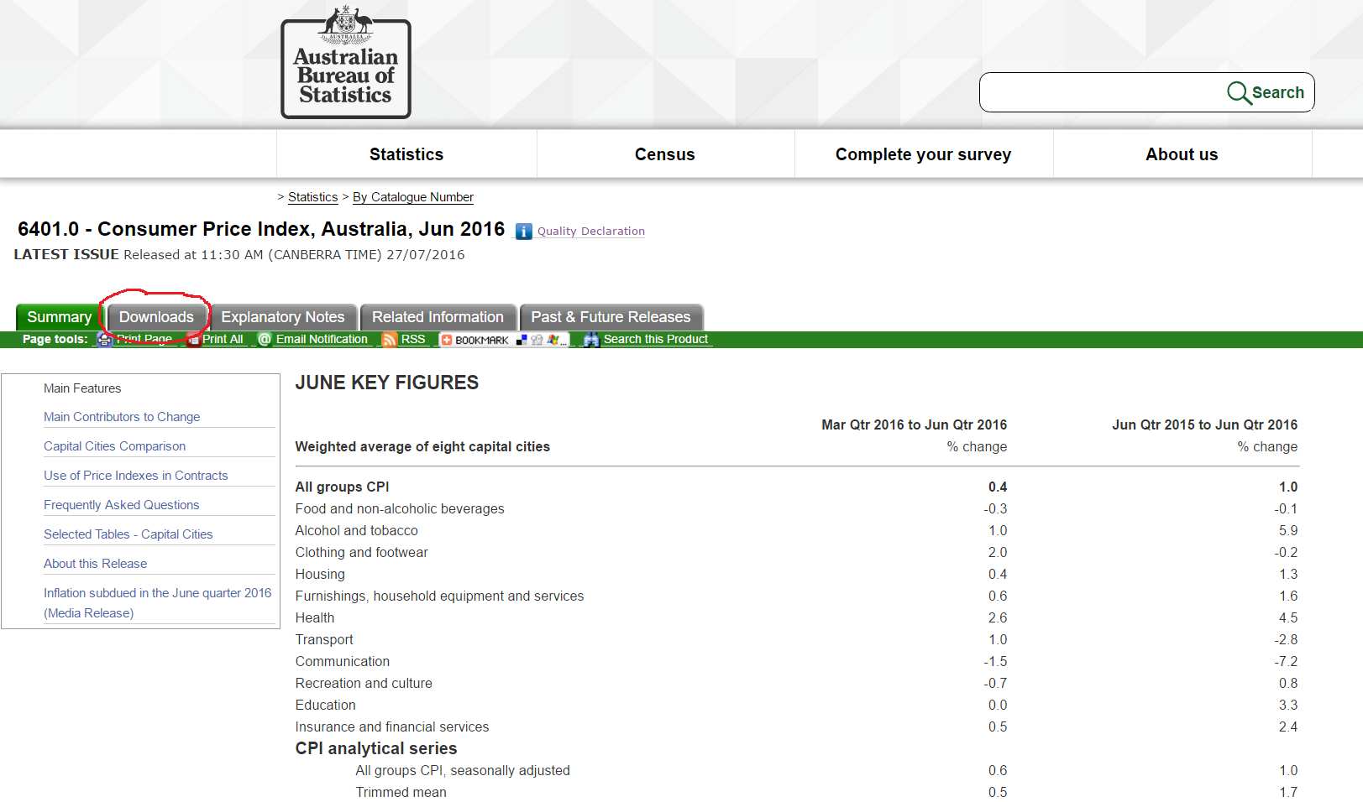
When you click on that tab it will take you to the following page – Just click on the pdf icon to download – it is highlighted in red for you on the screenshot below
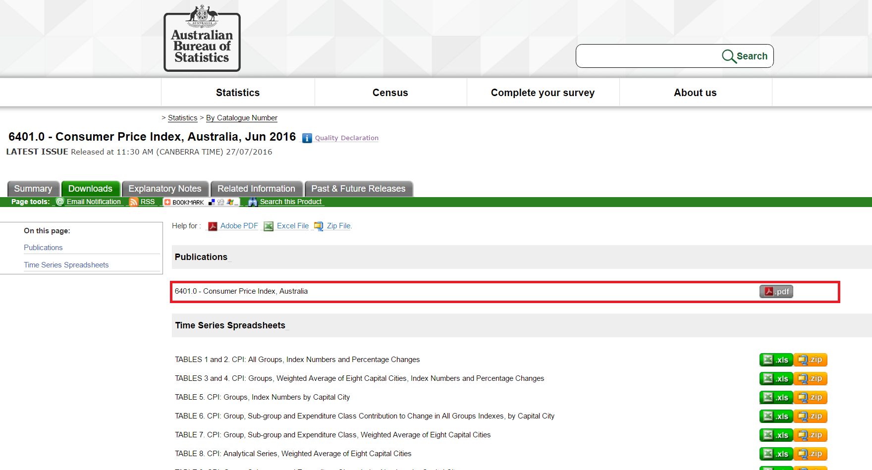
You can either email your tenant or send them a copy of the letter in the post – or you can do both.
Please refer to the sample letter in the module and modify it to suit your tenant details per the lease.
Rent Review
A rent review is a market review of the rent that is currently being paid by other similar premises/businesses in the same area. A rent review occurs per the lease, so can be every year, 2 years or 3 or 5 years. You need to refer to the lease to see when it is due.
If your lease does not have options, then you will need to write to your client at the end of their lease term to offer them a new lease, and that will include a market rent review. Usually rent reviews occur when an option is exercised or just prior to it.
It is the usual practice for a rent review to list out 3-4 similar premises and what the current rent they are charging and then give your tenants an option to start a new lease or exercise their option at either 1, 2 or 3 or 5 years. Usually you don’t offer a discount for 1 year but start offering gradual discounts for 2year leases and a bigger one for 3 years and a much bigger incentive for 5 year leases
If your tenant is going to start a new lease and no options are left on their current lease, then some of the incentives you can offer them for starting on a 5year lease are
  - 10% off the market rent
  - 1 month rent free period (but give a smaller discount off the market rent)
  - To add value to their premise (the tenant may want new air con, painting, some other refurb)
Make sure in your rent review letter you give your tenant a date to respond to your letter and follow up with your tenant about a week before the deadline is due. Once your tenant has decided which option they will choose then you will need to get a lease drawn up. You have two choices for a lease; one is a standard real estate institute lease which you can buy from the real estate institute in your state or you can get a solicitor to draw one up. If your tenant only intends to stay on for another year than you may want to just go with a real estate institute lease. However, if your tenant wants to stay on for longer than 2 years it is worthwhile to get a lease drawn up by a solicitor. Both leases are legal documents but the one from the solicitor is more formal and well worth the money especially if you offer your tenants options to extend their lease later on.

A sample of a rent review letter is provided for you to modify in this module
Once you have written up the letter for rent review then you need to follow the steps below in communicating with your tenant:
- Email or post the letter to your tenant

