
ECLASS 2 - WORKBOOK
Content
Eclass 2 thoroughly explains an information memorandum by dissecting through samples of an IM from different states in Australia. The module will introduce you to the common contents and how they will help you find the right commercial property.
Questions
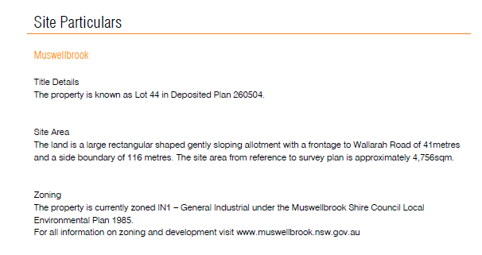
- What is the importance of “Site Particulars” in an IM?

- What is the use of “Lease Details” in an IM?

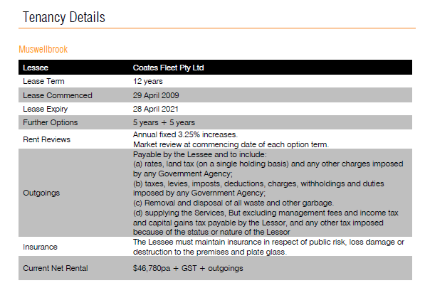

- How does the conveyance process for each state affect an IM?

- How can checking the “Tenant Profile” in an IM help you in making the right decision?

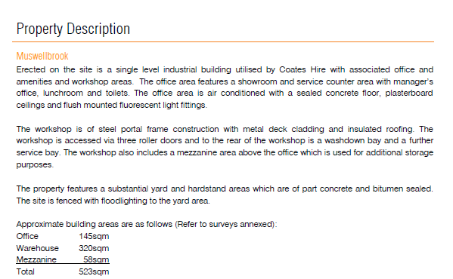
- What is the importance of “Property Description” in an IM?

Answers
- What is the importance of “Site Particulars” in an IM?
Site Particulars are important as you need to match them up with the site diagram in the sales contract to make sure the land you are buying is the same size and zoning as state in the IM.
- What is the importance of “Lease Details” in an IM?
Lease details for the property are used to analyse the property and work out the yield.

- How does the conveyance process for each state affect an IM?

The way the IMs are put together and the documents included in them are primarily different because of the different conveyance process in each state and territory.

- How can checking the “Tenant Profile” in an IM help you in making the right decision?

The tenant profile can help you to determine the tenant’s viability in paying their rent and exercising their lease options.

- What is the importance of “Property Description” in an IM?

The property description can be used as a guide when you do the inspection of the property.

