Starter Deal Finder Checklist
This document is for the beginner get started in commercial property investment. It is a step by step direction on how to source your first tenanted positive cash flowed commercial property.
 | Tasks | Done (tick)
1 | List 5 suburbs you would like to invest in
2 | Log on to www.realcommercial.com.au
3 | Enter all 5 suburbs in the search bar and press “SEARCH” button  
4 | Once the search has been produced – on the left side there is dropped down menu where you can refine your search  Add in Tenanted investment and in yield put in 6%+  Then press the “update” button to get the refined search  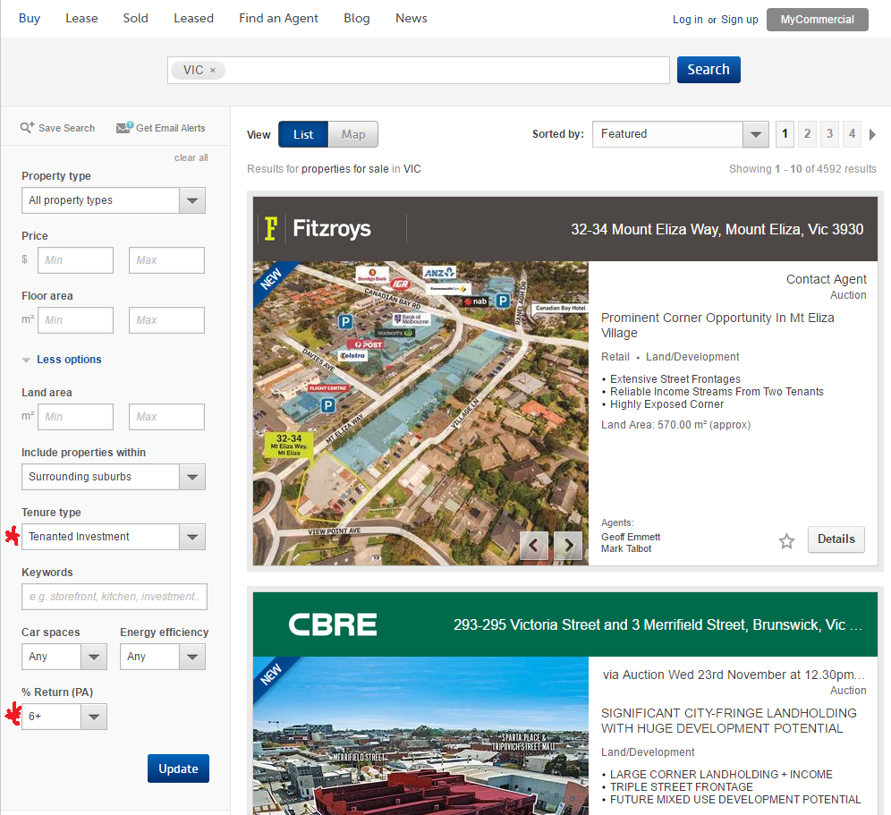
5 | Look through the listing and pick out one each of the following you like  - Office  - Industrial/warehouse  - Retail
6. | Put in an enquiry for IM (information memorandum) and ask for the lease on the property – click on the button under the agent’s name to “email the agent”  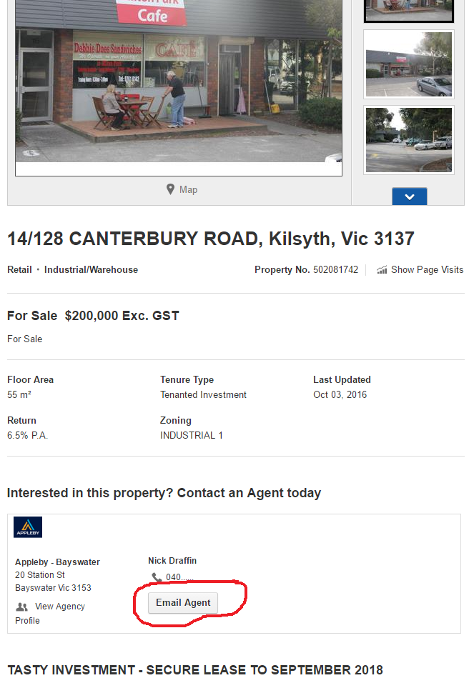
7. | The IM and Lease should come back to you in a day or two
8. | Read through all the IMs and Leases – Make notes on the following for each property:  - Rent  - Outgoings – who pays for the outgoings  - Asking price of the property  - Type of Property – Retail, Office, Warehouse/industrial  - Tenant – name and type of business the tenant is in  - Length of lease – how long is the lease in total and how long it has left  - Options – is there an option on the lease?
9. | Work out the yield to the property based on the net rent divided into the asking price  E.g. $20,000 Rent, Asking Price $250,000  $20000/ $250000 = 0.08 x 100 = 8% net rental return  Do this calculation for all the properties
10. | Write all information down of the 3 properties on a piece of paper and then compare them side by side (make sure the rent is net – if a gross rent is given take the outgoings out of it to get net rent)
11. | When compared side by side see which one of the properties out of the 3 you like best
12. | Think about what you like about the property – write that down on a different piece of paper
13. | You should have on the new piece of a profile of your ideal property
14. | Start new search on Real Commercial website using the profile of your new property – if you have a budget then put that in the search as well – make sure to include surrounding areas  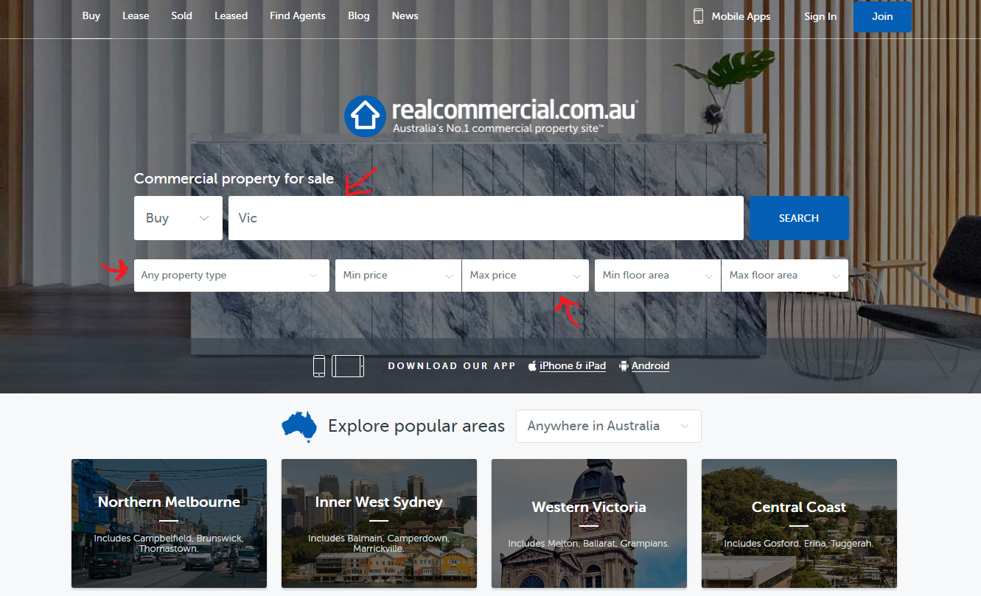  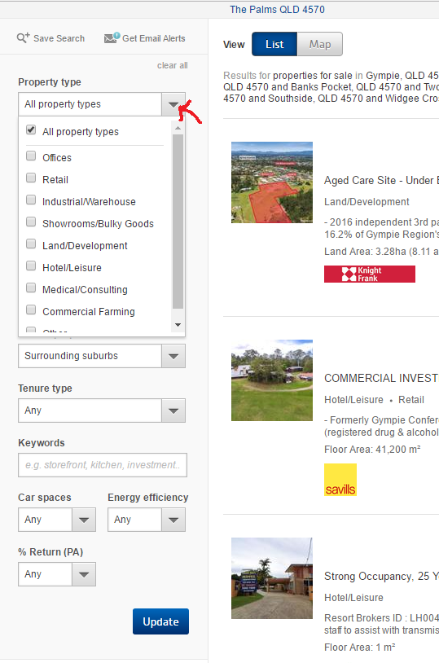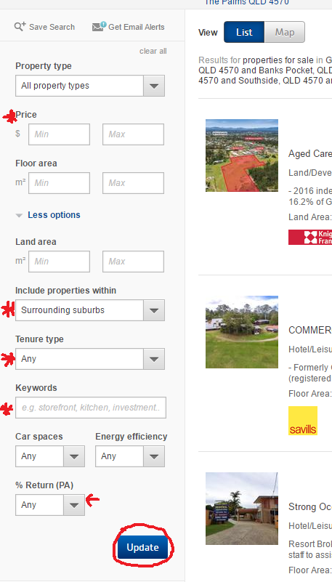
15. | If you do not find something in the suburb you have listed then something in the surrounding suburb or look for a suburb with the same profile – same demographic size, same features (coastal, inland or regional hub)
16. | Once you have done that search you should have a list of properties closer to your ideal property profile – remember there is never going to be a perfect property but they will be one that will come close to it
17. | Go through the listing and pick out the ones you like (as many as you want) and repeat above  step 6-10
18. | Refine your search to 2 – 3 properties and ask the agent for more information:  - How long has the tenant been there?  - Is the rent the tenant is paying current market rent?  - Do you have an asbestos report?  - If Strata/Body Corporate – ask for last strata/body corporate meeting minutes and last AGM meeting  - If Freehold – ask for estimation of building insurance and any refurbs and maintenance on the building including air conditioning
19. | Do some background research on the tenant – do they have a website you can visit, or if they are local could you visit the business
20. | Do research on suburb background – what is the demographics, the industry that support the area, how much is the residential price, has residential pricing grown in the last 5 years, other type of businesses for sale in the area and other type of businesses near your business
21. | Compare the all properties side by side after you have done all your research above and narrow it down to 1-2 properties
22. | Work out your ideal yield for the above properties and write them down  E.g. 9% of $250,000 = $22,500 net rent (0.09 x 250000)
23. | Put in an offer within half a percent above your net rent to give you room to negotiate  E.g. 9.5% of $250,000 = $23,750  This leaves you room to negotiate  Remember though if you get a great property but the vendor will not sell at your ideal yield then don’t lose the property based on half a percent so if the property is 8.5% return instead of 9% it is still worth it because it will be 9% in a couple of years and the goal is to hold the property in the long term
24. | Put your offer to the agent in writing – one property at a time if you are looking at a couple of different ones
25. | Wait for the agent to get back to you – the vendor may accept your offer, counter offer or reject your offer. Once you hear back from the agent you can either counter offer if your offer is rejected or there is another counteroffer or accept the counter offer (remember it is not worth losing on a great property because if a few thousand dollars because you will make that back in a couple of years)
Next Step | PLEASE NOW REFER TO MY COMMERCIAL PROPERTY PROCESS AND DOCUMENT CHECKLIST AND THE CONVEYANCING PROCESS FOR YOUR NEXT STEPS

