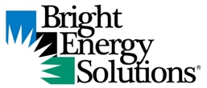
BES Business Overview – Radio Ad Copy
[30 seconds / 95 words]
At <<Utility Name>>, we know that when our local businesses thrive, we all do better. That’s why our Bright Energy Solutions® program offers rebates that can help businesses cut energy costs, improve operational efficiency and invest in a sustainable future — all while boosting their bottom line.
Whether it's upgrading kitchen equipment, lighting systems, HVAC units or compressed-air systems, we provide a wide range of rebates to power local businesses with smarter energy solutions.
Partner with us today by calling <<Utility Phone #>>, or visit bright energy solutions dot com. That’s bright energy solutions dot com.

