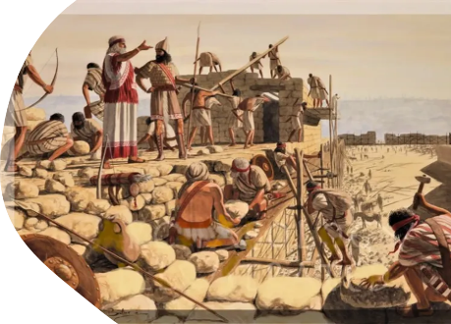
Part 1 Introduction

What is restorationism?

Thank you for visiting our webpage.
Someone said, “The more you say, the less people remember.” Hopefully, this brief introduction will prove the truth of this adage.
The Hamilton church of Christ is an autonomous, self-governing body whose members are united in their love for God and His people (Matt 22:36-40). It is our earnest desire to help people enjoy the peace that comes from fellowship with God and the encouragement that comes from the support of like-minded individuals.
Since love for God always manifests itself in obedience to His will, we are also united in our belief that the church must understand its function as “pillar and support of the truth” (1 Tim 3:15) – not the originator of new truth. We are convinced that the Bible is the sole and sufficient source of salvific truth. It is our understanding that the New Testament claims to present a pattern of beliefs, practices, and church organisation that is normative for Christians in every age. This pattern or model was set forth by uniquely qualified, inspired writers of the first century who intended that it function as a blueprint for God’s people until the Lord returns. In many different locations throughout the world, brethren who share this view of scripture have adopted a simple plea: “Let us speak where the Bible speaks and remain silent where the Bible is silent.” This well-known slogan summarises what is often called the restoration plea.
It is a matter of concern that, since the close of the apostolic age, a multitude of unauthorised human councils, man-made structures, and traditions foreign to scripture have led to departures from the New Testament pattern. Division, confusion, and contention have followed. The articles which follow include discussions of the restoration movement and our appeal for unity based upon the truth of Scripture. It is our hope that they will strike a chord and that you will give sympathetic consideration to our plea.
We welcome any comments or questions.

Rex

Christians meeting at 360 Peachgrove Road Hamilton

