



POWERWELL – a financial wellness dashboard for
credit unions
Concept Document

Team Members
Alec Adsit / Westby Co-op Credit Union
Kristyl Marten / Blackhawk Community Credit Union
Joanna McGinn / Heartland Credit Union
Emily Ruffini / Blackhawk Community Credit Union
Janel Thoune / CoVantage Credit Union
Madeleine Vincent / Fort Community Credit Union

Target Market

We are team SOAR, and we describe ourselves as a pioneering, vibrant, and diverse group of people. Individually, we represent different backgrounds, talents, and skill sets; however, put together, we create a beautiful culmination of color capable of soaring to new heights. Based on the Six Thinking Hats framework, our team has multiple-colored hats representing optimism, feelings, creativity, and process thinking. We are represented by the Painted Bunting – a bird native to North America known for its brilliant blue head, green back, red rump, and red belly. Like the Painted Bunting, Team Soar recognizes its ability to blend in when immersing ourselves into our daily routine and responsibilities; and while it’s easy to blend in, our unique perspective also helps us stand out in the field of credit union innovation. We recognize that, like us, our membership is diverse, and they all have individual wants and needs, but one thing remains true: the credit union is here to see them through. In general, a credit union’s membership relies on our services for transactional reasons, financial education, and relationship building. We care about our members, we want to see them succeed financially, and we want to assist them in doing so. While this is the case, each credit union takes a different approach on how to deliver financial wellness initiatives in absence of any industry standard. The primary group we are solving for is credit unions from an institutional perspective that have financial wellness initiatives.

Problem Definition

As a team, one thing we always agreed upon was a consumer’s need to be financially aware with access to resources that are helpful for one’s migration to true financial wellness. Data exists about our membership, their financial stability, and is obtained through the account opening process, loan applications, and general inquiries; however, it is vital for the credit union itself from an institutional perspective to be able to measure its effectiveness in providing members with the financial wellness programs they so desperately need and deserve. Without some type of tool, there is no way to consistently measure, evaluate, and implement changes or improvements to existing wellness programs or to even exercise the awareness to potentially implement programming if it doesn’t already exist.

There are many different tools and programs out there to help people make better financial decisions, however it is also difficult for credit unions to know what type of programming and services to focus on. There is no consistent way to evaluate effectiveness of financial wellness programs from a credit union perspective. Tools have been designed to evaluate financial wellness from an individual member level, but no one is looking at this problem from a holistic credit union organization level. How does a credit union decide what it wants to offer members in the area of financial wellness (program, tools, resources) that are the most effective for their investment?

In summary, we have focused on the idea of “How might we help credit unions make their financial wellness programs more effective?”

Innovative Solution
Our POWERWELL Financial Wellness Dashboard allows credit unions to gauge the effectiveness of their existing financial wellness/education efforts by using data in your core system to develop an easy-to-read dashboard. POWERWELL has the added benefit of combining metrics from your retail, lending, and marketing departments on your dashboard to create a robust holistic picture of your overall credit union membership’s financial wellness. This is at the institutional rather than personal level. Credit unions will be able to access these metrics “at a glance” and have the option to select metrics for more information that can be broken down by member demographic.
This Financial Wellness Dashboard will give credit unions the option to keep their data in-house or allow your data to be compared to other credit unions locally and nationally. The benefits and uses for POWERWELL are almost endless. Credit unions will be able to utilize the data in their dashboard to identify gaps in their existing financial wellness efforts and then implement new products or policies that can help fill their membership’s needs.

Prototype

The prototype is a dashboard to help credit unions better understand their financial wellness program effectiveness on their overall membership. It tracks 11 different metrics in the categories of savings, debt, engagement, spending and credit over time and is designed for use at the credit union institution level. All statistics are aggregate for the full membership population. It provides a simple threshold system to indicate whether a metric is good (green), decent (yellow), or needs improvement (red) with an overall wellness score at the bottom.

The credit union can setup a data extract in their system to be sent over weekly or monthly. Metrics can be clicked to bring out a more in-depth breakdown of the metric, incorporating both past and current data to show trajectory over time. The purpose is to track effectiveness of programs, have metrics to show the tangible effects of your program, and compare with and alongside other credit unions (aggregated) to see how your program is doing. Appendix A includes metric definitions.

Figure 1 Prototype:
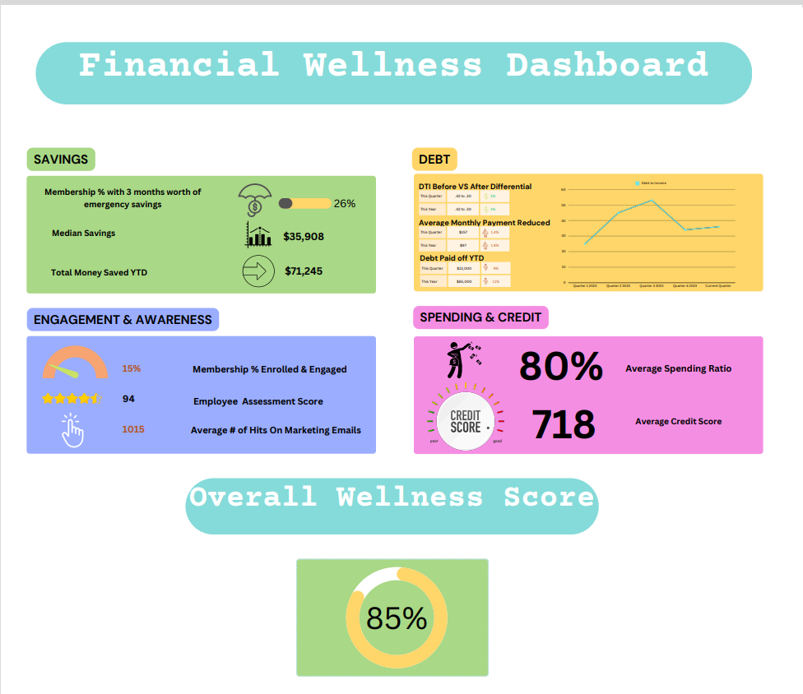

Testing and Results

Testing for team Soar consisted of utilizing two different surveys to gather information for our problem statement, “How might we help credit unions make their financial wellness programs more effective?” We split our target group, for our first survey we kept our target to credit union consumers, on our second survey we focused on employees with an interest or involvement in financial wellness efforts of credit unions.

For our first survey there were 140 responses. Of the respondents 54% stated their credit union had a financial wellness program and 31% weren’t aware one was offered. For our second survey there were a total of 54 responses with 43% chief/senior leaders, 19% directors, 26% managers, and 13% non-managerial staff at different credit unions. Of the respondents, 89% agreed a financial wellness dashboard would be a very valuable or somewhat valuable asset to their credit union. See Appendix B for survey results.

Business Model and Proforma

Initial development costs will cover the creation of the website, the integration of dynamic graphing, and the setup of the core code for the extract. The highest cost is estimated in the manhours required to set up the extract for several core system configurations. This would be accomplished by 1 staff person at 40 hours of web development time, and 2-3 staff at 15 hours a week envisioned as follows:
- Server Admin: Maintains servers and addresses technical issues as they arise.
- Implementations Specialist: Initial implementation and integrates extract to new core systems.
- Marketing/Engagement: Expands conversations to other credit unions to gather data and feedback.
Website hosting is estimated at $100 per month plus four manhours per month for maintenance. The credit unions’ main responsibility will be to submit the extract while we aim to partner and integrate with major core systems. Action beyond initial setup is limited to routine maintenance and continued operations. We are aiming for minimal operating costs allowing us to set a low price point. This allows us to either expand in the direction of making this a perk offered through a national credit union partner, or to expand into financial commercialization itself.
Our initial expansion plan centers on finding five or six interested credit unions through internal channels and working individually with them to ensure that the extract can be effectively set up and sent over on their system. From there, we’re aiming to continue expansion through two primary methods – recommendation by existing credit unions for other credit unions, and direct email advertising for credit unions with the value proposition.
Added value for our product focuses on three key factors:
- Unique metrics that provide hard evidence of the success or lack thereof of financial wellness programs, as well as the wellness of the population as a whole, and
- The ability to rate one’s own metrics against other credit union’s metrics.
- Minimal time and effort investment for setting up and maintaining this system.
This is a value proposition that we aim to make to both the program level (individual financial wellness programs within credit unions seeking to improve and show their worth) and at the executive level (prove how the program is doing, produce higher returns in aggregate through a healthier populace that’s able to take out more loans).

Operational and Other Considerations

Credit unions will need to determine if they can extract the data needed for these metrics. We identified several partners/sources that could help, including soft credit pulls of the membership for CECL reporting in nCino, SavvyMoney, credit bureaus, PowerBI, Portfolio Review, Credit Insights, Banno, and many core providers. Balancing security of data along with anonymity will need to be a priority. Survey participants noted the value of having benchmarks to get an overall wellness score but needed assurances on data security and restrictions on the level of detail shared. We propose credit union participants could access aggregated statistics to see national averages and benchmark scores but not identified data for each credit union.

Some survey participants also expressed an interest in a customizable dashboard held in-house. This is another consideration for a modified model that could be available as popularity for the product grows. If utilized in-house, we envision a subscription structure for purchase and use of a template.

Call To Action and Next Steps

Credit unions are continually searching for ways to remain competitive in a crowded marketplace, improve member loyalty, deepen relationships, and grow utilizing the credit union spirit of people helping people. Improving the financial wellness of our members has been proven to provide a positive ROI both for credit union balance sheets and the individual. This financial wellness dashboard will help credit unions make decisions in real time, implement changes to their financial wellness programs, and track in a tangible way whether their efforts are making meaningful, sustained change for their entire membership base. Currently there is no clear way to measure financial wellness results in the industry. This dashboard brings standardized, clearly defined metrics to be used to affect positive results for our members’ financial futures. Imagine a scenario where our entire membership base improves their finances and deepens relationships at the credit union–how much more good could we do in our communities when we are stronger together.

We are seeking a centralized, national credit union industry partner with the ability to bring together skillsets in database development to help us create the initial structure, as well as five or more interested credit unions who would like to partner in implementing this financial wellness dashboard idea. If your credit union does not want to partner on a national level, please consider the benefits gained in establishing a standardized dashboard for internal use to track progress on membership savings, debt reduction, credit score improvement, staff knowledge and increased member engagement.

Appendix A
The metric definitions for our dashboard prototype are as follows:

SAVINGS:
Membership % w/ 3 months emergency fund:
The measure of membership, expressed as a percentage, that has saved an average of three months living expenses.
Average Savings Account Balance:
A consumer’s savings balance, to be determined on the same day each month, within our focus group of individuals ages 18-39.
SPENDING:
Average Spending Ratio:
The measure of how much a consumer spends monthly based on needs, wants, and financial goals, in relation to their gross monthly income, expressed as a percentage.
Aggregate Credit Score:
An average score representing a consumer’s credit history, utilization, pay history, and mix of credit as determined by FICO for our focus group of individuals ages 18-39.
DEBT:
Debt to Income Ratio:
A measurement representing the relationship between a consumer’s total debt and total gross income, expressed as a percentage.
Average Monthly Payments Reduced:
The average reduction in monthly minimum payments of all people in the financial wellness program.
Debt Paid Off YTD:
The measure of the total amount of debt paid off by people while in a financial wellness program.
ENGAGEMENT & AWARENESS:
Membership % Enrolled/Engaged:
The percentage of membership that have elected to enroll or engage in a credit union’s financial wellness program.

Employee Assessment Score:
The average score of employees on a score/examination chosen to correspond to financial wellness.

Average Number of Hits on Marketing Emails:
Average number of member’s engagements with credit union marketing emails for the wellness program.

Appendix B
Survey 1: Credit Union consumers, 140 respondents

31% didn’t even know if a financial wellness program was even offered at their credit union!

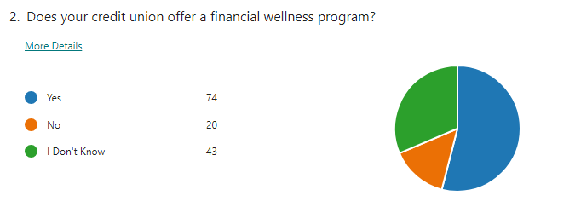
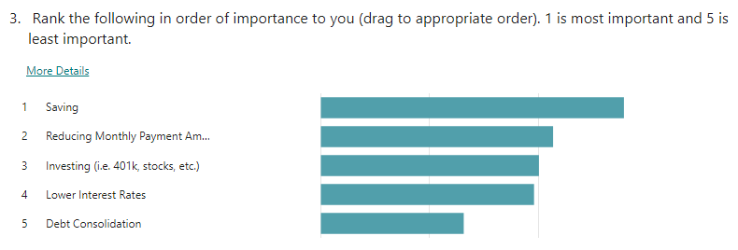

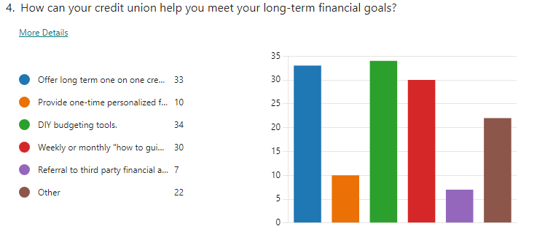

Survey 2: Credit Union employees, 54 respondents
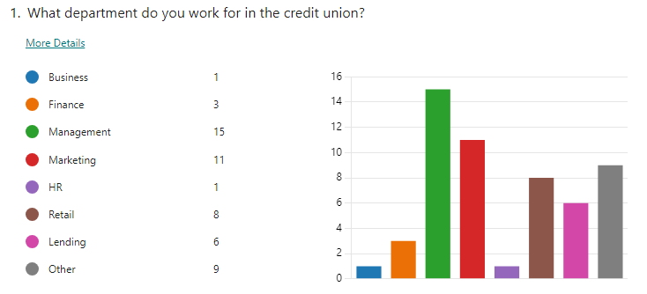
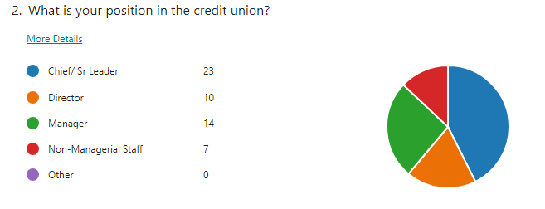
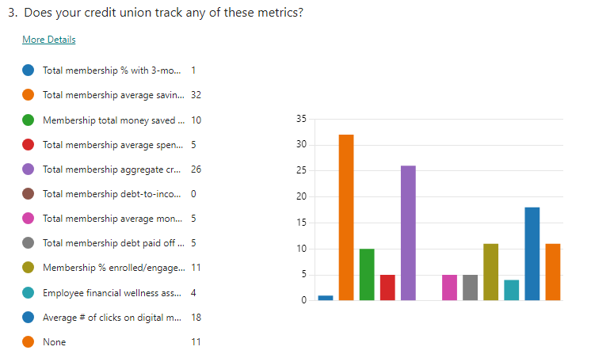

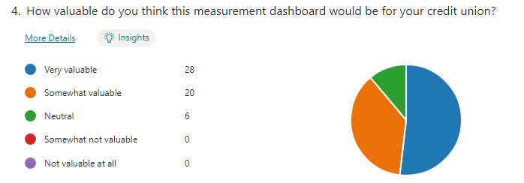
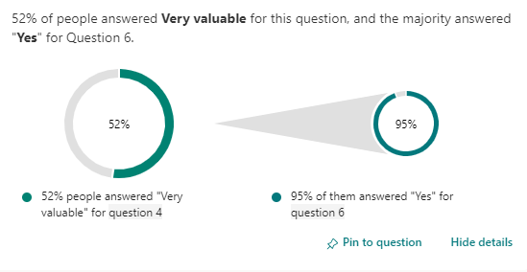
5.
Based on the dashboard metrics in slide three, what action would you take in your credit unions to improve your financial wellness scores?
ID | Name | Responses
1 | anonymous | use that information to target market individuals with specific products designed to help them.
2 | anonymous | Demonstrating the tools
3 | anonymous | Proactive use of data and dashboard to develop products that serve the community members
4 | anonymous | Track additional metrics not checked in the above survey
5 | anonymous | Debt
6 | anonymous | Knowing this information would help make big improvements, being able to see where everything is and how it is being used
7 | anonymous | Roll the financial Wellness program we created 3 years ago, branding aligned with a physical wellness check, including triage assessment, diagnosis, treatment and referrals to specialists. Partner with retail, marketing to promote it and transformation, experience and digital banking departments to track and operate it. This dashboard would be the perfect navigation tool to drive initiatives internally to improve it.
8 | anonymous | I feel credit unions can do more to increase financial wellness and by measuring the percentage of members with 3 months of savings at the credit union, we can put more awareness around the importance of financial wellness.
9 | anonymous | Track the effectiveness of our current financial education efforts, whereas today we provide members with financial education, but don't have metrics on the outcomes.
10 | anonymous | Membership % Enrolled/Engaged
11 | anonymous | Financial Wellness check ups annually with members; encourage emergency savings through debt consolidations to reduce payments and use this for savings.
12 | anonymous | Tracking credit scores will be costly, whether the data is derived via Portfolio Review or a credit monitoring platform like SavvyMoney. Relying upon a platform could be misleading due to limited enrollment and disproportionately accounting for those who are engaged in proactively managing their credit. Monitoring DTI will have to be based upon loan applications, which may also result in inaccurate results. The CU cannot rely upon direct deposit data, unless the CU accepted DTI as a percentage of Net Income as opposed to Gross Income. I envision the main uses of the dashboard to market the benefits of banking with the CU as opposed to alternative FI's and for recapturing loans financed elsewhere to reduce the Average Spending Ratio and Increase the Average Savings Account Balance.
13 | anonymous | I am not sure I understand the question. Encourage members to meet the 3-month emergency savings goal. Encourage members to enroll in the financial wellness program. Encourage members to maintain a healthy debt to income ratio.
14 | anonymous | We do financial counseling to members that struggle or request it.
15 | anonymous | Would allow us to target market based on individual member to increase savings or reduce debt/spending. Would allow us to personalize the experience more.
16 | anonymous | Actually what we are already doing - increasing the number of Retail staff with a certification in Financial Counseling.
17 | anonymous | Update external marketing campaigns/tactics to better promote specific services, Develop new marketing campaigns to promote successful metrics as a benefit to becoming a member, Create/celebrate milestones for lending staff reaching certain success thresholds.
18 | anonymous | I would need to gather more information and then chat with the team. We currently use Credit Insights, which also provides a lot of information regarding our member's habits- if they sign up for the free program.
19 | anonymous | Inspect what is expected based off the dashboard results
20 | anonymous | Depends. If we are able to adjust priorities for what our organization is looking for, that would be a big deal with this. Not all FIs look at financial wellness in the same way, so being able to adjust this would be helpful. We would also want to see a Year over Year metric. I also only put "no" below because of this. If we are able to adjust it a bit based off of our organization's goals, this would be a great informational consolidation tool.
21 | anonymous | Include opportunities for education throughout the year, create a more structured program for our members to utilize, and strategize on cost savings/awareness campaigns.
22 | anonymous | Encourage more member enrollment by using email and social media to promote the financial wellness program (in a fun and engaging, TikTok-style manner). Once members are enrolled, gamify the program to create member engagement. Run competitions, rewarding the top savers, debt-payers, etc. These campaigns could be done at the credit union level, but also across all participating credit unions.
23 | anonymous | Engage members and continue to educate them on tools, services and advice on how to better themselves to continue on the path to improved financial well-being.
24 | anonymous | Slide three in the PowerPoint I was sent was a the definitions so perhaps I did not receive the full slide deck. I would use the data to focus marketing efforts.
25 | anonymous | Making sure there are a variety of ways to educate members of financial planning/budgeting.
26 | anonymous | We currently have a financial wellness dashboard that we just developed. I would suggest that we add some of your metrics to our dashboard.
27 | anonymous | Hits on marketing emails
28 | anonymous | You could take a host of actions to better assist members.
29 | anonymous | I think there is a lot more that could be tracked. Having a central financial wellness program would be beneficial rather than a variety of one-off efforts.
30 | anonymous | We would keep track of trends and encourage members to enroll in financial wellness so that they are aware and it is visible to them.
31 | anonymous | spending numbers
32 | anonymous | try to make more information and education available to members. try to ensure the information presented is a complete picture of a members' financial situation.
33 | anonymous | I see this as an opportunity to set a benchmark for financial wellness scores that could be used to educate our members and help them elevate their financial position.
34 | anonymous | DTI
35 | anonymous | Through marketing and education driven initiatives.
36 | anonymous | Success stories - selling the importance in being financially well rather than not having a plan, education and communication through platforms that engage with our membership, like online banking, social media and advertising avenues. We do track some things behind the scenes. We use a vendor called NCINO and pull a SOFT pull of our entire membership every quarter to assess the overall health of our portfolio, it is my understanding that all credit unions do this, so the data is available. I like this idea of expanding our knowledge of our membership base. The more data available, the better we will be at assisting our membership.
37 | anonymous | Use that information to do target marketing to members, have conversations with members about their financial goals.
38 | anonymous | Send targeted messages to members that could benefit, provide statistics to our staff to engage them in helping our members
39 | anonymous | Spending
40 | anonymous | Target marketing, frontline education
41 | anonymous | Membership % Enrolled, Employee Assessment Score, and Average Number of Hits on Marketing Emails
42 | anonymous | Unknown
43 | anonymous | add one or two more metrics
44 | anonymous | Not sure. We'd need to talk with members who are struggling with these metrics to find out what resonates with them or motivates them.
45 | anonymous | Incentive program for utilizing score. Incentive being further access to lending opportunities.
46 | anonymous | The first action would be to ensure that all metrics are capable of being tracked through our current systems. Second action would be to focus on Employee Assessment Score. Having EEs onboard with and understanding initiatives will directly impact results of the program, especially member-facing EEs, as they are the ones building relationships, educating and advocating for our members.
47 | anonymous | We do a financial wellness program in our communities but don't measure its effectiveness or success as it is offered to members and non-members alike, so the dashboard would only measure the success rate of our members. Not sure if that would affect our current efforts
48 | anonymous | We would offer financial coaching sessions, budgeting classes, credit reviews with recommendations for improvement using Savvy Money.
49 | anonymous | I do think that having a tool with multiple scores on it would be very helpful. The only issue is getting enough CUs bought into this concept so the "overall score" held some weight. Based on these metrics, I would want to do more differentiated content and put in places where people are going. I would want to use social, branches, marketing, etc. to get the word out on the program and I would want to lead with specifically how it helps people so they use it.
50 | anonymous | We are currently working on how to measure member and team member financial wellness. Savings, debt, and credit score are certainly the three broad categories to track. We would also include some measurement of how our members/team members feel about their money.
51 | anonymous | Personally: Make better choices based on having the information. Professionally: Could use it to target messages to our membership to help them make better choices.
52 | anonymous | It would be paramount for us to benchmark and develop strategies to improve metrics that are below average.
53 | anonymous | Unsure - I am still very new to this role.
54 | anonymous | Member outreach to help them improve their financial situation and also to use this with local legislators to share our story of community value!

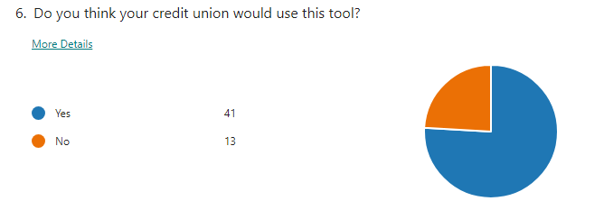

Appendix C

Sources

https://www.allaboutbirds.org/guide/Painted_Bunting/photo-gallery/67385111
Google Survey Analytics
Prototype developed by our team
https://barnumfinancialgroup.com/5-pillars-of-financial-wellness/

ABOUT FILENE

Filene Research Institute is an independent, consumer finance think and do tank. We are dedicated to scientific and thoughtful analysis about issues affecting the future of credit unions, retail banking, and cooperative finance.

Deeply embedded in the credit union tradition is an ongoing search for better ways to understand and serve credit union members. Open inquiry, the free flow of ideas, and debate are essential parts of the true democratic process. Since 1989, through Filene, leading scholars and thinkers have analyzed managerial problems, public policy questions, and consumer needs for the benefit of the credit union system. We workw to strengthen organizations through cutting-edge research, incubation opportunities to test and scale solutions, advisory services to help organizations implement innovation, and host communities and events to connect a community of leaders to improve financial well-being.

We live by the famous words of our namesake, credit union and retail pioneer Edward A. Filene: “Progress is the constant replacing of the best there is with something still better.” Together, Filene and our supporters seek progress for credit unions by challenging the status quo, thinking differently, looking outside, asking and answering tough questions, and collaborating with like-minded organizations.

Filene is a 501(c)(3) nonprofit organization. Nearly 1,000 members make our body of work possible. Learn more at filene.org.

ABOUT THE LEAGUE
Founded in 1934, The Wisconsin Credit Union League is the dues-supported trade association for Wisconsin's credit unions--not-for-profit financial institutions that are cooperatively owned by their more than 3.6 million members.
The League is dedicated to serving Wisconsin's credit unions and promoting The Credit Union Difference through advocacy, education, and public service. We are a proud member of the Credit Union National Association (CUNA) and of a worldwide credit union system centered on credit union members.
Leadership: League Staff | League Board of Directors
Data: Wisconsin Credit Union Profile

