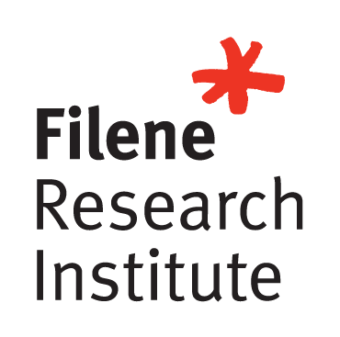


InnoConnect
Concept Document

Team Members
Berenice Valadez, Blackhawk Community Credit Union
Jennifer Tucker, Fort Community Credit Union
Matthew Mysliwiec, Altra Federal Credit Union
Melissa Janssen, Royal Credit Union
Randi Strangstalien, Westby Co-op Credit Union
Sydney Schulze, Blackhawk Community Credit Union

Target Market

In 2013, there were 6,795 federally insured Credit Unions in the United States. At the end of 2023, the NCUA reported that there were 4,604 remaining. Within a 10-year span, Credit Unions have declined by 2,191. Because of this, we know Credit Unions are changing their strategies to focus on growth. In today’s world, it is becoming more important for your Credit Union to develop a long-lasting and strong membership base. By developing a more intuitive onboarding strategy, we hope to help Credit Unions retain more engaged and lifelong members. Without proper growth and active members, Credit Unions cannot succeed.

Our primary goal is to build a stronger connection between new members, Credit Unions, and their employees. Membership engagement and retention becomes difficult during the new account opening process due to the amount of information received during a short span of time. Oftentimes, employees may be spending time sharing information about products and services the member isn’t interested in. Sometimes members are so focused on a single want or need, that they may not consider or understand all the ways your Credit Union can help them reach their financial goals.

Problem Definition

During the account opening process, members and employees may feel easily overwhelmed by the amount of information that is shared. In many cases, this interaction is the only touchpoint, and many things may be missed or forgotten. An Onboarding Communication Kit will allow employees the ability to build trust and rapport with their members by inquiring about their goals and sharing information that is truly relevant to them. In doing so, members will learn more about your Credit Union, what products and services are offered, and how they can become engaged and financially stable during this process. With a comprehensive Onboarding Communication Kit tailored to each individual member, we believe Credit Unions will build stronger relationships with their members and create loyalty in doing so.

From our survey results, we found that many individuals felt like having a connection to their Credit Union was an important part of being a Credit Union member. 81.6% of Credit Union members wanted to be contacted between 1-4 times after the initial account opening process was completed.
According to a CU 2.0 study in 2020, almost one third of all new members close their account in the first 100-days. This is a significant indicator of lost potential revenue and missed opportunities for your new member to develop a trusted relationship with your Credit Union. This also affects growth and could impact revenue.

Many options exist when it comes to onboarding strategies for new members, although these tend to be Credit Union-centric. Our key differentiator in the Onboarding Communication Kit is a tailored and customized approach to each touchpoint. It is member-centric to truly understand the individual needs of our members instead of pushing the products we’d like to see them utilize.

Innovative Solution

We believe creating a strong relationship beyond the account opening process is crucial to building a strong membership base. Our innovative solution is an Onboarding Communication Kit that can be tailored to each individual member that opens an account with you. Our prototype will identify six touchpoints within the first 12 months of membership where the content is customized based on the members' preferences and needs.

- Day 1: Account Opening Survey
- Day 14: Satisfaction Check-in
- Day 45: Tailored Product or Service Education
- Month 3: Community Impact Connection
- Month 6: Financial Goals Exploration
- Year 1: Year in Review Recap

Our Onboarding Communication Kit will ensure new members are given an opportunity to learn as much about your Credit Union as possible without feeling overwhelmed and overinformed in one sitting. This will allow members to easily retain any important information given to them and keep them aware of products and services that may enhance their financial well-being. Using member data and input to customize this process can improve the member's future interactions. Having members who are actively involved in your Credit Union helps drive membership retention and growth and enhances word of mouth recommendations to others who currently do not interact with your Credit Union.

Additionally, Credit Unions that actively engage their members are more likely to retain new members beyond the 100-day mark, opening future opportunities for additional products and services to better serve them. Members empowered by relevant information will have improved financial health and wellbeing.
While there may be a cost associated with implementing these recommendations, it is an investment that will pay off. According to a recent CU Times article, data shows that the cost of acquiring a new member is about 7 times that of maintaining an existing relationship. Additional studies have shown that of all new members, almost a third of them close their account in the first 100 days, and 40% will leave before their account has become profitable. Our Onboarding Communication Kit will help to reduce this attrition. Furthermore, creating meaningful connections with members will make them more likely to promote your services to others. A Temkin Group report stated that 77% of members would recommend a brand to a friend after a single positive experience.

According to a recent article by Bryn Conway of Beyond Consulting, “Member Engagement is the measure of how likely a member is to forgive you for making a mistake. It will tell you how likely your members will refer a friend or family member to your Credit Union – as it is only highly engaged members who will speak out on your behalf to their communities. Engaged members will use your Credit Union for their next financial product or service, even though a competitor may have a lower price or a more convenient location.”

With a comprehensive member onboarding plan, Credit Unions will increase member engagement, expand growth, and create long-lasting members to promote the longevity of their Credit Union. Quantifiable measurements of member engagement include increased services per member, higher Net Promoter Scores, and member retention and loyalty. This can also increase revenue.
Additionally, members benefit by having a deeper understanding of relevant products, an enhanced new account experience and improved financial health and wellbeing. By identifying their goals, members are more likely to achieve them with your Credit Union as their trusted advisor.

Prototype
We believe creating a strong relationship during the account opening process is crucial to building a strong membership base. Our innovative solution is an Onboarding Communication Kit that can be tailored to each individual member that opens an account with you. Our prototype identifies six touchpoints within the first 12 months of membership where the content is customized based on the members' preferences and needs.

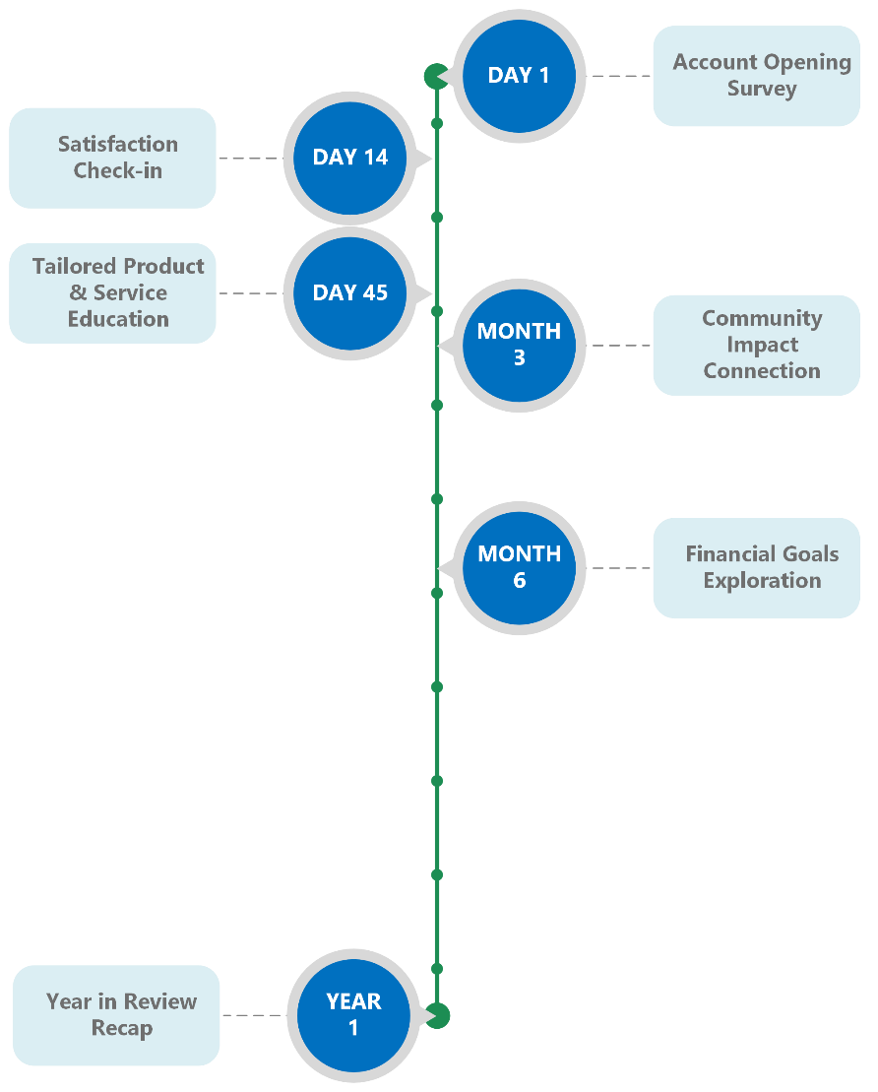

(Day 1) Account Opening Survey: This is to determine a communication preference for all follow-up content in the Onboarding Communication Kit and to determine which content to share with the new member throughout the identified touch points. This should be a mandatory addition to the account opening process as it will drive all future communications.
(14 Days from Account Opening) Satisfaction Check-in: The purpose of this touchpoint is to ask about and provide more information about the specific product(s) the member opened.
(45 Days from Account Opening) Tailored Product & Service Education: The purpose of this touchpoint is to demonstrate your Credit Union is responding to the interests of the new member by tailoring the content of the message to follow-up on the services or products they selected in the Account Opening Survey.
(3 Months from Account Opening) Community Impact Connection: The purpose of this touchpoint is to share the philanthropic impact of your Credit Union in order to create an emotional connection with the new member.
(6 Months from Account Opening) Financial Goals Exploration: The purpose of this touchpoint is a reminder of the goal(s) set by the member at the time of opening their account.
(1 Year Anniversary) Year in Review Recap: The purpose of this touchpoint is to solidify your Credit Union as a lifelong partner in the member’s financial journey. Some recommended data points to include are number of online banking logins, dividends paid, interest saved (compared to higher rates at banks), number of products or services utilized or added throughout the year, dollars saved by refinancing, debit card swipes, etc.

Each of the touch points is intended to be tailored to a specific communication avenue: mail, in-person consultation, outbound phone call, text messages, emails, online banking messaging, etc. A full version of this Prototype is included in the Appendix.

Testing and Results

Our initial survey was sent out to Credit Union employees at 5 different Wisconsin Credit Unions. We were looking to determine if there was a need for better connections with members during the account opening process. Through this survey, which received 67 responses, we could better understand what was working well, and what wasn’t working well, so we knew where we could improve this process. For the second survey we sent it out to friends and family via Social Media platforms to try and understand how the people opening the accounts felt the process was. We received 134 survey responses, of which 99 were Credit Union members and 35 were with other financial institutions. Individuals that were Credit Union members told us that it was important for them to feel connected to their Credit Union, 4.16 out of 5. On the flip side, individuals who banked with other financial institutions didn’t find connection as important, 3.4 out of 5. The third and final survey was an evaluation of our prototype by people from various departments of several Credit Unions. We felt it was important to get a wider range of prospectives and send the surveys to Executives, Marketing, Member Services, Contact Center, Branch Operations, IT, Financial Services, Tellers and Member Account Representatives From our results we found that a large majority of people did have one contact point and it was typically in the first 30-days after the account opening.

Business Model and Proforma

When developing our innovative solution, it was important for us to create something that could be implemented by Credit Unions of all asset sizes. We want to make this program accessible to everyone, easy to use and have limited expenses to implement. The Onboarding Communication Kit is customizable for each individual Credit Union. There may be an opportunity to integrate this plan to work within your current onboarding program and use some of the tools, people and processes you already have in place. However, additional investment may be needed to utilize the Onboarding Communication Kit to its fullest potential and automate the touchpoints.

Opportunities for implementation include investing in people and allowing staff more time to manually follow up with members. The creation of a specific team to oversee the member onboarding process would be advantageous as they could monitor and adjust the communication journeys overtime and assign a specific team to become the point of contact for members who open their accounts online.

Investment in tools would help automate the process and reduce employee workload. Email and text messaging software can be used to distribute tailored content based off tags added during the initial survey. This technology can make it appear that email or text message is coming from the team member that opened the account to further the personal connection. Customer relationship management software could ensure messages are sent at the appropriate time. Additionally, AI technology could be used to create a more unique interactions focused on specific member wants, needs and goals, to assess new opportunities within new member relationships and to track effectiveness of the communication strategy.

Processes will have to be evaluated to help gather needed information. The account opening procedure will need to be revised to include the mandatory onboarding survey and reduce the amount of information shared during this first interaction. We recommend creating special promotions that can be shared at the Day 45: Product and Services Education touchpoint to increase the likelihood of product adoption. Data tracking and analytics will be needed to gather the statistics shared in the Month 3 Community Impact Connection and Year-in-Review touchpoints.

Operational and Other Considerations
After the Onboarding Communication Kit has been established, we encourage A/B testing within each of the touchpoints to test both your timing and content of materials. As opportunities for additional communication channels become available within your Credit Union, consider how these channels may be utilized in conjunction with the Onboarding Communication Kit. With this Onboarding Communication Kit focusing on specific members' wants, needs and goals, the use of AI Technology could be an added feature going forward to create a more unique interaction with each member based on their needs and communication preferences.

As your Credit Union looks to adopt and implement the Onboarding Communication Kit, we recommend building content templates to be used for each of the touch points. As an example, for the Financial Goals Exploration, we recommend developing content for each of the different potential themes (home ownership, debt reduction, college savings, new vehicle, etc.).

Call To Action and Next Steps
Your Credit Union now has an opportunity to step back and review your current Onboarding Strategy to review it for alignment and congruence with this Onboarding Communication Kit. By taking the first step and implementing this program you have let your employees, and your new members know that you care about them and their future. As you identify gaps in your outreach, this Onboarding Communication Kit offers potential connection points that will drive engagement and product awareness, thus building stronger relationships between members and your Credit Union. Through stronger relationships, members will be on a clearer path to financial wellness, as their Credit Union will have become a trusted partner they can rely on. One of the great things about this program is the easy customization. As you begin the process of using this program there will be things that work and things that need to be updated and improved. There are so many directions that you can go with this but the fact that you are making those changes will only improve that connection to each member.

Research has shown that making people feel heard and like they belong is a critical step in retaining your membership. As credit unions face increasing competition and technological advancements, focusing on strategic growth and retention is essential for long-term success. Implementing a comprehensive onboarding strategy that prioritizes inclusivity and communication can lay a strong foundation for expanding membership. Leveraging technology and AI through an Onboarding Communication Kit can help credit unions thrive in this evolving landscape.

Appendix

Prototype Details
1. (Day 1) Account Opening Survey: This is to determine a communication preference for all follow-up content in the communication kit and to determine which content to share with the new member throughout the identified touch points. These questions should be a mandatory addition to the account opening process as the responses will drive all future touchpoints.
Q: We’ve got a lot to offer. What might you be interested in? (Select all that apply.)
Online Services
- Credit Cards
- Home
- Remodeling
- Car
- Personal
- Refinancing
- Checking
- Debit Card
- Savings Accounts
- High Yield
- Certificates
- Savings Rates
- Products for Kids
- Financial Counseling/Coaching
- Financial Advising/Investments
- Overdraft Protection
- Other
Q: What are your financial goals? (Open Ended)

Q: How do you want to hear from us moving forward? (Select one.)
- Mail
- In-Person
- Phone Call
- Texting
- Email
- Online Banking

2. (14 Days from Account Opening) Satisfaction Check-in: The purpose of this touchpoint is to ask about and provide more information about the specific product(s) the member opened.
It is also an opportunity to ensure the member is adopting tools that may assist them with their current accounts like e-services and online banking. The goal is to establish your Credit Union as a relevant and helpful partner on the member’s financial journey. This should be used to follow-up on the start of the relationship with the staff person who opened the account and develop a rapport. You should not promote additional products or services at this time.

3. (45 Days from Account Opening) Tailored Product or Service Education: The purpose of this touchpoint is to demonstrate your Credit Union is responding to the interests of the new member by tailoring the content of the message to follow-up on the services or products they selected in Question 1 of the survey. It is recommended to create an ongoing introductory special for some of the products or services a new member may be interested in (0% for 90 days on a credit card, $250 for a new checking account with direct deposit, closing costs credit on HELOC or mortgage, etc.) It is also an opportunity to highlight FAQs about the products and services the new member already has adopted.

4. (3 Months from Account Opening) Community Impact Connection: The purpose of this touchpoint is to share the philanthropic impact of your Credit Union in order to create an emotional connection with the new member. Our research shows the membership prioritizes and cares about volunteering and monetary donations made in their communities. The touchpoint is an opportunity to highlight the difference between Credit Unions and Banks. Research has shown that Millennials and Generation Z are especially concerned about making a positive impact. Because of this, our cooperative model and “people helping people” mission will resonate with these groups leading to a stronger connection. Highlights can include small business partnerships, recent events or sponsorships, community service, donations etc. It is recommended to update this message with timely examples and geo-target your examples based on where the member lives.

5. (6 Months from Account Opening) Financial Goals Exploration: The purpose of this touchpoint is a reminder of the goal(s) set by the member at the time of opening their account. It is an opportunity for your Credit Union to provide relevant content to the theme of their goal with information about how to schedule an appointment to meet with the knowledgeable staff person from your Credit Union based on the topic. Examples would include first-time home buyer information, debt consolidation, credit score counseling, etc. Through this touchpoint, your Credit Union can utilize a survey to inquire how confident the member feels in their progress towards reaching the goal or if there is a new goal they are working towards.

6. (1 Year Anniversary) Year in Review Recap: The purpose of this touchpoint is to solidify your Credit Union as a lifelong partner in the member’s financial journey. It is recommended to continue this touchpoint annually. Some recommended data points to include are number of online banking logins, dividends paid, interest saved (compared to higher rates at banks), number of products or services utilized or added throughout the year, dollars saved by refinancing, debit card swipes, etc. Additionally, we recommend including annual statistics for your memberships (new members, new communities, total dividends paid out to the entire membership, dollars donated, etc.)

Testing Results

Survey 1: Link to full survey results: New Member Connections (office.com)

We wanted to see which products Credit Union employees felt members might benefit from hearing more about.

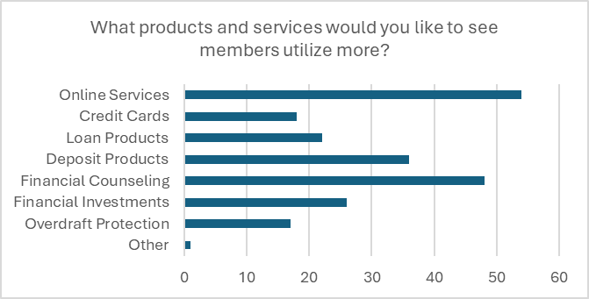

We were also curious about how many times we should be reaching out to new members following their account opening.
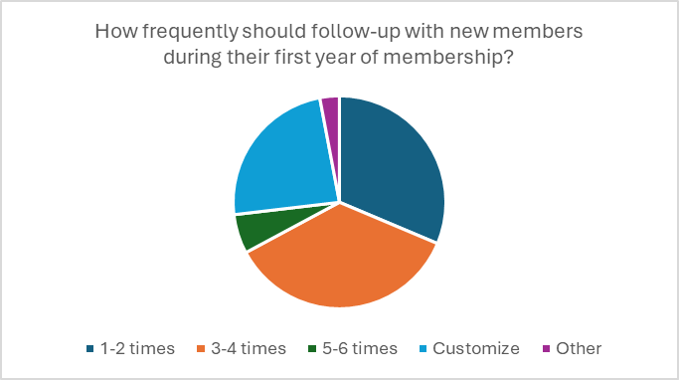
Here are a few employee quotes that stood out during this process.

“Providing too much information at once. It can seem overwhelming especially to a new member or someone that's maybe a bit younger and has never been through the process.”

“I’d like to see more literature for our new members. Just in case you forget to mention something, it gives them a reference.”

“We throw a lot of info at them, sometimes it can be easy to forget things…”

Survey 2: Link to full survey results:- New Account Connections (office.com)

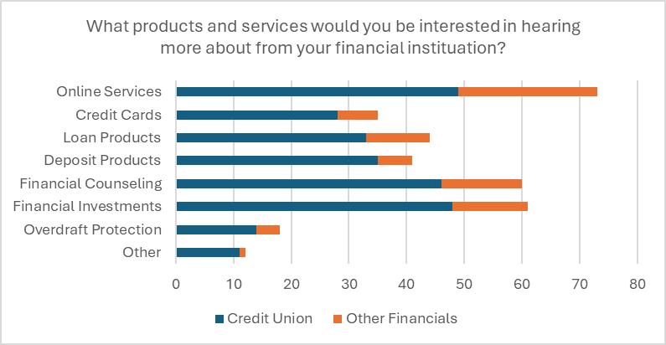

Like the employee results we found people typically would prefer 1-4 contact points after their account is initially opened.

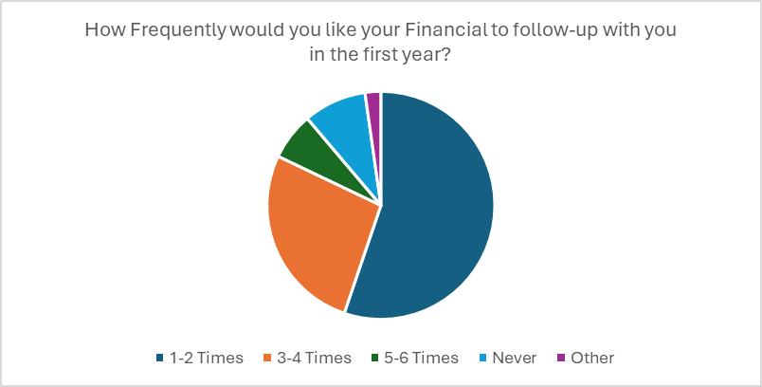

Here are a few comments from friends and family we took away from the survey.

“Knowing that my financial goals are also the Credit Union’s goals for me… and knowing that the Credit Union supports communities and groups that I support.”

“Not only are they available to help with personal financial needs, but they are also involved in the community.”

Survey 3: Link to full survey results: Onboarding Communication Kit (office.com)
We wanted to get an idea of what types of things were being covered during that touch point if they were indeed reaching out to their members. As you can see, the large majority were following up to make sure the new account was going well and make sure there weren’t any concerns.

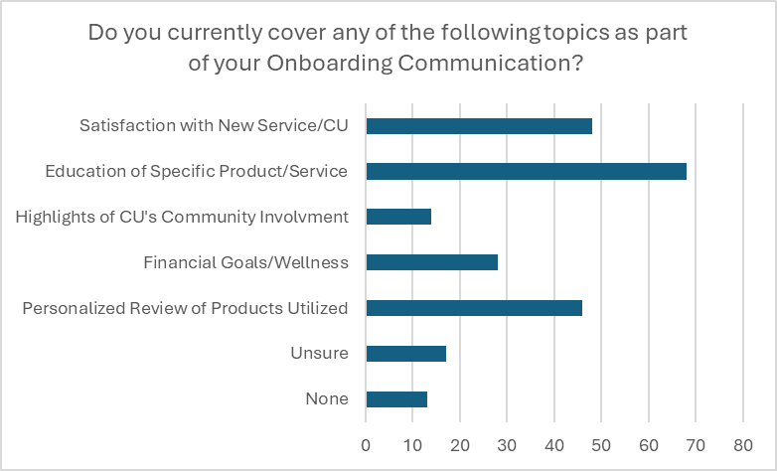

We also wanted to see if people were already doing the customization aspect of the onboarding process.

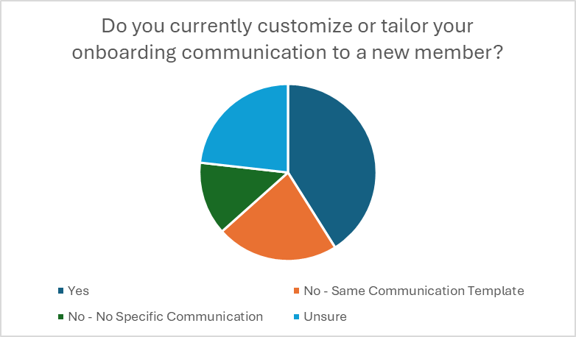

Many individuals that said they tailored the onboarding process commented about how they asked questions about what they had done for the member.

“If a checking account was opened, I ask if they received their checks, if they need any assistance with our OLB, if we financed a vehicle, I ask if they are enjoying their new car, see if we can sign them up for Auto payments if we hadn't already.”

“I call and or email to follow up and speak specifically on what we did if they have any questions/needs.”

“If we talked about a specific product or situation, I would bring that up.”

Sources:
NCUA’s released 2023 Q4 system performance data continues trend of declining credit union numbers - CUInsight
https://www.statista.com/statistics/516845/number-of-credit-unions-usa/

https://www.strumplatform.com/blog/best-practices-for-onboarding

https://www.idomoo.com/blog/a-better-customer-onboarding-experience-7-examples-we-love/

https://www.wyzowl.com/customer-onboarding-statistics/

https://cu-2.com/how-many-new-members-leave-your-credit-union-in-the-first-100-days/

https://www.linkedin.com/pulse/mastering-metrics-measure-your-members-engagement-conway-cude

Why Should Credit Unions Prioritize Member Retention? | CU Management

ABOUT FILENE

Filene Research Institute is an independent, consumer finance think and do tank. We are dedicated to scientific and thoughtful analysis of issues affecting the future of credit unions, retail banking, and cooperative finance.

Deeply embedded in the credit union tradition is an ongoing search for better ways to understand and serve credit union members. Open inquiry, the free flow of ideas, and debate are essential parts of the true democratic process. Since 1989, through Filene, leading scholars and thinkers have analyzed managerial problems, public policy questions, and consumer needs for the benefit of the credit union system. We work to strengthen organizations through cutting-edge research, incubation opportunities to test and scale solutions, advisory services to help organizations implement innovation, and host communities and events to connect a community of leaders to improve financial well-being.

We live by the famous words of our namesake, credit union and retail pioneer Edward A. Filene: “Progress is the constant replacing of the best there is with something still better.” Together, Filene and our supporters seek progress for credit unions by challenging the status quo, thinking differently, looking outside, asking and answering tough questions, and collaborating with like-minded organizations.

Filene is a 501(c)(3) nonprofit organization. Nearly 1,000 members make our body of work possible. Learn more at filene.org.

ABOUT THE LEAGUE
Founded in 1934, The Wisconsin Credit Union League is the dues-supported trade association for Wisconsin's credit unions--not-for-profit financial institutions that are cooperatively owned by their more than 3.6 million members.
The League is dedicated to serving Wisconsin's credit unions and promoting The Credit Union Difference through advocacy, education, and public service. We are a proud member of the Credit Union National Association (CUNA) and of a worldwide credit union system centered on credit union members.
Leadership: League Staff | League Board of Directors
Data: Wisconsin Credit Union Profile

