Bio-Bridge Initiative
Funding Proposal Form
2024
The Bio-Bridge Initiative (BBI) aims to facilitate technical and scientific cooperation among Parties to the Convention on Biological Diversity (CBD) and to its Protocols, under Article 18. As part of its mandate, seed funding support of up to USD $ 20,000 may be provided to incubate projects and partnerships that promote exemplary technical and scientific cooperation approaches, particularly South-South and triangular cooperation, that directly contribute to country-led efforts to achieve Global Biodiversity Framework targets.
The Secretariat of the CBD is now accepting proposals under the Bio-Bridge Initiative’s new round of projects. The applicable requirements and assessment criteria are available here on the BBI webpage. The present application form should be completed for consideration for seed funding.
This form, which shall not exceed 10 pages, should be submitted as a signed Word file or as a signed PDF file together with an unsigned Word file to the following e-mail address: bbiproposals@cbd.int before the deadline specified in the notification or announcement.
The contact person of the main applicant (project lead) will receive all correspondence regarding this submission to BBI, on behalf of all project partners. It is strongly encouraged for applicants to contact their CBD National Focal Points to avoid multiple proposals on the same topic from the same country and to promote stronger collaboration and alignment on various thematic areas.
Applicants from developing countries and countries with economies in transition, as well as indigenous peoples and local communities, are eligible for funding. Priority is given to applicants from least developed countries, small island developing States, and megadiverse developing countries. Applicants from countries that have not received funding during the previous rounds of the Bio-Bridge Initiative are strongly encouraged to apply.
The specific instructions indicated in italics on the form below may be deleted before submission.
1. Does this project proposal involve institutions from two countries or more?
Please note that to be eligible, proposals must involve project partners and/or technical assistance providers from at least two countries.
Yes  ☐ | No  ☐

2. Country of the main applicant (project lead)
3. Name of requesting government agency, institution, or organization
4. Website
5. Contact person
First name and last name:
Department or unit:
Position or job title:
Email:
Phone number:
Address:

Please add as many partners as necessary:

6a. Country of partner 1
Name of the project partner
Website
Contact person
First name and last name:
Department or unit:
Position or job title:
Email:
Phone number:
Address:

6b. Country of partner 2
Name of the project partner
Website
Contact person
First and last names:
Department or unit:
Position or job title:
Email:
Phone number:
Address:

7. Title of the project
8. Project summary
Please provide a concise description of the project and what it aims to achieve (main goal), including prospects for fostering long-term cooperation.

9. Project location(s)
10. Contribution to the implementation of the Kunming-Montreal Global Biodiversity Framework targets, national priorities and targets specified in NBSAPs, or other national policy documents
Please indicate which specific target(s) of the Kunming-Montreal Global Biodiversity Framework the project will contribute towards. For a complete list of the targets, visit https://www.cbd.int/gbf/targets/.
Where possible, provide specific references on how the proposal meets the priorities and targets specified in NBSAPs or other national policy documents.
If applicable, please also indicate how the project will consider existing gender policies/strategies or plans during its implementation.

11. Problem and context analysis
Please provide a clear description of the biodiversity-related problem/need(s)/gap(s) the project proposes to address through technical and scientific cooperation.

12. Stakeholder analysis and involvement
Identify the key stakeholders with an interest in the project, such as government officials, indigenous peoples and local communities, researchers, women, youth, businesses, etc.
Please describe:
- The project’s stakeholder engagement strategy, as applicable;
- Who the main project beneficiaries are; and
- How they will be better off as a result of the project intervention.

13. Complementarity or synergy with other environmental multilateral agreements and/or initiatives
Please describe, if applicable, how the proposal would complement or build synergies with efforts under other environmental multilateral agreements and/or past or ongoing initiatives to address the problem/need(s)/gap(s) identified above.

14. Specific technological or expertise barrier(s)
Building upon the context and stakeholder analyses and taking into consideration the existing efforts described above, please describe technological/knowledge or expertise barriers that need to be overcome to address the identified problem/need(s)/ gap(s).

15. Project objective
Please provide a two-line sentence on the project objective. The objective is the intended environmental, social, institutional, or other development result towards which the project is expected to contribute. The objective of the proposed project should be closely linked to the Kunming-Montreal Global Biodiversity Framework targets.

16. Expected project outcomes
Please provide a description of 2-3 key outcomes that the project aims to achieve. Outcomes are changes in behaviour, capacity, knowledge, and skills that result from the use, uptake, adoption, and/or application of an output by intended target audiences (an example could be “local community members apply new knowledge and skills to identify invasive alien species”).
To the extent appropriate, please indicate how gender considerations will be addressed.
- Outcome 1
- Outcome 2
- Etc.

17. Expected project outputs
Please provide a description of the project output(s) and the causal link explaining how they will contribute to the outcomes described above. Outputs are new products, services, and/or gains in knowledge, abilities and awareness that result from the completion of activities (an example could be “local community members trained in invasive alien species identification”.
To the extent appropriate, please indicate how gender considerations will be addressed.
- Output 1
- Output 2
- Etc.

18. Proposed activities
Please provide a description of the project activities. Activities are actions taken or work performed, through which inputs are utilised to produce the outputs described above, which in turn will lead to the expected outcomes (an example could be “provide training to at least x number of local community members in invasive alien species identification”).
Please note that the timeline of the project should be between six (6) and 12 months.
- Activity 1
- Activity 2
- Activity 3
- Etc.

19. Does the project involve the utilization of genetic resources and/or traditional knowledge associated with genetic resources within the scope of the Convention and/or the Nagoya Protocol?
Yes  ☐ | No  ☐
If the answer is “Yes”, please provide details about the specific activities aimed at ensuring compliance with applicable domestic regulatory requirements in participating countries.

20. Project partners’ roles and responsibilities
Please provide a description of the key roles/responsibilities of all project partners, including the project lead. The description should make explicit reference to the project activities described above.
Please submit evidence of the project partners’ commitment to contribute to the project (e.g., letter or email correspondence) as well as willingness to engage in long-term cooperation beyond the lifetime of the proposed project.

21. Project management and coordination
Please provide a description of how the project will be implemented, managed, and coordinated, clearly identifying the lead institution, project coordinator, and proposed project management arrangements.

22. It is anticipated that the start date of the projects will vary depending on several factors, including processing times and institutional preparedness. Please indicate when you would ideally like the project to start.
Apr.-Jun. 2024  ☐ | Jul.-Sep. 2024  ☐ |  | Oct.-Dec. 2024  ☐ |  | Jan.-Mar. 2025  ☐
23. Estimated budget – Total BBI seed funding not exceeding USD $ 20,000
Please note that BBI seed grant funds cannot be used to pay for salaries, staff costs, regular operating costs, administrative overheads, or capital expenses (e.g., office rent, equipment, printed materials). Funds can be used to cover travel costs (including daily subsistence allowance) for participants/ resource persons/ researchers, and procurement of services and supplies (e.g., meeting or laboratory supplies, data storage and processing in the cloud) needed for the execution of the project.
Activity |  | BBI seed funding |  | Co-financing and/or in-kind contribution |  | Total per activity
Activity 1 |  | Amount |  | Source(s) of co-financing and amount(s)
Activity 2
Activity 3
Etc.
Total

24. Monitoring plan
Please provide a description of how progress will be tracked and reported and how the success of the project will be measured using verifiable indicators. Please use the logframe template provided below in Annex I.
To the extent appropriate, please ensure gender-responsive reporting, including gender disaggregated information.

25. Risks and mitigation measures
Please identify potential risks/challenges that might affect the project's successful implementation and describe strategies to mitigate them. More information and guidance on best practices are available here.

26. Sustainability
Please describe the measures taken to ensure that the outcomes of this project are sustained over time.

27. Environmental impact
Please describe the potential positive and negative impacts that the project will have on the environment.

Annex I – Project Work Plan and Reporting Template

Overall objective
Ex.: To minimize the impact of invasive alien species in area XY (related to Target 6 of the Global Biodiversity Framework)
Expected outcomes | Outputs | Performance indicators | Activities | Baseline
Ex.: Local community members apply new knowledge and skills to identify invasive alien species | Ex.: Local community members trained in identifying invasive alien species | Ex.: Number of men and women community members trained in invasive alien species identification | Ex.: Provide training to at least x number of local community members in invasive alien species identification | Ex.: 0 local community members trained in invasive alien species identification
Outcome 2:

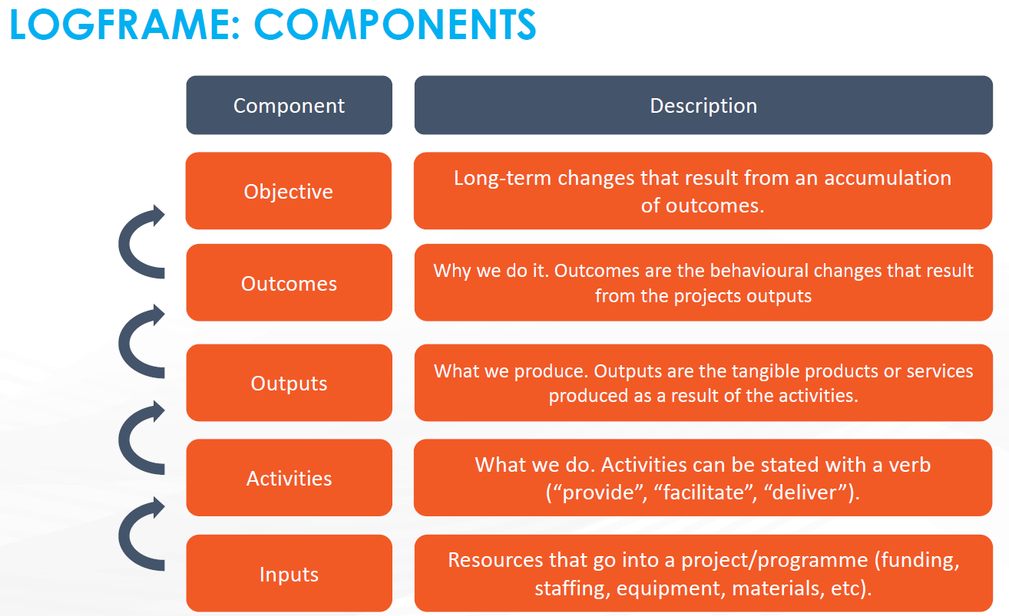

Technical and scientific cooperation refers to a process whereby institutions in two or more countries pursue their individual or collective biodiversity-related goals through cooperative actions. This may include the creation and/or exchange of scientific knowledge, data, expertise, resources, technologies, and technical know-how. It may also include human resources development, institution building, exchange of experts, joint research programmes, joint ventures for the development and diffusion of technologies (including indigenous and traditional technologies), and the transfer of technology and know-how.
https://www.cbd.int/gbf/
Excluding the partners’ commitment letters and the logframe template, as applicable, which can be included as annexes.
A risk is an uncertain event or condition that, if it materialises, can have a positive or negative effect on a project's objectives.

