Satoko Miyahara

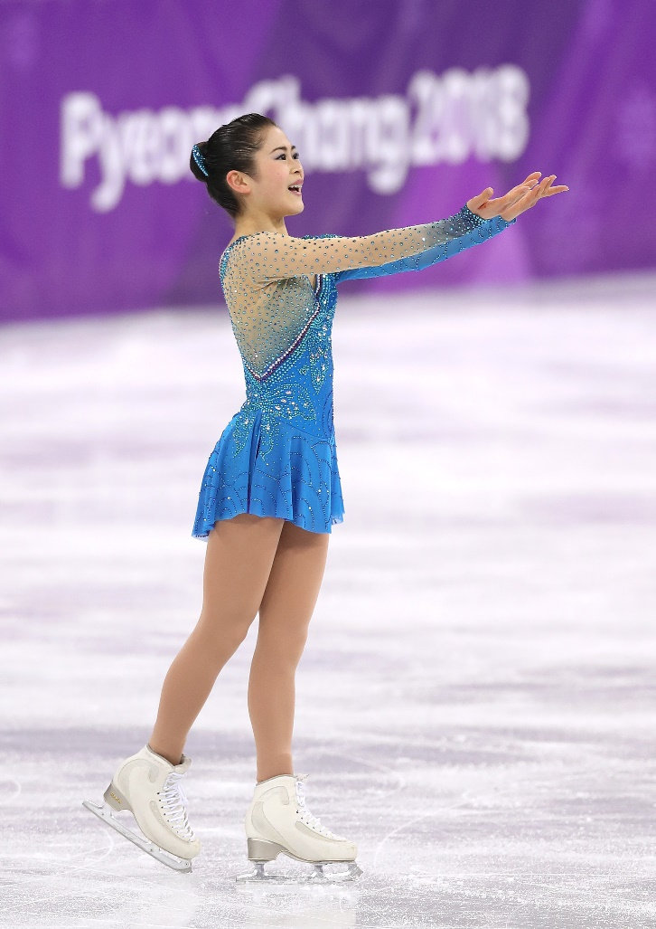

Birth date： March 26, 1998
Birth place： Kyoto, Japan
Training: Toronto, Ont., Canada
School： Kansai University – Graduated in March, 2021
Results： Professional
2023 Japan Open 1st as Team Japan
Amateur
2018 Worlds 3rd
2018 Olympics 4th
2016 Four Continents 1st
2015 Worlds 2nd
2015・2016 GP Finals 2nd
2015-2016 World Ranking 1st
2014・2015・2016・2017 Japan Nationals 1st

Due to her parents' work, she moved to Houston, Texas when she was 4 years old and had returned to Kyoto when she was 7 years old. After making many achievements, she announced her retirement as an amateur skater on her birthday in 2022.

She is the first Japanese skater who joined Stars on Ice Canada Tour as a cast member, March 2022.
She joined Stars on Ice Japan/Canada/US in 2023, 2024 and 2025.

She was selected as a director of Japan Skating Federation in September, 2024 – the youngest director ever.

She enjoys reading in Japanese and English, cooking and coloring books.



