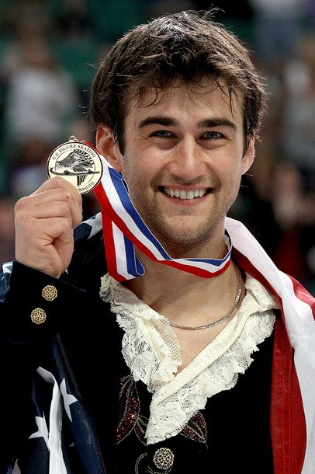 | Ryan Bradley  Date of Birth: 11/17/83  Height: 5’11’’  Birthplace: St. Joseph, MO  Facebook: www.facebook.com/RyanSBradley

U.S. Champion * Three-time Collegiate Champion * Two-time Grand Prix Medalist
Competitive Career Highlights
2011: 1st U.S. Figure Skating Championships  2010: 4th U.S. Figure Skating Championships  5th Four Continents Championships  18th World Championships  2009: 4th U.S. Figure Skating Championships  9th Trophee Eric Bompard  4th Nebelhorn Trophy | 2008: 5th U.S. Figure Skating Championships  2nd Skate Canada  2007: 2nd U.S. Figure Skating Championships  15th World Figure Skating Championships  2006: 1st U.S. Collegiate Championships  8th Skate America  8th U.S. Figure Skating Championships
Background
Ryan Bradley thought his competitive skating career had come to a close back in March 2010 when an injured foot landed him in 18th place at the World Championships in Torino. A longtime competitor and a natural showman, Ryan decided maybe it was time to entertain audiences instead of judges.

So he took some time off from competitive training, performed in several shows around the country and overall, he felt pretty good.

But inside, he knew he wasn’t finished. Not yet.

He didn’t reach his ultimate goal of competing in the Olympic Winter Games in Vancouver, finishing fourth at the 2010 U.S. Championships --- the top three men made the U.S. Olympic team --- but that didn’t mean he was finished.

His fans encouraged him to continue competing, too, sending him emails and messages on social media persuading with him to give his competitive skating career one more shot.

Eventually, he decided to come back.

And, man, is he ever happy he did.

When he arrived at the 2011 U.S. Figure Skating Championships in Greensboro, N.C., many were surprised by his presence. However, once he started skating, Ryan provided more surprises. His short program was dominating, including an incredible quadruple jump and he became the overnight leader. In the free skate, Ryan scored enough points to secure his first U.S. title in 11 trips to the national championships.

"I need to go home and make sure this really happened,’’ Ryan said after his victory. “We were on the podium with our flowers and I was like, `I don't think you can smell in dreams.’ So I smelled the flowers to make sure I'm awake."

The flowers smelled beautiful, and yes, this has been a dream year for Ryan but make certain of this: It is no dream.

Since his retirement from competitive skating in March, 2012, Ryan spent time entertaining vacationers in skating shows aboard the Royal Caribbean Liberty of the Seas cruise ship. “I really enjoyed the lifestyle,” says Ryan. “The small rink makes it really personal. You can look into their eyes; it’s like they’re all sitting in the front row. It was very appealing to me.”

Ever the consummate entertainer, Ryan realized a lifelong dream as he was invited to join the Stars on Ice cast where he spent several years touring throughout the US, Canada and Japan.

During the Summers, Ryan enjoys being part of “Sun Valley On Ice.” He is a coach at the Community First Igloo in Jacksonville, FL.

“I feel it is very important to stay so involved in the sport of figure skating," he said. "I want to use my knowledge and passion to keep the sport moving in the right direction."

He is an avid Kansas City sports fan – go Chiefs and Royals!

