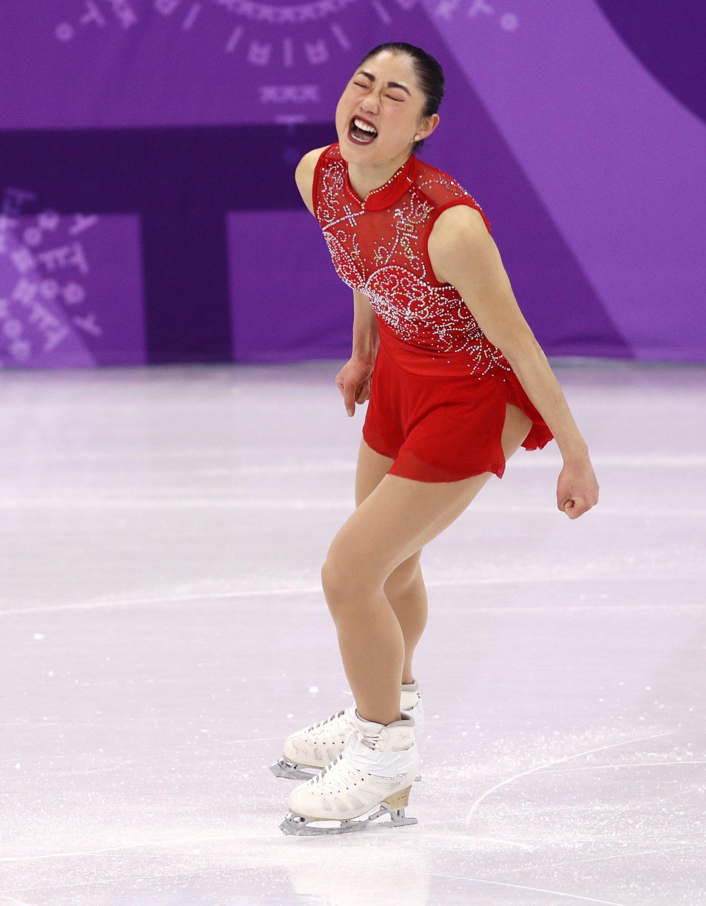 | Mirai Nagasu  Born: April 16, 1993  Birthplace: Montebello, CA  Residence: Boston, MA

2018 Olympic Bronze Medalist (Team) * U.S. Champion *
* U.S. Junior Champion * U.S. Collegiate Champion * Two-Time Olympian *
Competitive Career Highlights
2018 - World Championships - 10th  2018 – Olympic Winter Games – 3rd (Team)  2018 – Olympic Winter Games – 10th  2018 - US Championships – 2nd  2017 - Four Continents Championships - 3rd  2017 - U.S. Championships - 4th  2016 - Autumn Classic International - 1st  2016 - World Championships - 10th  2016 - U.S. Championships - 4th  2015 - U.S. Collegiate Championships - 1st  2015 - U.S. Championships - 10th | 2014 - U.S. Championships - 3rd  2013 - U.S. Championships - 7th  2011 - U.S. Championships - 3rd  2010 - World Championships - 7th  2010 - Olympic Games - 4th  2010 - U.S. Championships - 2nd  2009 - U.S. Championships - 5th  2008 - U.S. Championships - 1st  2007 - Junior Grand Prix Final - 1st  2007 - World Junior Championships - 2nd  2007 - U.S. Championships, Junior - 1st
Background

“Mirai” means “future” in Japanese, and Olympic figure skater Mirai Nagasu has always been focused on it.

Mirai’s journey began in Montebello, California. An only child, Mirai was born to Kiyoto and Ikuko Nagasu and raised in Arcadia, California, where her parents own the restaurant, Sushi Kiyosuzu. As the daughter of Japanese immigrants, Mirai holds dual citizenship in the United States and Japan. She notes the importance of her mixed heritage, embracing the blend of U.S. and Japanese culture.

Mirai began skating at the age of five, citing the fortuitous beginnings to her love of the ice. “Due to typical sunny beautiful California weather, my parents always loved to take me to play golf with them...but one rainy day, my mom decided to take me ice skating and that's when I knew I wanted to keep skating...Bye bye golf!”

Mirai quickly took the skating world by storm.

Mirai won the U.S. junior national title at the 2007 U.S. Figure Skating Championships. The following year, she won the U.S. senior title - an incredible feat for any skater.

In 2010, with the Olympics on the line, Mirai came through like a star placing second at 2010 U.S. Championships. Mirai stole the show, lighting up the rink with her energy, poise and infectious smile. She placed a very impressive 4th place finish at the 2010 Olympic Games in Vancouver.

In the ensuing years, Mirai battled injuries and coaching changes, but her passion for skating never wavered.
In 2014, she came so close to qualifying for the Olympics a second time. Mirai placed third at the U.S. Championships, but was left off the Olympic Team. This setback did not deter Mirai, but only made her stronger. Mirai made it one of her goals to become one of a select group of women in the world to land the triple axel jump.

In January 2018, Mirai was the buzz of the national championships. She was praised for her commitment to the sport, and for coming back after the sting of missing the 2014 Olympic Team. Mirai won the silver medal and was so emotional after her free skate that she sobbed in the kiss and cry. This time, they were tears of joy as she earned her spot back on the U.S. Olympic Team.

“I really took time to remodel myself, because I didn’t want to feel that regret,” Mirai said during the announcement on NBC’s Today Show. “This has been about my journey and my goal to get here. To accomplish it has been a dream come true.”

At the 2018 Winter Olympics in PyeongChang, Mirai made history by becoming the first American woman and only the third woman in history to land a triple axel in an Olympic Winter Games. She performed the difficult three-and-a-half revolution jump, helping Team USA win a bronze medal in the Olympic team event. “It was my dream moment,” Mirai said. “It felt like the stars aligned.”

Immediately after the Olympics, Mirai competed on Season 26 of Dancing with the Stars with her partner, Alan Bersten while touring with Stars on Ice. Mirai was a houseguest on CBS’ Celebrity Big Brother 2 (US).

In 2020, Mirai graduated from UCCS (University of Colorado Colorado Springs) with a degree in business administration.

Mirai, 32, resides and coaches in Boston. She has a son named Taiga who was born on April 13, 2024.

She looks forward to performing again with the 2025 Stars on Ice Holiday tour!

Mirai’s Social Media:

- Instagram: MiraiNagasu

