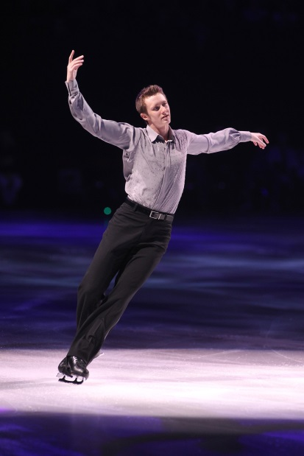

**Jeremy Abbott**

**Four-time U.S. National Champion and 2010/2014 Olympian**

**Date of Birth:** June 5, 1985

**Hometown:** Aspen, CO

Jeremy Abbott is a four-time U.S. National Champion (2009, 2010, 2012 and 2014), 2007 Four Continents Bronze Medalist and the 2008 Grand Prix Final Champion. After winning the 2010 U.S. National Championships, Jeremy was nominated to represent the 2010 U.S. Olympic Team, in Vancouver, BC. He placed ninth overall. The 2014 U.S. Olympic team placed third.

Abbott began skating at the age of two, but really grew into the sport and knew he wanted to skate passionately, at the age of four after seeing Olympic Champion Robin Cousins skate live in Aspen, CO.

Jeremy Abbott is unique in the fact that he has had experience with three different figure skating disciplines. He began competing as an Ice Dancer (1995 – 1998), then competed in Pairs skating (1998 – 2000) and eventually settled into competing as a Men’s singles skater beginning with the 2000-2001 competitive season, as a Novice. Jeremy won the Junior National Title at the 2005 U.S. Figure Skating Championships.

In 2007, Jeremy qualified for his first Senior National Championship where he finished a strong fourth, winning the pewter medal. He made his presence known at the 2007 Four Continents Championships by capturing the bronze medal. Abbott had a stellar 2008-09 season, becoming the first American man to ever win the Grand Prix Final of Figure Skating.

Hobbies and interests, off the ice, for Jeremy include drawing, writing, anything involving music, snowboarding and reading. He also maintains the *Jeremy Abbott Training Fund* that stands by the motto “Pigs Can Fly”. Jeremy sends the message all over the World that dreams do come true. Founded in 2005, the fund provides financial assistance to boys skating competitively for the Aspen Figure Skating Club, which was Jeremy’s first club.

**Competitive results**

**2013/2014 Season**

NHK Trophy 3rd US National 1st

Skate Canada 6th

Olympic Game 12th

World 5th

**2012/2013 Season**

Skate America 5th US National 3rd

Trophee Eric Bompard 3rd

**2011/2012 Season**

Cup of China 1st US National 1st

Rostelecom Cup 3rd

GP Final 5th

**2010/2011 Season**

NHK Trophy 2nd US National 4th

Cup of Russia 3rd

Four Continents 3rd

**2009/2010 Season**

NHK Trophy 5th US National 1st

Skate Canada 1st

GP Final 4th

Olympic Game 9th

World 5th

**2008/2009 Season**

GP Final 1st US National 1st