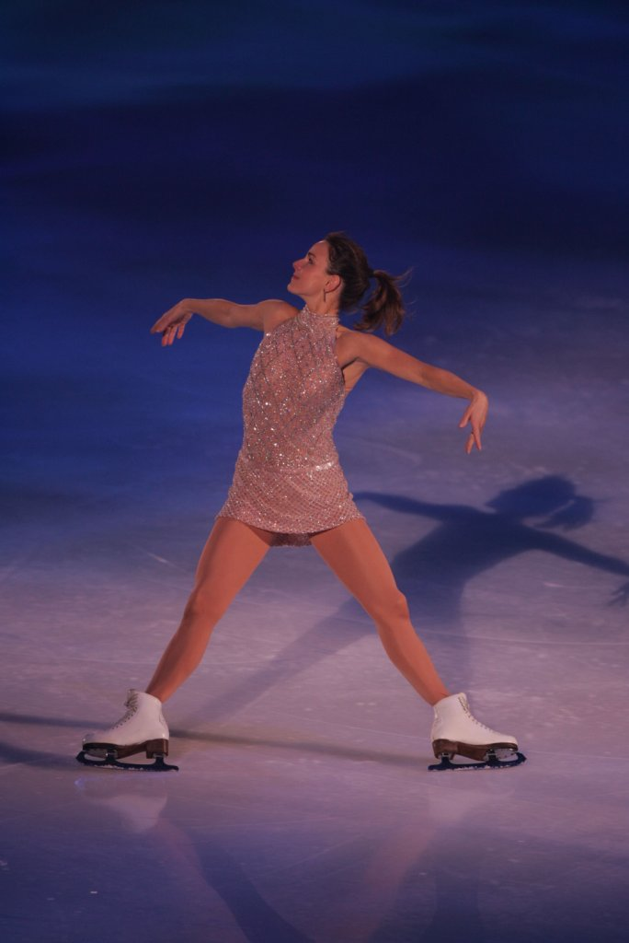 | Ekaterina Gordeeva  Residence: Dallas, TX  Place of Birth: Moscow, Russia  Date of Birth: May 28, 1971  Instagram: KatiaGordeeva

Two-Time Olympic Champion (Pair) • Four-Time World Champion (Pair)

Competitive Career Highlights
(with late husband Sergei Grinkov)
1994: Olympic Pair Champions
3-Time World Professional Champions (1994, 1992, 1991)
2-Time World Challenge of Champions (1995, 1991)
1990: World Professional Championships Silver Medalists
4-Time World Pair Champions (1990, 1989, 1987, 1986)
1990: Goodwill Games Pair Champions
1988: Olympic Pair Champions
1988: World Pair Silver Medalists
Background
There are few skaters in history that possess such ethereal beauty and grace as Ekaterina “Katia” Gordeeva. Like a quiet ballerina, she floats on the ice seemingly in a world of her own creation, and we are the lucky participants, fortunate enough to be touched by her soulful athleticism. It is with her former partner and late husband, the great Sergei Grinkov, that Katia first seduced the world with her elegance. In their thirteen years together, they came to define pair skating, lifting the sport to new heights, artistically and athletically. With a style all their own, Gordeeva and Grinkov made a name for themselves as the most recognizable pair team ever from the former Soviet Union.

Born May 28th, 1971 to Elena and Alexander Gordeev, Katia’s life seemed blessed from the start. Her father was a dancer with the Moiseev Dance Company, a world-famous folk dancing troupe. It is perhaps from him that Katia derives her single-minded determination and graceful flair. Alexander instilled in his daughter a remarkable work ethic that has served Katia well in her career. Even as a young girl, she took her training very seriously; indeed, she was the one that would often have to raise her parents at 5 AM, determined not to miss a second of vital ice time. From Elena, Katia borrows her beauty and gentle soul. It is through her mother’s eyes that Katia sees the world, and through her mother’s spirit that she raises her children.

Though Alexander wished for his young daughter to become a ballerina, it was the former Soviet Union’s Central Red Army Club (CSKA), the elite body that developed the country’s great athletes, that determined Katia’s destiny. From the tender age of 4, Katia exhibited a potential on the ice worthy of her selection to the elite sports club, and due to her slight stature she would forever remain on the ice, never fulfilling her father’s original dreams.

Katia’s early years were defined as much by her happy home life as they were by her determination to become an accomplished skater. She grew up with her parents and younger sister, Maria, in a Moscow apartment. Though her parents both worked hard, her father dancing away in distant lands, her mother working twelve-hour shifts for the Soviet News agency Tass, they would spend restful vacations at their
dacha, their summer home in the country north of Moscow. Joining them on their vacations would be Katia’s dear babushka and diaka, her grandmother and grandfather, two influential people in her life.

It wasn’t long before the CSKA determined that Katia was more suited to the demands of pair skating. On a fateful day at age 11, she was paired with a slender, golden-haired young boy named Sergei Grinkov, four years her senior. From that point on, the serious young girl and the carefree, talented Grinkov formed a partnership that would define both their own lives and the world of figure skating.

Three years later, after countless hours of rigorous on and off-ice training, Gordeeva and Grinkov joined forces with Marina Zueva who would become their longtime choreographer and perhaps the most influential force in their skating careers. Soon after this partnership formed, the pair won the World Junior Championships in Colorado Springs in 1984. Two years later, in 1986 in Geneva, they won the World Championships in their first try, defeating the defending champion pair team of Elena Volova and Oleg Vaesiliev.

Though the successes of this young pair quickly mounted, their off-ice relationship proceeded at a more gradual pace. The two spent little time together away from their training, and while the playful Grinkov was constantly testing authority and exploring life with a large group of friends, Katia’s existence was more isolated. Her eyes turned not to those around her, but inward. Due to her relative youth (in comparison with the other skaters) and shyness, Katia found solace on the ice and in her training. Though Sergei would become the anchoring force in their partnership, Katia’s steadfast determination and remarkable work ethic was an integral factor in the pair’s enormous success. She focused almost exclusively on a single goal: capturing Olympic Gold in Calgary.

Gordeeva and Grinkov successfully defended their World title in 1987 in Cincinnati. After the World Championships, they toured North America in Champions on Ice and then proceeded to set their sights on the Olympics. During training, in November ’87, Sergei caught a blade on the ice and dropped Katia while holding her aloft. She landed on her forehead, forcing a brief stay in the hospital. Sergei visited Katia quite a bit during that period. From that point forward, Sergei’s attentions to his partner grew more intimate, more caring, and whenever he held Katia on the ice, it was as if he would never let her go.

1988 proved to be a heady year for Katia. Things changed rapidly, both on and off the ice. Her trip to Calgary was a success, as she and Sergei won the Gold Medal in their first Olympics. But Katia felt increasingly lonely and isolated as her longing for Sergei developed without an outlet. Again, she focused intently on her training; but a stress fracture in her ankle restricted even this diversion. Katia took advantage of her time off to learn English and eventually became her skating partner’s official translator. Then, seemingly out of nowhere, Gordeeva and Grinkov went from being partners, to good friends, to sweethearts, a transformation marked exquisitely by their first kiss on New Year’s Eve, 1988.

Gordeeva and Grinkov won Worlds again in 1989 in the romantic city of Paris but were so consumed with love that the skating hardly seemed to matter. For once, their time together off the ice was more important. After successfully defending their World Championship in 1990 (their fourth title), the couple turned professional in 1991. That year, however, marked a more prominent transition in their lives: on April 28, 1991, they were married.

The next few years brought more dramatic changes to Gordeeva and Grinkov as life began to move at a faster, more hectic pace. In addition to an increase in skating tours (Champions on Ice through North America, Russian All-Stars through South Africa), there arrived a barrage of responsibilities new to the couple: simple financial and housing matters previously handled by the old Soviet Regime. And on September 11, 1992 came the most precious responsibility of all, their daughter Daria. Though thrilled with parenthood, the couple needed to support themselves, which meant more touring. During the 1991-1992 season, Gordeeva and Grinkov decided to join the Stars on Ice tour, the world’s most prestigious figure skating production. The sixty city, three-month road show made travel virtually impossible with their newborn, so they entrusted Daria’s care to Katia’s mother, a difficult but necessary decision for the young parents.

In 1994, Gordeeva and Grinkov took advantage of a new rule allowing professional skaters to be reinstated for Olympic eligibility and headed for Lillehammer. This time they won the Gold for each other. The couple returned to the United States, their historic significance in the sport of figure skating forever cemented, and found a permanent residence in Simsbury, CT, near their new training center. The same year, Katia was selected as one of People Magazine’s 50 Most Beautiful People.

Life for Katia and Sergei was complete, both personally and professionally. During their career, they had amassed two Olympic Gold Medals, four World Amateur Championships, and three World Professional Championships in addition to various other first and second place finishes. Now, finally settled in their new home and in their new country, they looked forward to the future.

Despite Sergei’s nagging back injury, 1995 was destined to be a wonderful year. Again, they decided to rejoin Stars on Ice, and though this meant another long three months on the road, at least this year they were able to bring their daughter Daria along with them to the lengthy Stars training sessions in Lake Placid. But sadly, fate intervened. On Monday, November 20, 1995, while rehearsing a number with their choreographer Marina Zueva, Sergei suffered a fatal heart attack. The world lost one of its greatest performers, and Katia lost her husband, partner, and best friend.

Though the next year was extraordinarily difficult for Katia, she again found her solace and inspiration on the ice. In February of 1996, she began her solo career with a heartfelt tribute to her late husband in A Celebration of a Life, which aired on CBS. In November 1996, Katia chronicled her life and love affair in her book My Sergei, A Love Story (Warner Books), which became a national best seller. That same year, she starred in her first television special Disney’s Beauty and the Beast along with friend and fellow skater Scott Hamilton.

Since then, Katia has emerged as one of the world’s most familiar faces. She signed a multi-year partnership with Target Stores that includes commercials and product endorsements. Katia’s first project with Target was a starring role, along with her daughter Daria, in the holiday musical Snowden on Ice, which aired in November 1997 on CBS. In February 1998, CBS aired the television docudrama My Sergei, (based on the book), and in April 1998 Little Brown published Katia’s second book A Letter for Daria. Target’s 1998 sequel to Snowden on Ice, The Snowden Raggedy Ann and Andy Holiday Show was equally as successful.

Target introduced a fragrance and bath and body line, simply called “Katia”, in March of 1998. Katia is only the second athlete (Michael Jordan being the first), to have a fragrance named after them. “Katia” was distinguished with a Fifi award nomination, the prestigious perfume industry’s award for fragrances. A second fragrance, called “Katia Sport”, was released exclusively in Target Stores in April 1999. Target also displayed their support for Katia by dedicating a memorial to Sergei named the “Sergei Garden” within Target House, a 50-unit apartment complex and a home-away-from-home for long-term patients and their families while receiving treatment at the St. Jude Children’s Research Hospital in Memphis, Tennessee.

During this period, Katia also signed a multi-year agreement with Rolex. She has appeared in a print ad campaign solo and with female skating legend Peggy Fleming. She also was featured in the popular “Milk Mustache” ad campaign with her daughter Daria.

As a solo artist, Katia spent twelve years on the Stars on Ice tour as a full-time cast member or as a guest star. Katia continues to perform in figure skating exhibitions throughout the world. She briefly returned to pairs skating during the 2008-09 season when she participated in Russian reality television show, Ice Age 2 a figure skating version of Dancing with the Stars. She and her partner, Russian actor Egor Beroev won the show. In November 2010, Katia and her partner hockey star, Valeri Bure, won season two of CBC’s hit reality show, Battle of the Blades.

Katia recently relocated from Edmonton to Dallas with her husband, David Pelletier, who is an assistant coach for the Dallas Stars. Her daughter Liza is in college, earning her master’s to become a chiropractor and Daria works in the fashion industry.

