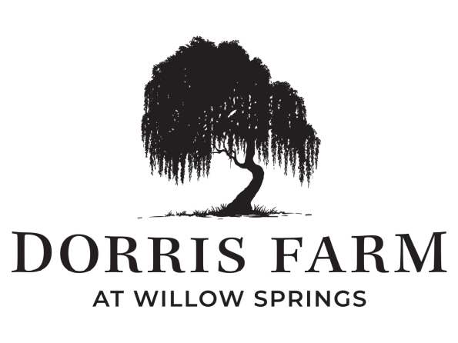
ARC Guidelines, Rules & Regulations
As our community continues to grow, it becomes important for all homeowners to keep their properties properly maintained. This is instrumental in keeping our neighborhood a desirable place to live and a competitive property value.

The documents contained herein are provided to help the homeowners of the Dorris Farm @ Willow Springs Community understand the rules of the Homeowner Association (HOA). Additional information can be found in The Covenants, Conditions and Restrictions (CC&Rs).

The guidelines are intended to serve as clarification of the CCR’s and guidance as to changes, maintenance, location, and size of existing and additional structures on any lot and other Architectural issues. This document is available through the Dorris Farm @ Willow Springs management company (Ghertner & Company: ghertner.com/owner or 615-277-0358). The Architectural Review Committee may impose additional restrictions and grant variances to those restrictions as allowed by the CCR’s and HOA Board.
Owner’s Responsibility
Each Owner shall maintain his or her Lot, as well as the Residential Unit and all other structures or improvements thereon, including exterior surfaces of the residence, parking areas, fences and other improvements located on the Lot in a manner consistent with the Community-Wide Standard and all applicable provisions of the Documents, unless such maintenance responsibility is otherwise assumed by or assigned to the Association.
Violations
If the Board determines that any owner has failed or refused to properly maintain the lot/unit, the Association shall give the owner written notice. The owner will have 14 days to complete maintenance, repair, or replacement. The Board can enforce this through monetary fines against the owner or lot each day the maintenance, repair, or replacement is not completed and can constitute a separate violation for which fines may be assessed daily to the owner per the Fine Policy on page 19. If you have any outstanding balances, and money paid to the HOA will go towards any outstanding balance first and then to the Assessments owed to the Association.

Table of Contents
ARC Project Requirement Checklist Page 4
Architectural Review Criteria Page 4
ARC Guidelines, Rules & Regulations Page 5
Additions Page 5
Air Conditioning Units Page 6
Animals and Pets Page 6
Antennas and Satellite Dishes Page 6
Awnings/Patio Covers Page 6
Basketball or Playground Equipment, Trampolines, Clotheslines Page 7
Boats, Trailers, and Motor Vehicles Page 7
Bird Feeders vs Birdhouses Page 7
Curb Leveler Page 8
Drainage and Septic Systems Page 8
Fences Page 9
Retaining Wall Page 10
Garage Sales Page 10
Generators Page 11
Hobbies and Guns Page 11
Irrigation Page 11
Leasing Page 11
Lighting/Decorating Page 12
Mail Kiosk Systems Page 13
Noise, Nuisance, and Hazardous Substances Page 13
On Street Parking Page 13
Parking and Garages Page 13
Signs and Flagpoles Page 13
Storm Doors Page 14
Swimming Pools and Hot Tubs Page 14
Tanks Page 15
Tents, Trailers, Temporary Structures and Outbuildings Page 15
Trash Page 16
Garbage Enclosures Page 16
Landscaping Page 16
Artificial Vegetation, Exterior Sculpture, & Similar Items Page 17
Trees, Shrubs, and Bushes Page 17
Patios/Decks Page 18
Screened in Patio Page 18
Motorized Screens Page 18
Fine Policy Page 19
Reference Section Page 19
ARC Project Requirement Checklist

- Completed and Signed ARC Request Form available through Property Management company.
- A summary/list of the proposed project(s).
- Select the Type of Request
- Based on the Type of your Requested Project as checked, make sure you have supplied the following information:
  - Original Plot Plan showing the exact location of the alteration in relation to the home on the lot
  - Elevation Views facing the improvement (may be photos)
  - Color Description
  - Bill of Materials
  - Identify plantings, (name, height and width when fully grown)
  - Product Brochures
  - Photos where improvement will be located
  - Fence may be Required (trampolines)
  - Copy of Permits including any Variances
  - Copy of the Contract with the company performing the work

- Description of the Project Request.
- Check boxes stating you understand the requirements.
- Sign the Application.

**Without all necessary information the request may be delayed or rejected. **
The ARC’s decisions are based on the information presented and its conformity to other projects within the community. The ARC is responsible for maintaining a consistent design and maintain property values while allowing you to get your approved project completed as quickly as possible.
Architectural Review Criteria
The ARC evaluates all submissions on the individual merits of each application. The characteristics of the house type and the individual site are taken into account when evaluating the particular design proposal. What may be an acceptable structural change or design of an exterior in one instance may not be for another.
The following criteria represent the general standards that will be used in reviewing and evaluating such application for structural or design change.
- Validity of Concept
The basic idea must be sound and appropriate to its surroundings.
- Design Compatibility
The proposed improvement must be compatible with the architectural characteristics of the applicant’s house, adjoining houses, and the neighborhood setting. Compatibility is defined as similarity in architectural style, quality of workmanship, similar use of materials, color and construction details.
- Location and Impact on Neighbors
The proposed alteration should relate favorably to the landscape, the existing structure and the neighborhood. The primary concerns include, but are not limited to access, view, sunlight, ventilation and drainage.
- Good Neighbor Policy
When proposed alteration has possible impact on adjacent property, the ARC may solicit comments from adjoining property owners regarding certain applications. Responses would not determine consent or denial but allow the ARC to consider comments along with the proposed alteration.
- Color
Exterior colors must conform to the original scheme designed by the builder. Before changing the color of any exterior portion of their home, including fences, doors, windows, shutters, and roof, new color samples and a photograph of the home must be included with ARC Request form.

Shutters and doors will complement the exterior color scheme, and maintain the original colors intended by the builder. Brick may not be painted by the Homeowner after purchase but can be painted by the builder during construction.
- Materials
Continuity is established by use of the same or compatible materials as were used in the original house. The options may be limited somewhat by the design and materials of the original house. For instance, horizontal siding on the original house should be reflected in an addition.
- Workmanship
Workmanship is another standard which is applied to all exterior alterations. The quality of work should be equal to or better than that of the community. Poor practices, besides causing the owner problems, can be visually objectionable to others. Poor workmanship can also create safety hazards.

ARC Guidelines, Rules & Regulations

Additions
Additions must be of materials, colors, and styles that match the existing home. Detailed plan and elevation drawings are required for all additions. Paint samples, photos, or brochures of all new building materials must be submitted with the ARC Request Form.

Brick or siding must match the home’s materials and be sufficiently reworked to tie into the home in order to blend the new addition with the existing structure.

Roofing must be of a consistent color and type and slope which complement the existing roof line. Flat roofs are not allowed. If replacement or repair is required, the roof must be restored to the original design specification.

Replacement / maintenance of home exterior is pre-approved provided it is restored to the original design specification and color scheme.

No garage may be permanently altered in any way that would reduce the number of automobiles for which the garage was originally constructed.

No additions are permitted for Villas, Townhomes or Cottages.

Air Conditioning Units
No windows or wall type air conditioning unit shall be permitted.
- Air Conditioners or heat pumps can be screened with perennials or low structures. Colors and materials must be included with the application. Care should be taken to ensure structures or plantings do not interfere with air flow or maintenance access.
- Window air conditioner units and solar panels are not allowed. However, solar roof tiles that can be incorporated into the roof shingles and not stand out will be considered.

Animals and Pets
No animals, reptiles, rodents, livestock, birds, fish or poultry of any kind shall be raised, bred, or kept in or on any portion of the Subdivision, except as otherwise provided below. Dogs, cats, or other usual and common household pets not to exceed a total of two (2) with respect to Villa homes and three (3) with respect to single family homes may be permitted with respect to each Lot. Pets are not permitted to roam free, and at the sole discretion of the Association, any pets which endanger the health, make objectionable noise, or constitute a nuisance or inconvenience to the Owners of other Lots or the owner of any portion of the Subdivision shall be removed upon request of the Board. If the Owner fails to honor such request, the pet may be removed by the Board and turned over to the appropriate agency for keeping or disposal. No pets shall be kept, bred, or maintained for any commercial purpose.
Dogs, which are household pets, whenever they are outside a residence must be confined on a leash held by and under the physical control of a responsible person. Local laws governing leashing, control, etc., of animals shall apply to the residents of the community. Homeowners shall be responsible for cleaning up after their pet.

Antennas and Satellite Dishes
All television antennas and equipment used for such must be twenty-four (24) inches or less in diameter. All antennas and satellite dishes must be placed in the rear of the home and not visible from the street. Any exception must be approved in advance by the Board of Directors.

Awnings/Patio Covers
A. Must not be located on the front or side portions of the house.
B. ARC Request must include color, location, materials, upkeep procedures, picture and/or design of awning
C. NO plastic, vinyl, or metal will be permitted.
D. Patio Covers must match the roof and trim of the home.

Awnings
- Awnings are not permitted on the front or side portions of the house.
- Awnings may be allowed on the rear portion of a home with ARC approval.
- The ARC reserves the right to restrict awnings based on color, location, materials and upkeep.
- A picture/design of the awning and sample of the material must be submitted with the ARC Request Form for approval.
- No plastic, vinyl, or metal awnings will be allowed

Basketball or Playground Equipment, Trampolines, Clotheslines-
- Permanent basketball hoops shall not be permitted, unless prior approval has been obtained from the ARC. Portable basketball hoops shall be used only between 8am and 10pm & stored out of sight when not in use.
- All playground equipment located upon Lots including, but not limited to, swing sets, slides, seesaws, playhouses and/or climbing apparatuses shall be maintained in good condition, constructed of natural wood and finished with a natural wood exterior surface and shall be approved by the ARC prior to installation. No painted wood finish, predominately plastic, or metal structures shall be allowed. Any allowable playground equipment must be hidden as much as possible from the street view and from the view of adjoining Owners. ANY OTHER OUTDOOR TOYS OR PLAY EQUIPMENT MUST BE STORED WHEN NOT IN USE.
- All trampolines must be within a fence that is ARC approved.
- No clothes lines, above ground tanks, or other similar items shall be placed, allowed, or maintained upon any portion of the Community, including any Lot.

Boats, Trailers, and Motor Vehicles
No commercial vehicles, boats, jet-skis, boat trailers, buses, house trailers, motor homes, panel trucks camping trailers, vans, motorcycles, motor scooters, go-carts, motorbikes or other similar vehicles (“Non-permitted Vehicle”), whether of a recreational nature or otherwise, with the exception only of four-wheeled passenger automobiles and pickup trucks, shall be placed, parked or stored upon any Lot. Trucks, vans, commercial vehicles, and vehicles with commercial writings on their exterior shall be allowed temporarily on the Common Area during normal business hours for the purpose of serving any Lots or the Common Area, provided they do not remain overnight without prior written approval from the Board. The Association shall have the right to authorize towing of any vehicles which are in violation of these provisions, or the Traffic Regulations promulgated by the Association, and to collect the cost thereof from Owners, as an Individual Assessment.

Bird Houses vs Bird Feeders (Both require ARC Approval)
What’s the Difference and Why It Matters
The Association supports responsible enjoyment of wildlife while also ensuring community cleanliness, health, and appearance. Because bird feeders and birdhouses serve very different purposes, they are treated differently under HOA guidelines.

Bird Feeders (Food Sources)
What they are:
Devices that provide seed, suet, or other food to birds.
Why they are regulated more strictly:
In Tennessee communities, bird feeders often:
- Attract unintended wildlife such as rodents, raccoons, or feral animals
- Create sanitation concerns due to spilled seed and droppings
- Cause property staining or damage
- Lead to complaints related to pests or nuisance activity
Birdhouses (Nesting Structures)
What they are:
Structures designed to provide shelter or nesting space for birds — they do not contain food.
Why they are treated differently:
Birdhouses typically:
Do not attract pests or nuisance wildlife
- Do not create sanitation or drainage issues
- Are considered decorative or environmental features when properly placed
Bird Feeder & Birdhouse Guidelines
Bird feeders may be permitted at the sole discretion of the Architectural Committee. If approved, feeders must be limited in number (only 1 per lot), placed in rear yards only, not visible from streets or common areas, and maintained in a clean and sanitary condition not allowing seed to collect on the ground.
Approval is conditional and may be revoked at any time if the bird feeder results in unsanitary conditions, attracts pests or wildlife, creates a nuisance, or negatively impacts the community. The Association reserves the right to require immediate removal at the homeowner’s expense.
Curb Leveler
- Must be black in color
- Must be temporary plastic material(s).
- Only curb levelers that are hollow inside that all water to flow through will be allowed.
- Curb levelers that are made of concrete or asphalt are not permitted.
- Must not be affixed to the curb or street
- Must not impede drainage to the lot or community
- The homeowner assumes all risk if the curb leveler is damaged, destroyed, or if it causes damage to the curb. The city nor the HOA will not be responsible for any damage that occurs to the levelers
- See example
  - 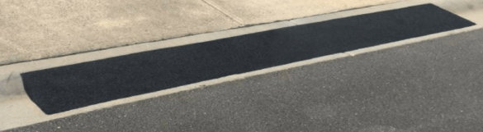
Drainage and Septic Systems
Catch basins and drainage areas are for the purpose of natural flow of water only. No obstructions or debris shall be placed in these areas. No Person other than Declarant may obstruct or re-channel the drainage flows after location and installation of drainage swales, storm sewers, or storm drains. Septic systems are prohibited upon any lot or within the Subdivision.

Fences
Fences must comply with Fence Guidelines. All fences must receive ARC approval prior to construction.
- Fences must be aluminum material.
- Fence panels must be 48” or 60” in height.
- No fence shall be installed in any way to disturb or impede drainage to the lot or subdivision.
- Fences shall not encroach a public right-of-way, including alleys, or in areas reserved or dedicated for public right-of-way
- ARC Committee can determine if attaching to the neighbor’s fence will impede drainage.
- Fence’s must go on the lot line. Determination of the lot line and placement of the fence is the sole responsibility of the owner.
- Property lines must be surveyed and staked before the fence is constructed.
- All fences must meet code requirements for the city.
- Homeowners are required to obtain any necessary permits from the City before the fence is constructed.
- Must repair or replace any damaged landscape.

See Example
- Single Family
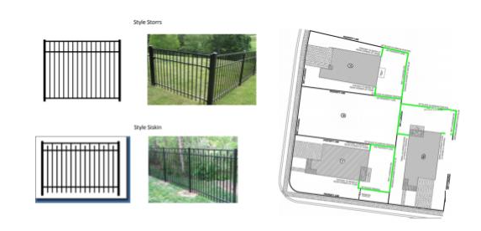
- Villas
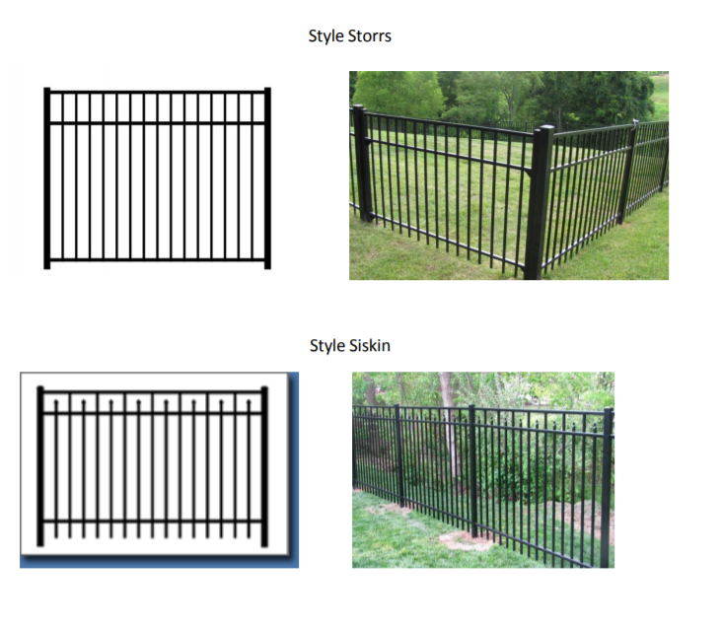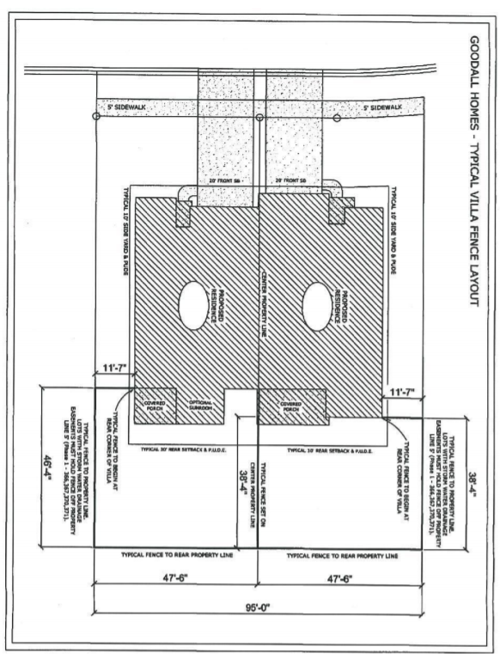

Invisible Pet Fence
1.Must only be placed in the backyard.
2. Must have utilities located prior to digging.
3. Must repair or replace any damaged landscape.
4. Must have invisible fence flags removed within four weeks after installation.
5. Fence shall not be installed in any way to disturb or impede drainage to the lot or subdivision.

Retaining Wall
- Retaining walls are permitted and require ARC Approval. Retaining walls are used for leveling the property within the homeowner’s lot. Setbacks / buffer areas may be required depending on usage; however, no retaining wall shall be built from property line to property line and cannot be attached to a home. No privacy fence shall be installed on or directly to a Retaining Wall.

- All Retaining Walls will be made of either concrete or stone or a decorative retaining wall block. Any Retaining Wall over 4 feet shall require a permit and an engineering plan. Any Retaining Wall of 30 inches or more in height shall have Guard / Safety rails of black aluminum or wrought iron with a height of a minimum of 3 feet to prevent accidental falling off the Retaining Wall. The Guard / Safety rail cannot exceed the boundaries of the retraining wall and cannot be attached to the home or a privacy fence.

- A Garden Wall which is similar to a Retaining wall is used to contain trees and vegetation and not open space. Garden Walls will be under 4 feet in height and do not require a Safety / Guard rail.
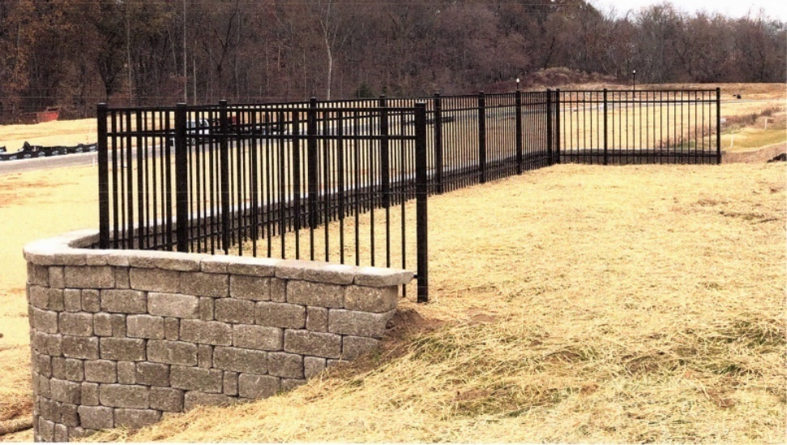

Garage Sales
The Board of Directors may choose to approve community wide yard sales. No individual homeowner may conduct a garage sale, yard sale or similar activity.

Generators
A device that is stationary and is an internal combustion engine or turbine that serves solely as a secondary source of electrical power whenever the primary electrical source has been disrupted due to a temporary outage.
- Must be connected to the main natural gas line to the home. No other external sources may be used.
- Must be placed on a concrete slab.
- Output must be connected to the homes fuse box. A permit is required.
- ARC approval is required. Submission must contain a picture of the location where the Generator will be located, location outlined on a Developer Plot Plan, brochure of the device selected and copies of the contractor’s contract.
- Must be 15’ back from the front of the house

Hobbies & Guns
The pursuit of hobbies that are inherently dangerous or objectionable to adjoining lot owners including, without limitation, the assembly and disassembly of motor vehicles or other mechanical devises, shall not be permitted. Activities such as fireworks or pyrotechnic devices of any type or size and other such activities shall not be pursued or undertaken on any part of any Lot or upon the Common Areas without the consent of the Board. The discharge of firearms within the Community is prohibited. The term “firearms” includes “B-B” guns, pellet guns, and other firearms of all types, regardless of size.
Irrigation
No irrigation system or lawn sprinkler system may be installed by or on behalf of an Owner of a Cottage, Townhome, and/or Villa Lot, except for systems installed by or on behalf of the Declarant or a Builder & maintained by the Association.
- Single Family: All in-ground irrigation systems (underground pipes or tubing) require ARC approval. Irrigation systems must be ARC Approved and meet local municipality requirements. Homeowners are advised that backflow preventers are to be inspected annually by a plumbing company and Homeowners must check with their respective utility for authorized inspectors.
Leasing
a) Definition. ''Leasing", is defined as regular, exclusive occupancy of a residence located upon a Lot by any person or persons other than the Owner for which the Owner receives any consideration or benefit, including, but not limited to a fee, service, gratuity, or emolument.
b) General. Lot residences may be rented only in their entirety; no fraction or portion may be rented. There shall be no subleasing of residences or assignment of leases unless prior written approval is obtained from the Board of Directors. No transient tenants may be accommodated in any residence or other improvements located upon the Lots. All leases shall be in writing and shall be for an initial term of no less than six (6) months, except with the prior written consent of the Board of Directors. Notice of any lease, together with such additional information as may be required by the Board, shall be given to the Board by the Owner within ten (10) days of execution of the lease. The Owner must make available to the lessee copies of the Documents.
c) Compliance with Declaration, Bylaw and Rules and Regulations: Every Owner shall cause all occupants of his or her residence to comply with the Association’s Governing Documents, and shall be responsible for all violations and losses to the Common Areas caused by such occupants, notwithstanding the fact that such occupants of a residence are fully liable and may be sanctioned for any violation of the Documents.

Lighting/Decorating
Except for seasonal Christmas decorative lights, which may be used between Thanksgiving and January 10 only, all exterior lights must be approved by the ARC. Holiday decorations must be removed in a timely manner per the guidelines below:

Any supplemental lighting beyond that provided by the builder must be submitted for ARC Approval. Applications for exterior lighting changes (whether individual or part of a deck, patio, or other landscaping application) must include wattage, height of fixture above ground, and a complete description of the light fixture (materials, design and number of bulbs on a single fixture) and the proposed location.

Seasonal / Holiday Decorations
All seasonal and holiday decorations must be installed so as not to pose electrical, windblown, or other safety hazards.

Small seasonal decorations (Winter, Spring, Summer, Fall) such as wreaths are pre-approved on the front of homes and must be removed at the end of the season. Other larger seasonal decorations should be approved in writing by the ARC.

Year-end holiday decorations and lights must be removed before January 10. All other holiday decorations (Easter, Halloween, Thanksgiving, etc.) may be installed 30 days prior and must be removed within 10 days of the end of the holiday.

Exterior lights on patios/balconies
- ARC Request must include the style, color, location, and photo of the additional lights.
- Lights must be white in color.
- Outdoor string lighting must be white in light color and the string color must match the coloring of the porch roof.
- Outdoor string lighting must be under the roof structure associated with the patio and cannot extend into the private yard.
Solar panel stakes
i. ARC Request must include number of stakes, location, color of light and lightbulb, and photo.
ii. Lights must be white in color.
iii. Any damaged landscape as a result of the installation of a retaining wall must be promptly repaired.

Solar panel roofing
i. ARC Request must include a photo and location of installation.
ii. Only allowed for Single Family detached homes.
iii. Solar panels must be located on the rear of the home on the roof.
iv. Solar panels may not be seen by adjacent neighbors from the front of the house.
v. A maximum of 5 panels are permitted.
vi. Solar panel color must match roof shingles.

Mailbox Kiosk Systems
  - If a mailbox key has been lost or stolen the homeowner must notify the United States Postal Service. The homeowner will be responsible for obtaining a new mail key and any fees incurred.
  - Homeowners are not allowed to alter any mailbox kiosk systems in the community.
  - On the original sale of the home, each home will receive three keys at closing, shortly thereafter, or once the mailbox kiosk has been established.

Noise, Nuisance and Hazardous Substances
No use or practice which is either an annoyance to Owners or an interference with the peaceful possession and use of the Property by Owners shall be permitted. No Owner shall commit or permit any nuisances or any immoral or illegal activity on or about the Property. For greater clarification, no owner shall knowingly or willfully make or create any unnecessary, excessive, or offensive noise or disturbance which destroys the peace, quiet and/or comfort of the Owners, or allow any such noise or disturbance to be made on or about his Lot. No substance, thing, or material shall be kept upon any lot or portion of the Community that will emit foul or obnoxious odors.

On Street Parking
In accordance with CC&Rs, parking upon any public streets or dedicated rights-of-way of the Subdivision shall be in compliance with applicable laws, ordinances, codes, and regulations of the City of White House.

Parking & Garages
No Owner shall keep more than two (2) vehicles parked in said Owner’s driveway at any time, provided however, that if the Lot only has a one-car garage, then said Owner or occupant shall not park more than one vehicle in said driveway. All other vehicles must be parked in garages, designated parking spaces, or other areas authorized in writing by the Board. - Vehicles shall not be parked on any lawn, yard, private street or alley. - No vehicle that does not have a current license tag or is inoperable may be parked on any lot or within the Subdivision. If there are guest parking spaces in the Common Area, this is used for guest parking only, unless approved in writing. PLEASE REFER TO CCRs ARTICLE XII, SECTION 2 FOR FURTHER RESTRICTIONS.

Garage doors shall remain closed at all times, except for necessary use for ingress and egress. Each garage should be maintained in such a manner that parking for the maximum number of motor vehicles for which it was originally designed to hold is allowed and possible.

Garage doors must be kept free of dirt, dents, broken windows, mildew, and the like. Garage doors that cannot be closed must be repaired within 48 hours. If replacement or repair is required, the garage door must be restored to the original design specification.

Screens for garage doors must be submitted and approved by ARC prior to installation.

Signs & Flagpoles
No sign, advertisement, billboards, or advertising structure of any kind shall be erected upon or displayed on owner's lot, with exception to advertising the sale of the home and political/campaign posters or signs as permitted pursuant to the “Tennessee Freedom of Speech Act of 2017”. Political/campaign posters or signs can be placed 60 days prior to a general election, including early voting, until 1 day after that general election.

No flagpoles shall be erected upon or displayed on an owner's lot, with exception to lots owned by the Declarant or any Builder where models, sales offices, or trailers are located. American flags will be allowed for display on a pole permitted under the “Freedom to Display the American Flag Act of 2005 & official military branch insignia flags are permitted.

Wall-mounted Flagpole - One temporary flagpole that does not exceed six feet (6’) in length and that is attached at an incline to the front wall or pillar of the home are pre-approved for display of American flag. All other types of flags & flagpoles are prohibited. (CCRs)

Pole-Mounted Flags - American flags, no larger than 4’ x 6’ are pre-approved. American flags should be displayed in accordance with Title 4 US Code - paragraph 6. Flags must be in good condition.

Storm Doors
Storm doors may be installed on the front or back door and shall be split glass doors. Frame color must match door or trim color. Wooden screen doors are not permitted. ARC approval is required for all storm doors. Note: anything other than split glass storm doors may void a warranty on the front door. See example:
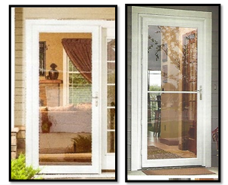

Swimming Pools and Hot Tubs
Below ground swimming pools are allowed provided lot size allows. Pools Must be approved by the ARC prior to construction. Above-ground pools are not allowed. Hot tubs must be approved by the ARC. Pools and Hot Tubs must have shrubbery screening since the permitted fences do not provide privacy.

a. Below ground swimming pools
1. Must fit within lot lines and setbacks.
2. Must include photo, location, any additional concrete, or lead walk.
3. Must have an approved fence installed prior to construction.
4. Must repair or replace any damaged landscape.

b. Hot tubs
1. Must include photo and location.
2. Must have a fence or screened in patio approved prior to construction and must be placed on back patio within roof line.
3. The size must not exceed the original size of patio at construction.
4. It is the homeowner’s responsibility to seek any required permits from City of Columbia, Spring Hill, White House, Gallatin, Murfreesboro, Franklin, etc.
5. Must repair or replace any damaged landscape.
See example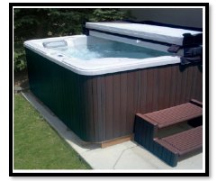

Tanks
Above or underground fuel storage tanks are not permitted (not including outside propane grill tanks).

Tents, Trailers, Temporary Structures and Outbuildings

No tent, utility, shed, shack, trailer, or other structure of temporary nature shall be placed upon a Lot or any part of the Community.

Outbuildings may be permitted if they meet the ARC Guidelines outlined in this paragraph. An ARC must be approved prior to commencement of construction. A building permit may be required. Outbuildings are enclosures that are not attached to the home such as sheds or enclosed storage units. All Outbuildings must match the residence on the lot with respect to color of siding, roof, and may not be made of metal. Flat roofs are not allowed. Outbuildings must be placed on a level base of concrete. Any outbuilding set on blocks must be bricked to grade using brick matching the residence.

Approved Outbuilding Criteria:

All outbuildings must meet the following criteria:
- Must be approved by the Board prior to installation.
- Must be installed by a licensed contractor
- Must meet/satisfy all building codes.
- Must be placed on a level concrete pad, installed by a licensed contractor (COI on file).
- Must Match the primary residence with respect to structure, color of siding and/or brick and roof shingles. Metal and/or flat roofs are not allowed.
- Must match primary residence door and framing color.

Note: All Outbuildings must be approved by the ARC. The following must be included in the ARC application packet and the homeowner must have the following approved prior to construction:
  - A completed application form, fee paid to the HOA.
  - A plot plan showing the placement of the shed.
  - A quote from the contractor.
  - Building Permit.
- Once the ARC has been approved, the HOA will notify the homeowner the application has been approved and construction may commence.

Trash
No Lot shall be used or maintained as a dumping ground for rubbish, trash, or other waste. All trash, garbage, and other waste shall be kept only in sanitary containers. All containers shall be kept within the garage or other ARC approved structures except during trash collection.

Garbage Enclosures
This enclosure guideline offers options for storage of up to two containers outside of the garage while still maintaining the intent of the CC&Rs. All enclosures require ARC approval. Options for outside storage are:
      - Within an ARC approved commercially available enclosure not visible from the street. Enclosures must match color scheme of the home.
      - Landscape Camouflage approved by ARC.
        - Must be placed on a level base of concrete/pavers.
        - Must use evergreen plant material, spaced 2-3’ apart.
        - Must repair or replace any damaged landscape resulting from installation of an enclosure.
      - On the side of the house (or in back of the house) completely behind and within an approved enclosure.
      - Minimum 15’ setback from front corner of the home.

Landscaping
Homeowners shall not remove, replace, or otherwise alter any landscaping in common areas. This includes plants directly in front of their unit. The ARC must approve all landscaping plans for all Property, including Lots. Vegetable and herb gardens are not allowed without written approval of the ARC.

Lawncare: Front Yards
Yards must be maintained so as not to degrade the appearance of the neighborhood. This includes but is not limited to:
- Over seeding or sodding to repair bare areas.
- Treatment of insects or diseases on trees, shrubs, and grass to prevent infestation of surrounding areas.
- Maintaining landscaping. This includes weeding and mulching, trimming and pruning, and replacing dead or diseased shrubs and trees. Lawns may not grow to more than the height stipulated by the City.

Artificial Vegetation, Exterior Sculpture, and Similar Items
No artificial vegetation shall be permitted on the exterior of any portion of any unit. Exterior sculptures, fountains, birdbaths, and similar items must be approved by the ARC.
- Exterior sculptures/statues: Cannot be over 24” tall. Must be made from ceramic, concrete, or metal material only. May only be a neutral or earth tone color. A maximum of three (3) sculptures are permitted per lot.
- Yard ornaments: Can be visible from street however, they cannot be positioned as a focal point. May be a maximum of 12” tall. Must be made from ceramic, concrete, or metal material only. May only be a neutral or earth tone color. A maximum of three (3) yard ornaments are permitted per lot.
- Fountains: Cannot be larger than 48”. Must be made from ceramic, concrete, or metal material. May only be neutral or earth tone color. Only one (1) fountain is permitted per lot and must be located in the back yard.
- Birdbaths: Cannot be larger than 48”. Must be made from ceramic, concrete, or metal material. May only be neutral or earth tone color. Only one (1) birdbath is permitted per lot and must be located in the back yard.
- Flower pots and planters: May be neutral colors or same colors included in the home’s color scheme. Should be within a landscaped area or on the porch, deck, or patio area.
- During the period in which the Declarant retains architectural control, alternative turf or groundcover shall not be permitted. Consideration of such requests may begin only after turnover and completion of all initial landscaping requirements.

Trees, Shrubs, and Bushes
Trees, shrubs, and bushes - must be trimmed and maintained. In addition, all trees, shrubs, and bushes bordering sidewalks, walkways, property lines, and common areas must be trimmed in such a fashion that they do not limit or impede access to these sidewalks, walkways, or common areas, or infringe on a neighboring property.

ARC Request forms must describe types and sizes (height, width, thickness, or diameter) of mature trees and shrubs. Trees and shrubs must not be placed in areas that block sidewalks, restrict drainage, or impede line of sight for vehicular traffic. Trees and shrubs that grow to a height that poses a threat to neighboring properties or have a root structure that interferes with utilities or could prove to be invasive to neighboring properties should be avoided. If the placement of trees or shrubs results in complaints from neighbors, the HOA may require the homeowner to remedy the problems.

Landscape improvement applications must include the type, growth, location, and photo of any additional flowers or plantings.
    - If you are installing a garden retaining wall, the type of material, height, width, photo, location, and drainage plan must be submitted with your ARC request. Any damaged landscape as a result of the installation of a retaining wall must be promptly repaired.
    - Vegetable and herb gardens: Must include the type, growth, location, and photo of any additional gardens. Garden must be no larger than 8’ by 8’ Garden must be located in the back yard. A maximum of two (2) vegetable or herb gardens are permitted per lot.
    - Raised gardens must be of natural wood and approved by the ARC. They must be placed in an area to be hidden from view as much as possible.
    - For corner lots must add landscape screening if installing garden boxes or other small improvements

- Suggested approved Tree Replacement
The following tree species are approved to replace trees in your yard. This is not an inclusive list. All other trees should be reviewed for height and canopy as well as invasiveness and susceptibility to disease.
    - American Hophornbeam (Ostrya Virginiana)
    - American Hornbeam (Caprinus Caroliniana)
    - Carolina Buckthorn (Rhamnus Caroliniana)
    - Dogwood (Cornus Florida) ‘Appalachian Joy’ cultivar
    - Hop Tree, Wafer Ash (Ptelea Trifoliata)
    - Redbud (Cercis Canadensis)
    - Sassafras (Sassafras albidum)
    - Sourwood (Oxydendrum Arboretum)
    - Japanese Maple (Acer Palmatum) - sun tolerant varieties
Patios/Decks
a.Each lot has unique topography, safety considerations, and orientation to other homes so walkways, decks, landings, stairways, or deck covers will be evaluated on a case by case basis.
b. ARC Request must include material, paint/stain samples, location, and size of patio/deck in relationship to the lot and house.
c. No flat roof lines are permitted. No solid metal roofs. Exterior lights on patios/balconies must include the style, color, location, and photo of the additional lights.

Screened in Patio
a. Frame/trim color must match home trim color.
b. It must contain one cross section.
c. It cannot be made of glass.
d. See example:
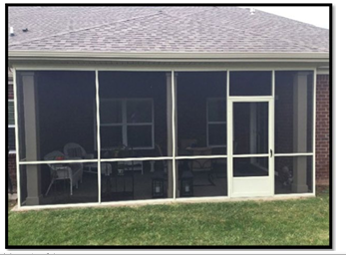

Motorized Screens
- The motorized mechanism must match the trim of the home.
- The screen must be black in color.
- The screen must cover each side of the patio.
- The shade may only be down when homeowner/guest are at the patio, otherwise the screen must be up.

Fine Policy
- Type I Fines:
Minor nuisance, Storage, Parking, Unsightly or Unkept Conditions, Trash Cans, Improper Landscaping, Lawn Maintenance, etc.:

• 1st Notice of violation: Courtesy notice/Fine notice (14 days to comply).
• 2nd Notice: 1st Fine Stage ($50.00) (14 days to comply).
• 3rd Notice: 2nd Fine Stage ($100.00) (14 days to comply).

Subsequent Notices: Lien and Legal charges will be assessed, and fines will continue to accrue at ($100.00) for each fourteen-day period.

- Type II Fines:
Additions/modifications to property or other construction with no prior ARC application approval or Board authorization:

• 1st Notice of violation: Courtesy notice/Fine notice (Construction – immediate stoppage of all construction or dirt movement within 24 hours of notice) and immediate and suspension of key fob access to pool and clubhouse, where applicable.
• 2nd Notice: 1st Fine Stage $100.00 (14 days to comply)
• 3rd Notice: 2nd Fine stage $100.00 each 14 days for each continued violation/infraction plus all legal fees. (Immediate lien for collection, if necessary)

Appeal Process
The Board has established a process to appeal fines.
● Write or e-mail the Management Company and explain the reason you would like appeal a fine.
● Your appeal must be received within 10 days of the notice of a fine being levied.
● If not appealed, you must correct the issue or compliance notices will continue to be escalated and additional fines levied in accordance with the HOA’s fine policy.
● The Board will review your appeal and deliver a final ruling.

