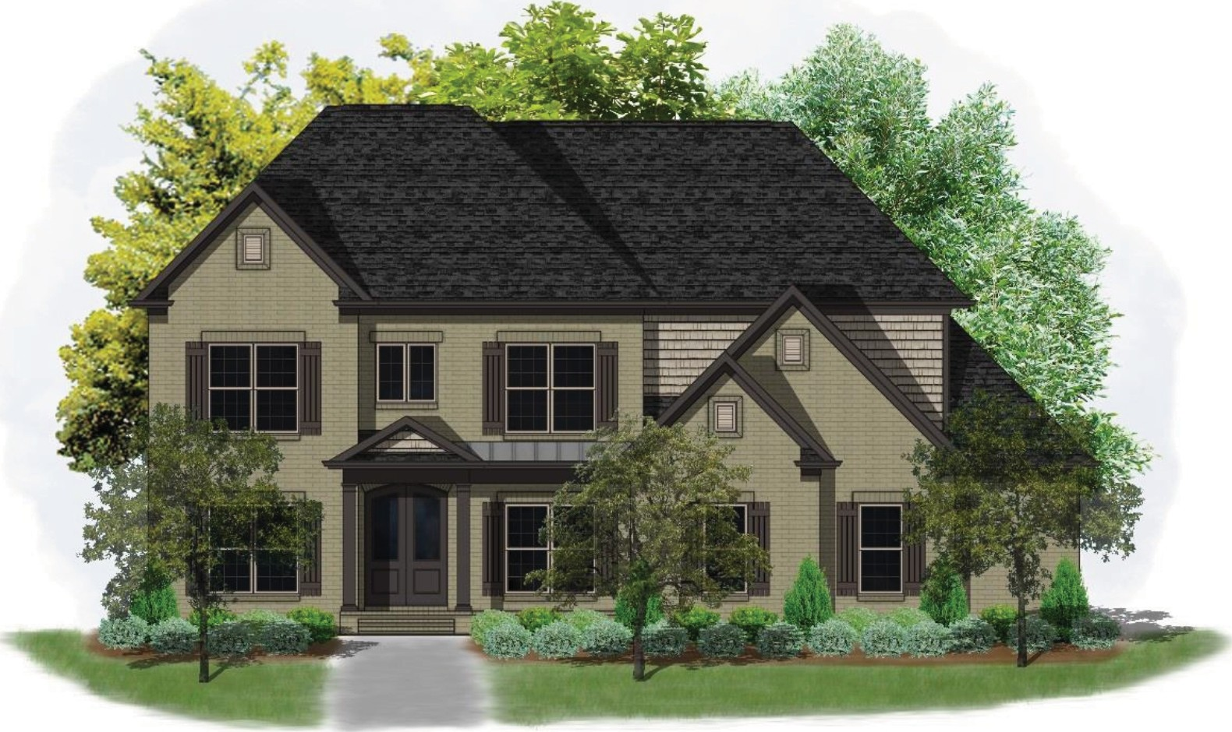

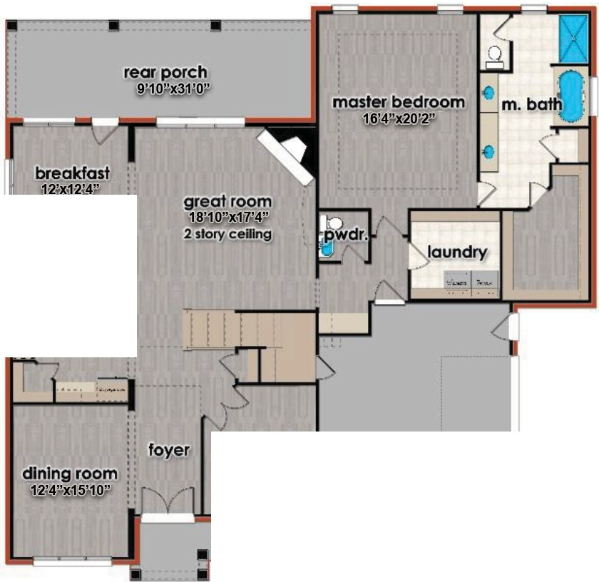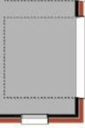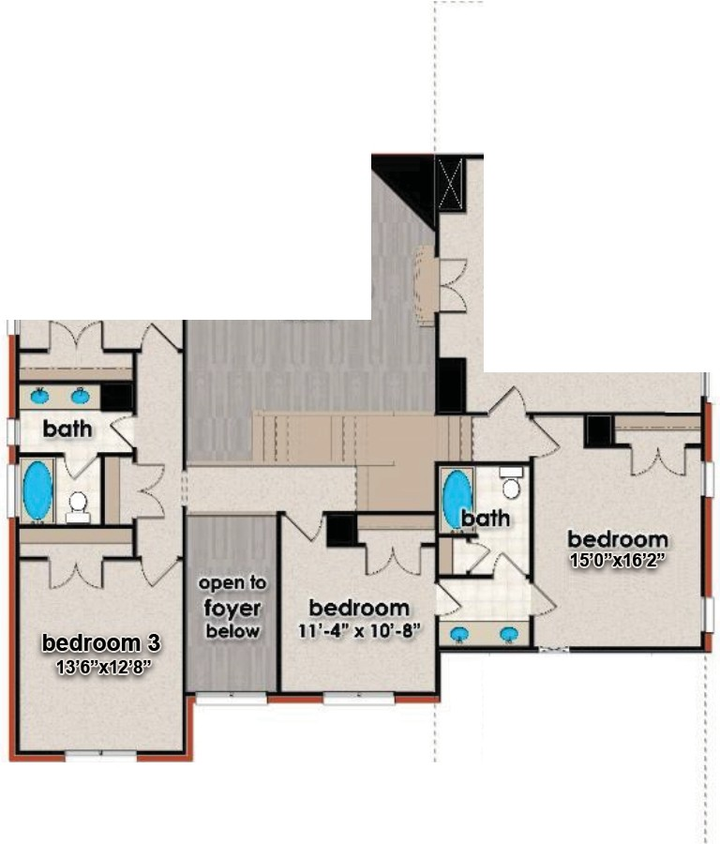1ronf r:Efevafion
·-; ,.k..lt.c,.□..uI
.I! '
study
i:&"x,1i3'6"
garage
2 .;.1;.;.x-33'3"
front porch
open to great room below
recreatton room
1.?J.9 ,!i1@g
storage

Main f.evef"ffoor Upper /:.eve("Ffoor
2.229J{ l.622Jf
for illustrative purposes only. design and prices are subject to change. reproduction without permission is prohibited.


3058 .f.eeman <ferry 1<.paa Suite(#
1-lunfsviffe, ;t1.k,6ama 35801
'Phone: 2.56.564.5960
We6sife: www,(1earsonhomesinc.com

