OHV Permit Process
If you are completing on a desktop
- Go to URL https://www.avimorapp.com/app#/home
- Sign into My Account or register a new account
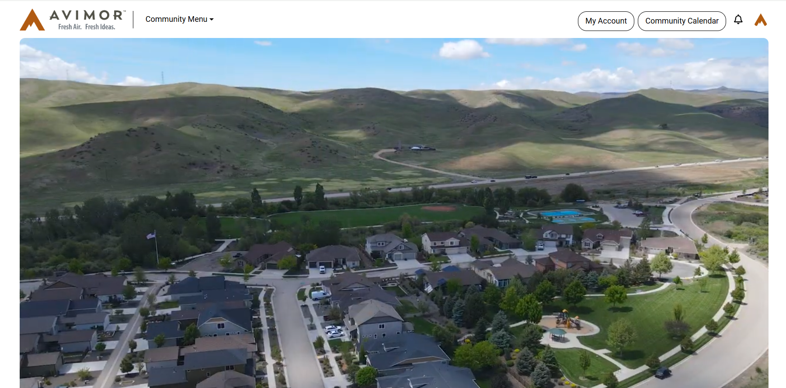

- Go to drop down menu in the left-hand corner

- Click Avimor OHV

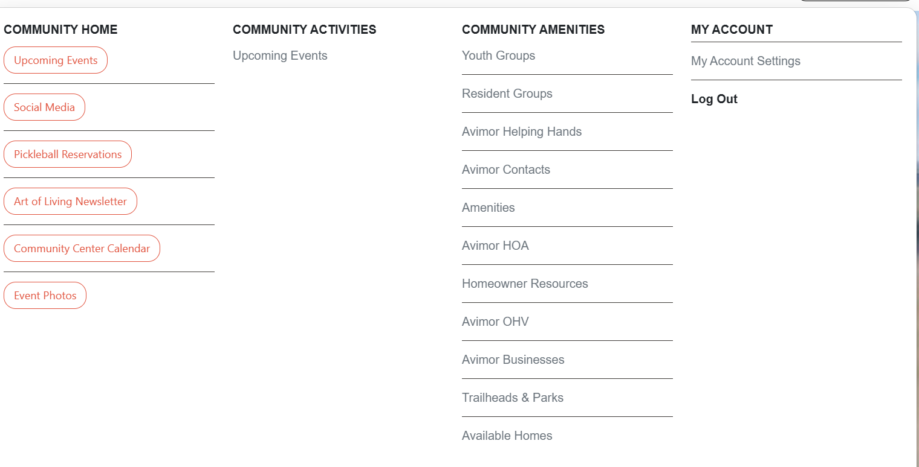

5. Click Avimor OHV permit Portal
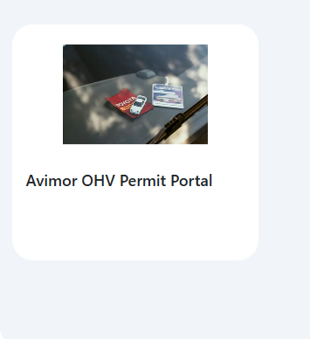
- Click sign in

- Click Sign up/ or Sign in to your account
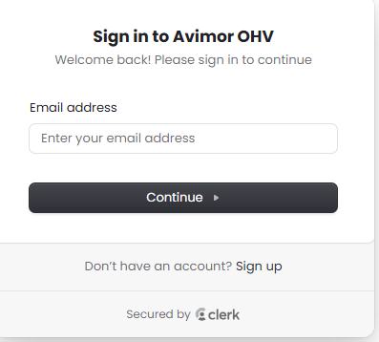

- Click Start a New Application button

- Click Start a New Application

- Fill out information
- Submit application
- Allow 48 hours for review of application
- Login to OHV account via the Avimor App.
- Check status

If you are completing on your phone open the Avimor App
- Login to your resident account
- Go to drop down menu in the left-hand corner
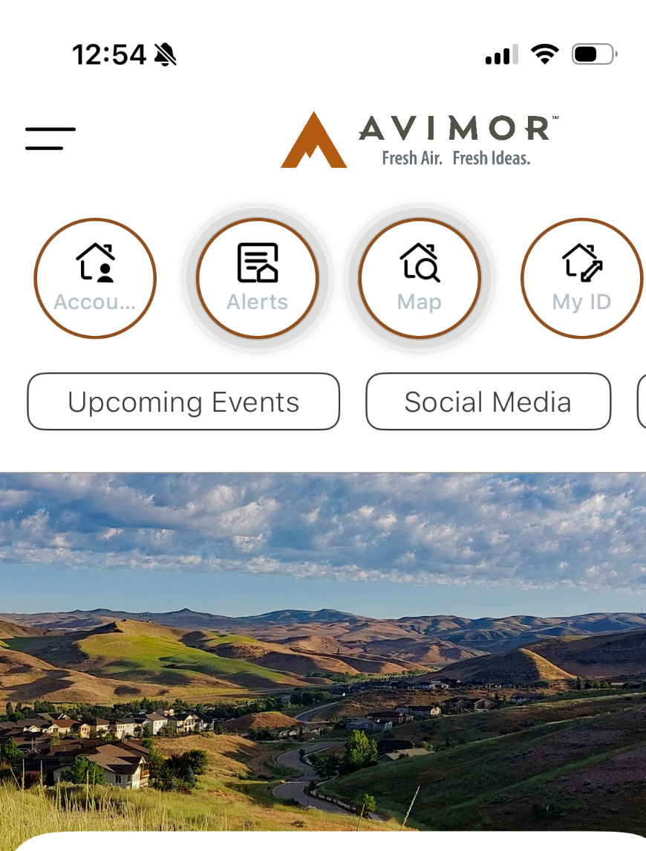
- Click Avimor OHV
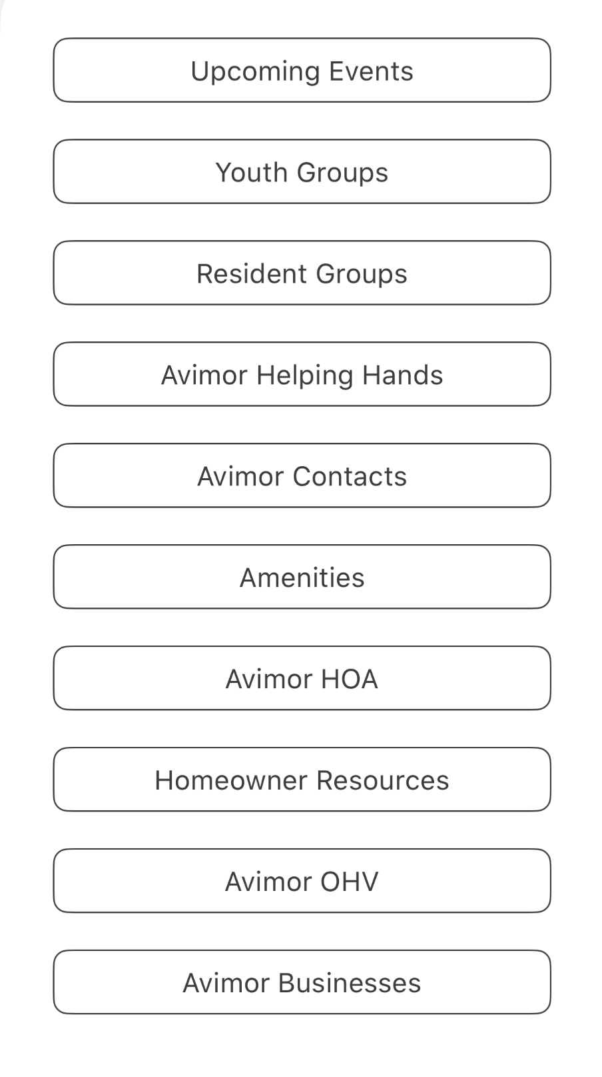

- Click Avimor OHV permit Portal
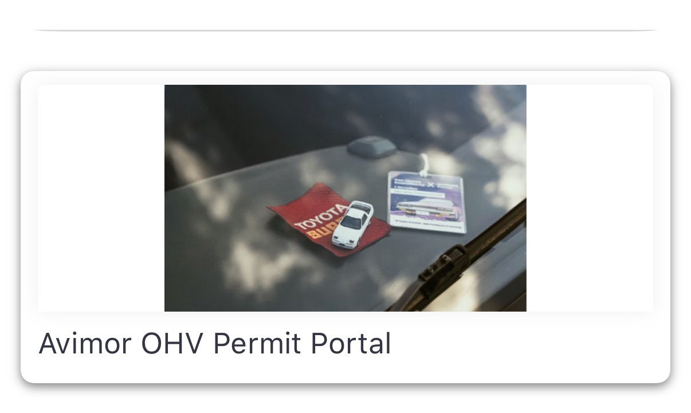
- Click sign up/ Sign into your account
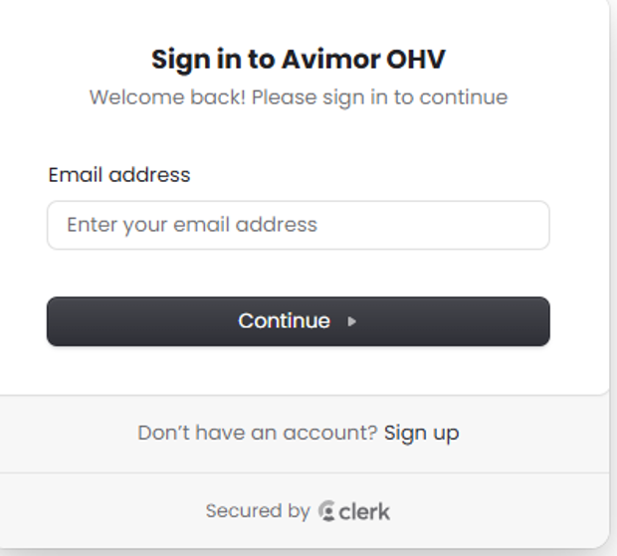

- Click Start Application

- Fill out information and submit
- Allow 48 hours for review of application
- Login to OHV account via the Avimor App.
- Check status

