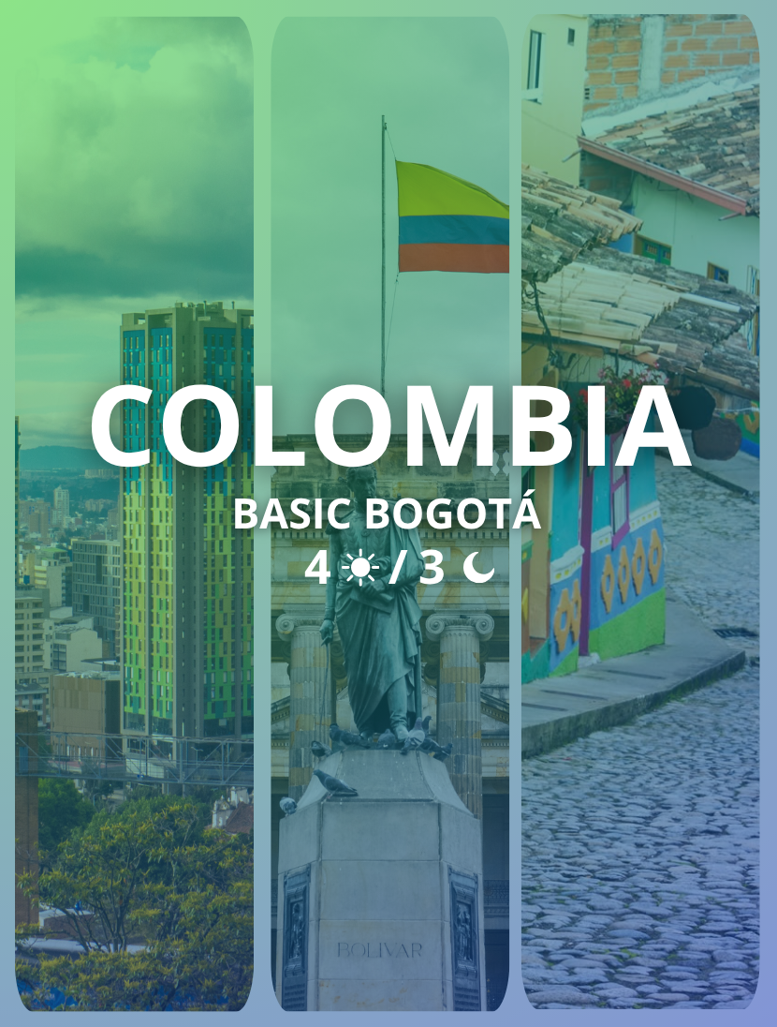

BASIC BOGOTÁ
Duration: 4 Days / 3 nigths

ITINERARY

Day 1: Arrival in Bogotá
Arrival in the city of Bogotá. Reception and transfer from the arrival point to the hotel. Check-in and the rest of the day at leisure for rest or personal activities. Accommodation in Bogotá.

Day 2: Panoramic City Tour Bogotá
Day dedicated to discovering the capital. During this experience, travelers will enjoy a tourist bus ticket to explore Bogotá, discover traditional and modern neighborhoods, learn about the city and access benefits such as discounts, souvenirs and courtesy coupons.
The panoramic bus allows passengers to hop on and off at key points around the city, accompanied by local experts. The complete route lasts approximately 4 to 4.5 hours, although it is recommended to get off at some stops to experience the city in a closer and more authentic way.
This experience connects the modern side of the capital with the colonial heart of the historic center in La Candelaria, offering a cultural immersion designed for travelers who want to discover Bogotá’s identity beyond the traditional route.
Accommodation in Bogotá.

Day 3: Free Day in Bogotá
Free day to enjoy the city at your own pace, rest or do personal activities. Accommodation in Bogotá.

Day 4: Departure from Bogotá
Check-out from the hotel. At the indicated time, departure transfer to the corresponding point to end the trip.

RATES
HOTEL CATEGORY | DOUBLE | TRIPLE | CHILD
Tourist | USD 235 | USD 205 | USD 95
Additional night | USD 55 | USD 49 | -
Superior Tourist | USD 275 | USD 220 | USD 95
Additional night | USD 50 | USD 40 | -
First Class | USD 325 | USD 259 | USD 95
Additional night | USD 69 | USD 55 | -
Rates are per person and subject to change and availability.

ACCOMMODATION
HOTELS | REFERENCE PHOTOS
ONE SIXTEEN | 
CHICO 97 | 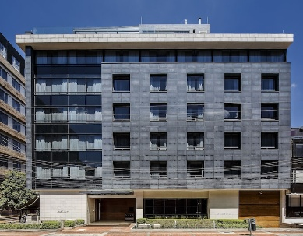
HOLIDAY INN BOGOTA - PARQUE DE LA 93 | 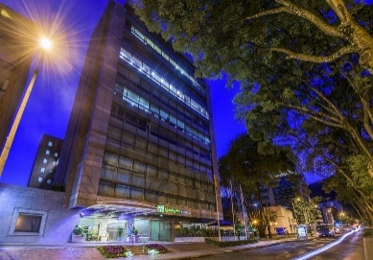

INCLUDES
- 3 nights of accommodation in a hotel with a privileged location.
- 3 breakfasts.
- All transfers mentioned.
- Tour with accompanying guide for 8 hours. (Professional guide supplement: USD 55).
- 24/7 assistance in Spanish during the trip.
- Entrance fees and visits according to the itinerary.

DOES NOT INCLUDE
- Personal expenses.
- Optional excursions.
- Lunches.
- Any service not specified.

