
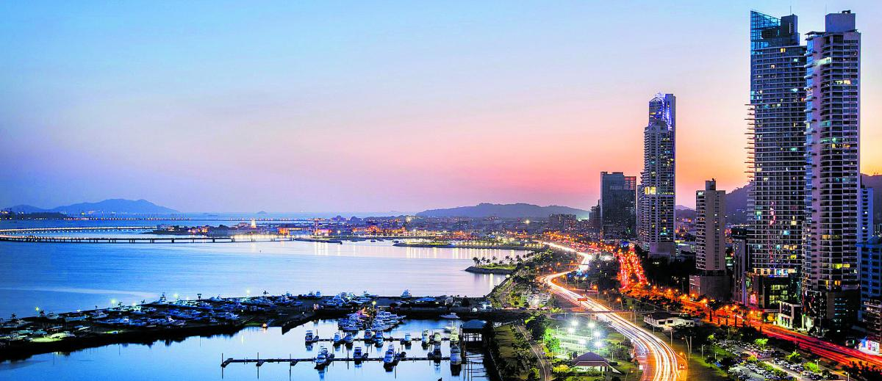

Panama City is a vibrant blend of modern skyscrapers and historic charm, offering a unique destination for tourists. Visitors can explore the famous Panama Canal, stroll through the colorful Casco Viejo district, and enjoy diverse cuisine. The city is also a shopper’s paradise, with luxury malls, artisan markets, and duty-free shops. Whether you’re interested in culture, history, or shopping, Panama City provides an exciting and memorable experience for every traveler.

Stop Over Panama Tourism

Itinerary
Day 1: Arrival in Panama City. Meet & Greet and transfer to the selected hotel.
Day 2: Breakfast. At the appointed time, city tour and Canal visit with lunch, ending at Albrook Mall or near your hotel.
Day 3: Breakfast. At the appointed time, transfer to La Rana Dorada for a craft beer tasting and a delicious appetizer.
Day 4: Breakfast. Free day to enjoy activities at your own pace.
Day 5: Breakfast. Free morning until the appointed time for your transfer to the airport for departure.

Prices are per person in US dollars.
Prices are subject to change without notice.

HOTELS PLANNED or similar | CATG | DBL
Aloft | 3* | 390
Las Americas Golden Tower | 4* | 435
Marriott Panama | 4* | 487
W Panama | 5* | 617

Includes:
- Transfer Airport/Hotel/Airport
- 4 Nights
- Breakfast
- City Tour +visit canal + Albrook Mall
- Visit Rana Dorada Brewery with beer tasting
- Travel assistance insurance with 40k coverage

Not included:
- Airfare to/from Panama (please consult price)
- Unspecified expenses

