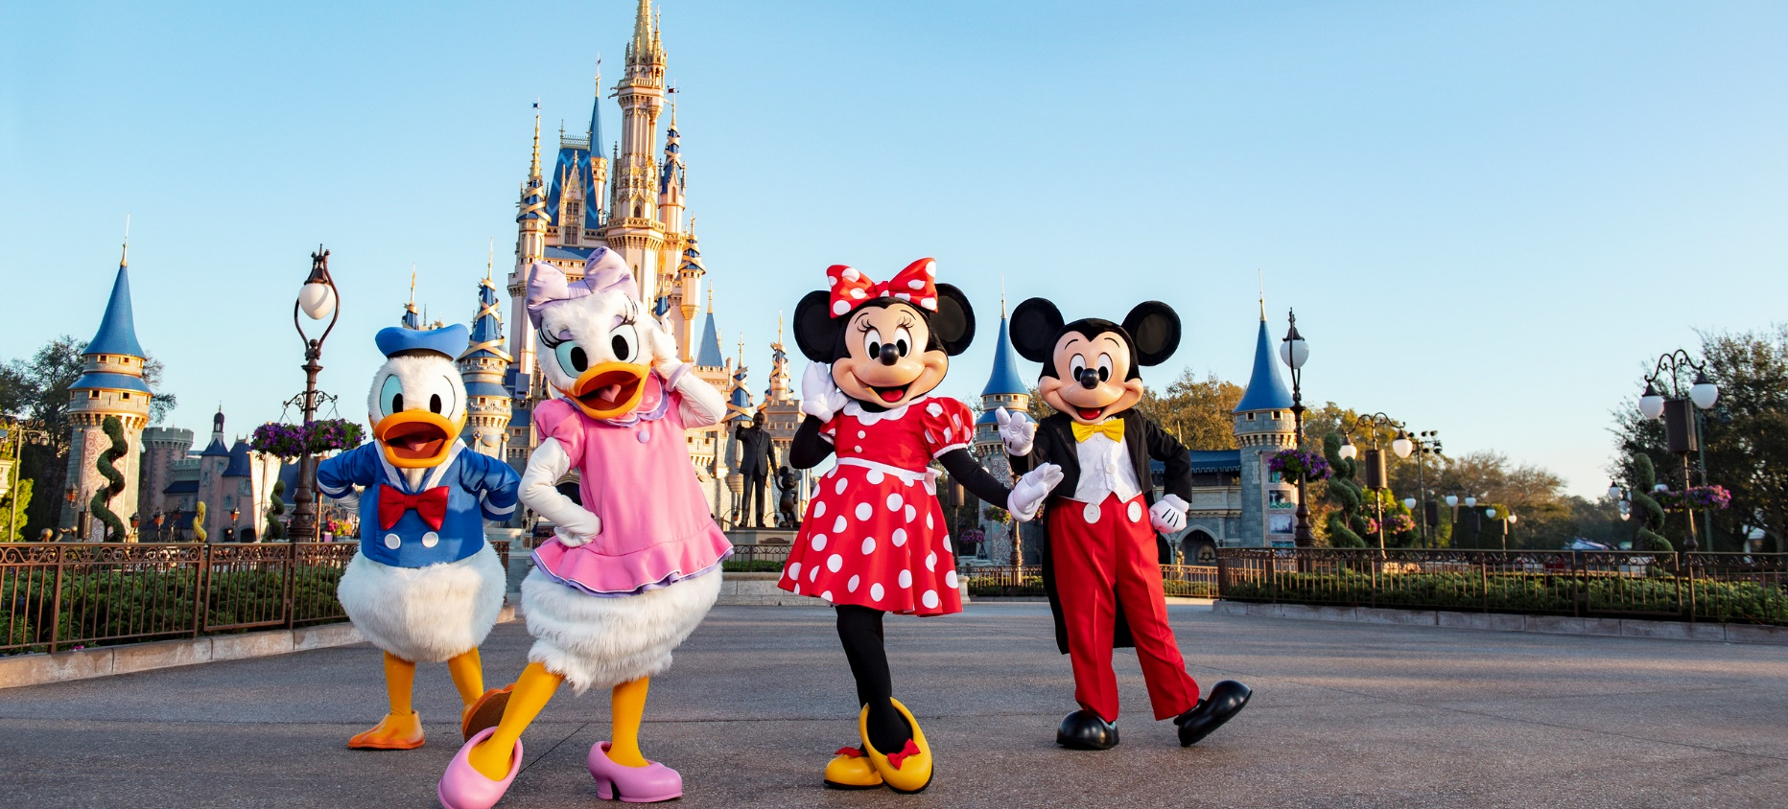


Walt Disney World Resort

Guaranteed Group Departure: Available Dates

Jul 25 to Aug 01 2026 | Aug 01 to Aug 08 2026 | Aug 08 to Aug 15 2026
BOOK BY JUNE 12, 2026

Price per person in USD
Program valid for a minimum of 2 passengers traveling together
Hotel of choice or similar | DBL | TPL | CUA | CHD
City Express by Marriott Orlando International Drive | 2194  $ | 2012  $ | 1911  $ | 1554  $

THE PROGRAM INCLUDES
- Accommodation for 7 nights
- Meals
  - Breakfast included every day.
  - Dinners included during the program.
- Included parks: admission to 5 theme parks:
  - Magic Kingdom
  - Animal Kingdom
  - EPCOT
  - Hollywood Studios
  - SeaWorld Orlando
- Additional experiences included
  - Shopping day at Premium Outlets.
  - Visit to Disney Springs with dinner at Planet Hollywood.
  - All Day Dining at SeaWorld.
  - Transportation and assistance
- All transfers during the program.
- Coordination and assistance throughout the entire experience.
- Traveler Assistance Insurance with $50,000 coverage

THE PROGRAM DOES NOT INCLUDE:
- Meals not described
- Domestic and international airfare.
- Expenses not described
- Tips

IMPORTANT CONDITIONS:
- Program valid for a minimum of 2 passengers traveling together.
- Group departure with limited spots and guaranteed dates.
- Rates subject to change without prior notice.
- Rates subject to availability.
- Child rates apply for ages between 3 and 9 years sharing a room with at least two adults.
- Prices expressed in USD per person.

