Quito Andino & Cultural
4Days /3Nights

Highlights
We will discover through the Andes Mountains majestic landscapes, volcanoes, diversity of fauna and flora. Ingapirca, the most important pre-Columbian archaeological site in Ecuador.

Detailed Itinerary

1.- Quito
Arrival at Quito's Mariscal Sucre Airport.
Private transfer from the airport to the centrally located hotel, with easy access to restaurants, bars, craft shops, and parks. On this first day, passengers will have time to explore on their own and start the discovery of this beautiful city. Quito is located at 2,800 meters above sea level, so we advise you to relax and prepare for the adventure that awaits you on this first day.
.

2.- Quito – City Tour Quito - Middle of the World
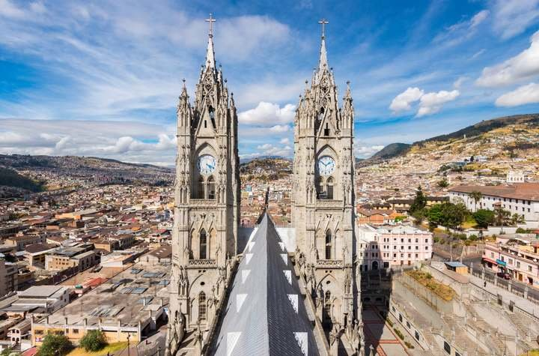
Breakfast at the hotel. Transfer to the historic center of the city of Quito, the largest and best preserved in Latin America. The first stop will be the Church of the Basilica of the National Vow, well known for its neo-Gothic style, with gargoyles and Ecuadorian fauna among its ornaments. We will continue the visit to the Plaza de la Independencia or Plaza Mayor, which is surrounded by the Presidential Palace, the Archbishop's Palace, the municipal building and the emblematic Church of the Metropolitan Cathedral.
Our next stop will be the Church of the Company, whose interior is decorated and made with gold leaf. We will visit the open square of San Francisco and its monumental Church and convent, known as El Escorial de los Andes, built in the 16th century by the indigenous people of the School of San Andrés.
Passengers will enjoy lunch at a haute cuisine restaurant located in the Historic Center.
We will continue to El Panecillo, a hill crowned by the winged Virgin of Quito from where we have a beautiful view of the city and the impressive Andean landscape.

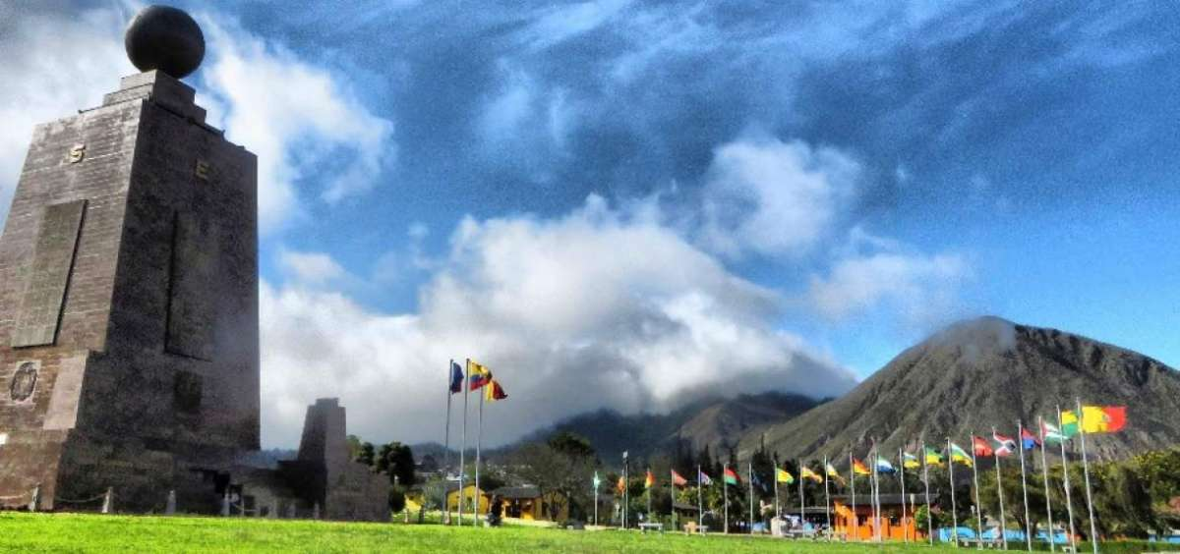
In the afternoon we continue the tour to the Middle of the World, located 22 km north of the city of Quito where the equator line is located. This location was determined in the 18th century by the French Geodesic Mission together with Spanish and Ecuadorian geographers. We will live the experience of standing in the two hemispheres and visiting the Intiñán museum, to carry out a series of dynamic experiments that confirm the location of the equator. At the end of the afternoon return to the hotel

3.- Quito – Cotopaxi National Park
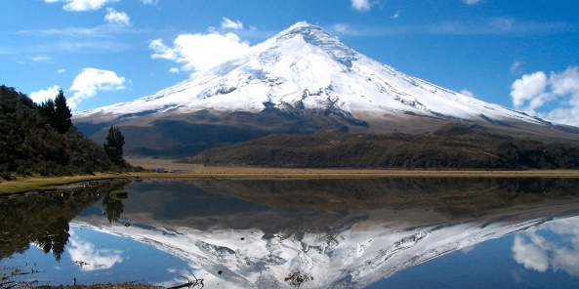
Breakfast at the hotel. Then, we will leave the city of Quito taking the Pan-American Highway to the south and after two hours of travel we will arrive at a rose plantation, where we will take a tour to learn about its cultivation and its export process
Then we will head to the Cotopaxi National Park, the Cotopaxi volcano is the second highest summit in Ecuador at 5,897 m.a.s.l., an active volcano, conical in shape, with snow on its top and surrounded by beautiful Andean paramo vegetation.
The visit begins with the registration of travelers at the southern control point of the National Park, and then we move to the interpretation center to learn about the fauna and flora of the area and general information about the volcano and the Andes Mountain range. After this stop, we will take a walk of approximately 1 hour, around the Limpiopungo lagoon, an ideal place to admire the majestic volcano and take beautiful photographs. Optionally, it is possible to go in the vehicle to the parking lot of the José Rivas mountain refuge, and from that point walk 200 meters to reach the refuge that is used as a base point by hikers who ascend to the top of the volcano. The parking lot is located at 4,600 meters above sea level. Passengers will enjoy lunch observing the Cotopaxi volcano, from the only hotel located inside the National Park. At the end of the day, we will head towards the hotel.

4.- Quito
Breakfast and Transfer from the hotel to Mariscal Sucre Airport, to take the international flight back home or continue with your connections in Ecuador.

PRICES PER PERSON
IN US DOLLARS

CATG | Hotels | DBL | TPL | CUA
Tourist Sup | Hotel Finlandia | 761 | 759 | 639
First | Dann Carlton | 901 | 899 | 779
First Sup | Go Quito Hotel | 935 | 932 | 811

Program Includes:
- Private transportation during transfers and excursions. Tours with 1-3 passengers are conducted with a driver-guide.
- Bilingual guide (Spanish and English) during transfers and excursions. Tours with 1-3 passengers are conducted with a driver-guide
- Accommodation at selected hotel
- Meals as detailed in the itinerary
- Visits as described in the itinerary
- Entrance fees to the visit sites detailed in the itinerary
- Taxes

Programs Do Not Include:
- National or international airfare
- Feeding not mentioned
- Alcoholic beverages during lunch or dinner
- Tours and activities not specified
- Tips and additional expenses

General Conditions
- All rates are in US dollars and per person.
- Rates apply throughout 2025 except on Ecuadorian holidays.
- Tours for 1 to 3 passengers are operated with a guide-driver; In the event that a different service is required, a supplement must be requested at an additional cost.
- Nights in the hotels indicated on the itineraries include breakfast and taxes.
- If local taxes change, rates will be updated.

Holidays
- April 18
- May 1-23
- August 11
- October 10
- November 3-4
- December 25

