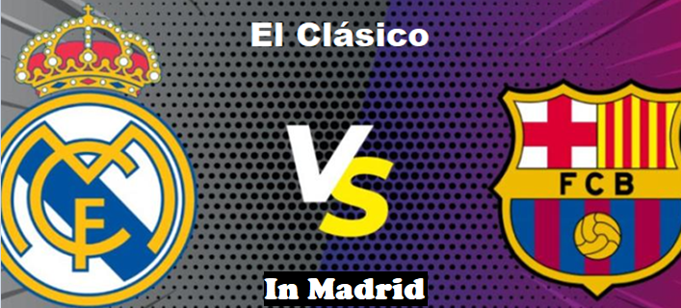From October 24th to 27th

El Clásico between Real Madrid and FC Barcelona, ​​scheduled for October 26, 2025, promises to be an exciting clash filled with rivalry and passion. Both teams, with a rich history in world football, will face off in a duel that will not only determine supremacy in La Liga but also attract the attention of millions of fans around the world. The vibrant atmosphere, the stars on the pitch, and the intense competition are the essence of this legendary football clash.

Prices Per person in a Double room
in American dollars
Category 3
From: $2229
Category 2
From: $2669
Category 1
From: $3109

PROGRAM INCLUDES
- Private airport-hotel-airport transfers
- 3-night accommodation with breakfast in a 4-star hotel.
- Travel assistance insurance.
- Admission to the game at the Santiago Bernabeu Stadium

PROGRAM NOT INCLUDED
- Domestic or international airline tickets
- Meals not described,
- Tips and expenses not specified.

Inventory and prices are subject to change. To guarantee these options, reserve today!
Important: Below are the terms and conditions, which are important to share with the customer. By continuing with the purchase, they are agreeing to these terms.

IMPORTANT
- Rate in USD. Per person.
- Rate subject to availability and changes at the time of booking.
- Ticket prices may change at any time depending on supply and demand.
- This is a quote; it does not imply a reservation.
- Tickets are digital, and guests must download the app indicated at the time of booking.
- For physical or digital tickets, the price shown is not binding on the retail price, as it includes handling, shipping/delivery, and taxes. The customer accepts and consents to this purchase, knowing that the aforementioned price is not subject to any claims. The price we provide includes handling, taxes, processing, and shipping fees.
- The name that appears on event tickets, both physical and electronic, may be different from the person who purchased the ticket (for the vast majority of events, bulk ticket purchases are made under a single name, so all tickets bear the same name: the name provided for the bulk purchase, not the name of the customer who ultimately purchases the ticket).
- The established categories according to our sales plan will always be honored, and may differ from those established by the event organizer. Customers are purchasing stadium seating based on the categories established by our vendor, which may or may not coincide with the category printed on the ticket.
- All sales are final. We cannot offer refunds for rescheduled events unless the artist, team, or venue cancels the event entirely, or state law directly stipulates otherwise.
- All ticket sales are final - NO EXCHANGES OR REFUNDS ALLOWED.
- Payment must be 100%

