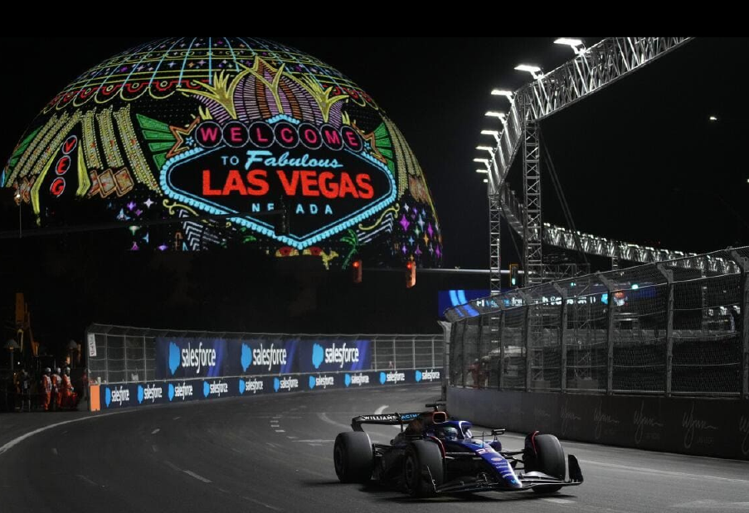
Las Vegas Grand Prix
5 days / 4 nights

Formula 1
LAS VEGAS, NV
November 20, 21 and 22

FORMULA 1 HEINEKEN SILVER - LAS VEGAS GRAND PRIX 2025

🏁 Get ready for 3 days of pure adrenaline in the heart of Las Vegas!🏙️🔥
From November 20-22, the asphalt of the iconic Las Vegas Strip becomes a battlefield where speed, strategy, and spectacle merge like never before.

✨ Thursday 20th – The excitement kicks off with the first free practice sessions: feel the city vibrate with the roar of the engines.

🚀 Friday 21st – Everything intensifies: the drivers fine-tune their machines in the final practice session and go all out in a mind-blowing night qualifying session.

🏆 Saturday 22 – The big day! Lights, action, and top-notch speed in a race that will tour the Strip's most iconic locations. F1 takes over Las Vegas
.
🎉 In addition to the races, enjoy exclusive parties, interactive activations, and a completely transformed city for a unique experience.

💥 Are you ready to be part of the most exciting Grand Prix on the calendar?
Don't just watch it... live it. 👉 Let's go to Las Vegas!

Map of the racetrack
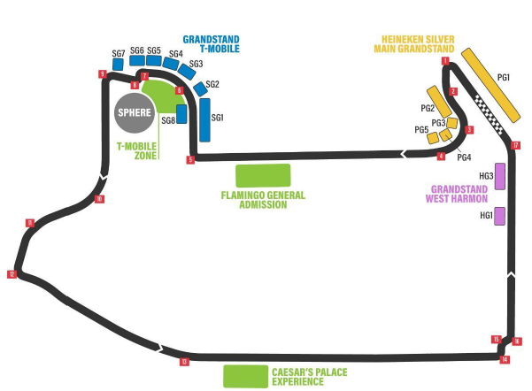

FORMULA 1 HEINEKEN SILVER PACKAGE - LAS VEGAS GRAND PRIX 2025
5 days / 4 nights
November 19-23, 2025

Included Services
- Arrival transfer from LAS Airport to Hotel. Private service.
- 4-night accommodation in Las Vegas at the selected hotel.
- 3-day admission to the 2025 Formula 1 Las Vegas Grand Prix : Lewis Hamilton Grandstand "West Harmon Zone" category, lower or upper row.
- Departure transfer from Hotel to LAS Airport. Private service.
- Travel assistance insurance

Services Not Included
- International or domestic airfare.
- Breakfast or any type of meal.
- Hotel-track-to-hotel transfers on all 3 race days. For hotels located on the Strip, transportation to the event will not be required, as the racetrack will be located on-site.
- Resort Fee for hotels that charge a resort fee. Mandatory payment by passengers at the selected hotel.
- Any service not listed.

4-NIGHT LAS VEGAS PACKAGE

HOTEL | SGL | DBL | TPL
Luxor Hotel and Casino 3* | 2915 | 2287 | 2073
The LINQ Hotel + Experience 4* | 3103 | 2368 | 2154
Flamingo Las Vegas 3* | 3076 | 2395 | 2189
Park MGM Las Vegas 4* | 3534 | 2644 | 2318
The Venetian Las Vegas 5* | 5350 | 3518 | 3012
Bellagio 5* | 5646 | 3639 | 3055
Prices per person in US dollars

ITINERARY

November 19: Arrival in Las Vegas
Arrival at Las Vegas International Airport and transfer to your selected hotel.

November 20: Las Vegas
Departure at your own expense to the Las Vegas Grand Prix Circuit for your ticket to Formula 1 Las Vegas 2024 - Practice:
4:30 PM - 5:30 PM: Practice 1. Formula 1 Las Vegas Grand Prix 2025
8:00 PM - 9:00 PM: Practice 2. Formula 1 Las Vegas Grand Prix 2025

November 21: Las Vegas
Departure at your own expense to the Las Vegas Grand Prix Circuit for your ticket to Formula 1 Las Vegas 2024 - Qualifying:
4:30 PM - 5:30 PM: Practice 3. Formula 1 Las Vegas Grand Prix 2025
8:00 PM - 9:00 PM: Qualifying. Formula 1 Las Vegas Grand Prix 2025

November 22: Las Vegas
Passenger-owned departure to the Las Vegas Grand Prix Circuit for admission to the Formula 1 Las Vegas 2024 Grand Prix:
8:00 PM: Race. Formula 1 Las Vegas Grand Prix 2025
*All times are PST and subject to change.

November 23: Las Vegas
At the scheduled time, transfer to Las Vegas International Airport.
End of Services
Category Change Supplements

Category | Section | Row | Price Per Pax
Lewis Hamilton  Grandstand | HG2102 - HG2106 | Middle | 94
Turn 3 | TG3101 - TG3104 | Lower or Upper | 525
Grandstand | TG4101 - TG4104 | Middle | 632
 | SG1101 – SG1114 | Lower or Upper | 612
T-Mobile  Grandstands | SG4101 - SG4104  SG5101 - SG5104  SG6101 - SG6106  SG7101 - SG7104 | Middle | 760
Heineken® Silver | PG1101 - PG1115 | Lower or Upper | 1655
Main Grandstand |  | Middle | 1796
Prices per person in US dollars

Descripción De Categorías

1. Lewis Hamilton Grandstand
Attendees in the Lewis Hamilton Grandstand will witness the drivers accelerate down the Harmon Straight and through the braking zone before the final corner and the finish line. All of this will be accompanied by the vibrant atmosphere of the West Harmon area, with interactive fan activations and entertainment..

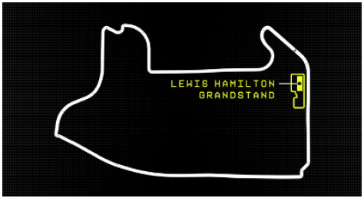
Includes:
- 3-Day Ticket: Valid for Thursday, Friday, and Saturday.
- Assigned Seating: Located in the West Harmon area.
- Access to all on-track sessions: Includes F1® and F1 ACADEMY™ sessions.
- Fan Zone: Interactive fan activations in the West Harmon area.
2. Turn 3 Grandstand
The Turn 3 grandstands offer up-close views as the drivers push their skills to the limit through Turns 3 and 4, before accelerating through the DRS zone on the Koval Straight. Enjoy the race from the largest fan area on the circuit.

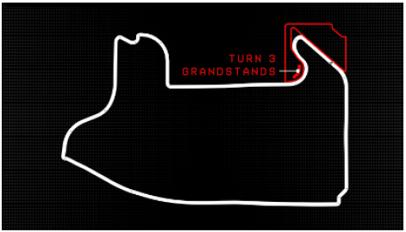

Includes:
- 3-Day Ticket: Valid for Thursday, Friday, and Saturday.
- Assigned Seating: Located in the East Harmon Zone by Virgin Hotels Las Vegas
- Access to all on-track sessions: Includes F1® and F1 ACADEMY™ sessions.
- Fan Zone: Interactive fan activations in the East Harmon Zone by Virgin Hotels Las Vegas and the Koval Zone by Heineken®
- Heineken® Silver Stage: Live entertainment and driver interviews throughout the weekend.
- F1 Academy Paddock View: Privileged access for an up-close look at the F1 ACADEMY paddock and garages, located in the Koval Zone by Heineken®

3. T-Mobile Grandstands
The biggest F1 party on track! Enjoy top-level performances, fan activations, and spectacular views of the circuit's most challenging points..
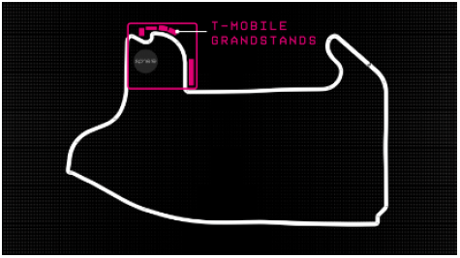
Includes:
- 3-Day Ticket: Valid for Thursday, Friday, and Saturday.
- Assigned Seating: Located in the T-Mobile Zone at Sphere.
- Access to all trackside sessions: Includes F1® and F1 ACADEMY™ sessions.
- T-Mobile Stage: Live performances with top-level artists and entertainment.
- Fan Zone: Interactive fan activations in the T-Mobile Zone at Sphere.

4. Heineken® Silver Main Grandstand
Get a front-row seat to the start-finish action and watch the drivers battle it out from the start line to the checkered flag! Enjoy pit lane views, F1 simulators, pit stop challenges, and much more.

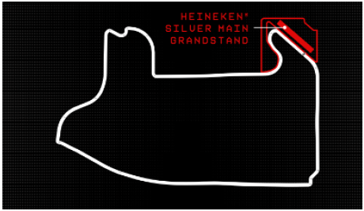

Includes:
- 3-Day Ticket: Valid for Thursday, Friday, and Saturday.
- Assigned Seating: Located in the East Harmon Zone by Virgin Hotels Las Vegas
- Access to all on-track sessions: Includes F1® and F1 ACADEMY™ sessions.
- Fan Zone: Interactive fan activations in the East Harmon Zone by Virgin Hotels Las Vegas and the Koval Zone by Heineken®
- Heineken® Silver Stage: Live entertainment and driver interviews throughout the weekend
- F1 Academy Paddock View: Get up close and personal with the F1 ACADEMY paddock and garages, located in the Koval Zone by Heineken®

IMPORTANT NOTES:
- Rates per person in US dollars.
- Rates subject to availability and subject to change without notice.
- This is only a quote; none of the services described are blocked or reserved.
- Please confirm price and availability before receiving money from the customer.
- Admission prices may change at any time based on supply and demand.
- Check-in requires guests to be 21 or older and the reservation holder must present a credit card.
- Most US hotels charge a mandatory "Resort Fee," which must be paid by the guest directly to the hotel upon check-in (approximately USD 42 to USD 60 per room, per night).
- Hotels require mandatory deposits at check-in, in cash or by credit card, to cover incidental charges (approximately USD 50 to USD 150 per room, per night).
- FORMULA 1 Entries are non-refundable.
- Accommodation Fees are non-refundable.
- Dates and times are subject to change at the discretion of the F1 organizers.
- Tickets are mobile. Screenshots or PDFs will not be accepted at the ticket office.
- Tickets will be transferred via the app indicated at the time of booking. To transfer tickets via the app, we require the first name, last name, nationality, and email address of the lead passenger.
- LUGGAGE ALLOWANCE: 1 BRIEFCASE (23 KG) + HAND BAG (Non-Carry-On)
- Private transportation charges will apply if the contracted service hours are exceeded.
- A surcharge applies for night transfers to/from the airport between 9:00 PM and 6:00 AM.

CONDITIONS OF SALE
- Rates are subject to modification and change without prior notice. Bulafo.com and the destination provider are not responsible for the cancellation and/or change of event date. Reservations are confirmed upon full payment. Reservations are non-refundable, with a 100% penalty. Rescheduling the event due to force majeure by the organization does not warrant a refund.
- All sales are final, irrevocable, and definitive. Once access has been confirmed, managed, and paid for with the providers or organizers, there are no changes, cancellations, or refunds under any circumstances. This includes if any country imposes travel restrictions on citizens of certain nationalities for health or other reasons.
- Clients are responsible for being aware of and complying with the immigration and health requirements imposed by each government and organizer for entry into the country and attendance at the event, such as the use of masks, laboratory tests, vaccinations, health cards, etc. Lack of knowledge of these terms or the customer's inability to comply with them shall not constitute grounds for refund or cancellation of the purchase.
- In the event that the event is postponed or the date or time is changed by the event organizers, tickets will be valid for the new confirmed date and time without refund. This includes ancillary services, upgrades, and parking passes.
- In the event of a permanent cancellation of the event, a full refund will be issued within the timeframe established by the event provider or organizer, subject to Bilafo.com receiving a corresponding refund from said provider. In the event that Bulafo.com does not receive a refund from its providers, we regret to inform you that we will not be able to issue refunds to customers. We appreciate your understanding.
- Advance Shipments: If Bulafo.com receives the tickets before the stipulated deadline, they will be sent to the customer in advance. However, shipping and delivery are subject to arrival within three hours of the event.
- Please provide the following information, a copy of your passport, and your contact phone number when making your reservation.

