Ecuador Continental & Galapagos
8Days /7Nights
Highlights
We will discover through the Andes Mountains majestic landscapes, volcanoes, diversity of fauna and flora. Ingapirca, the most important pre-Columbian archaeological site in Ecuador

Detailed Itinerary
1.- Quito
Arrival at Quito's Mariscal Sucre Airport.
Private transfer from the airport to the centrally located hotel, with easy access to restaurants, bars, craft shops, and parks. On this first day, passengers will have time to explore on their own and start the discovery of this beautiful city. Quito is located at 2,800 meters above sea level, so we advise you to relax and prepare for the adventure that awaits you on this first day.
.
2.- Quito – City Tour Quito - Middle of the World
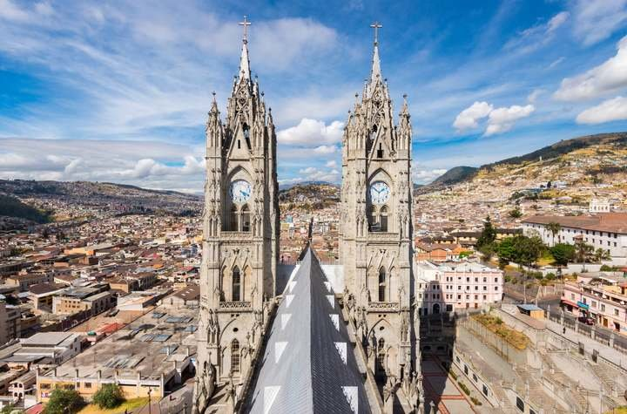
Breakfast at the hotel. Transfer to the historic center of the city of Quito, the largest and best preserved in Latin America. The first stop will be the Church of the Basilica of the National Vow, well known for its neo-Gothic style, with gargoyles and Ecuadorian fauna among its ornaments. We will continue the visit to the Plaza de la Independencia or Plaza Mayor, which is surrounded by the Presidential Palace, the Archbishop's Palace, the municipal building and the emblematic Church of the Metropolitan Cathedral.
Our next stop will be the Church of the Company, whose interior is decorated and made with gold leaf. We will visit the open square of San Francisco and its monumental Church and convent, known as El Escorial de los Andes, built in the 16th century by the indigenous people of the School of San Andrés. Passengers will enjoy lunch at a haute cuisine restaurant located in the Historic Center.
We will continue to El Panecillo, a hill crowned by the winged Virgin of Quito from where we have a beautiful view of the city and the impressive Andean landscape.

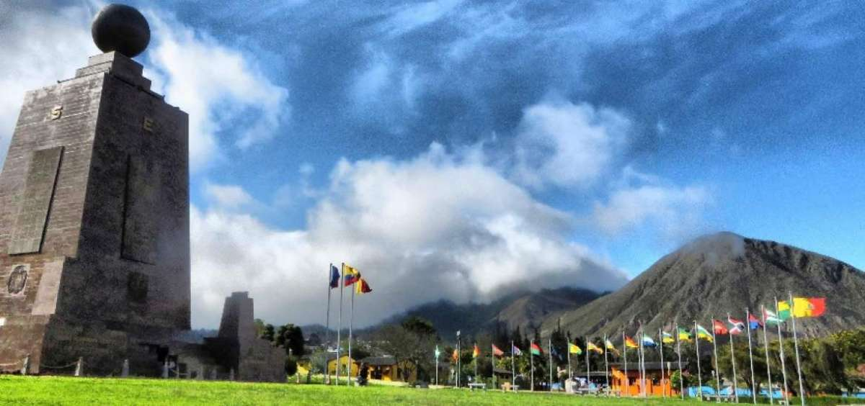
In the afternoon we continue the tour to the Middle of the World, located 22 km north of the city of Quito where the equator line is located. This location was determined in the 18th century by the French Geodesic Mission together with Spanish and Ecuadorian geographers. We will live the experience of standing in the two hemispheres and visiting the Intiñán museum, to carry out a series of dynamic experiments that confirm the location of the equator. At the end of the afternoon return to the hotel

3.- Quito – Cotopaxi National Park
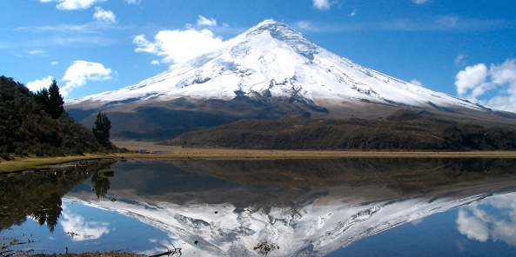
Breakfast at the hotel. Then, we will leave the city of Quito taking the Pan-American Highway to the south and after two hours of travel we will arrive at a rose plantation, where we will take a tour to learn about its cultivation and its export process. Then we will head to the Cotopaxi National Park, the Cotopaxi volcano is the second highest summit in Ecuador at 5,897 m.a.s.l., an active volcano, conical in shape, with snow on its top and surrounded by beautiful Andean paramo vegetation. The visit begins with the registration of travelers at the southern control point of the National Park, and then we move to the interpretation center to learn about the fauna and flora of the area and general information about the volcano and the Andes Mountain range. After this stop, we will take a walk of approximately 1 hour, around the Limpiopungo lagoon, an ideal place to admire the majestic volcano and take beautiful photographs. Optionally, it is possible to go in the vehicle to the parking lot of the José Rivas mountain refuge, and from that point walk 200 meters to reach the refuge that is used as a base point by hikers who ascend to the top of the volcano. The parking lot is located at 4,600 meters above sea level. Passengers will enjoy lunch observing the Cotopaxi volcano, from the only hotel located inside the National Park. At the end of the day, we will head towards the hotel.

4.- Quito
Breakfast , We recommend taking flights with arrival before noon, so that all activities can be enjoyed peacefully.
Flight from Quito or Guayaquil to Baltra Airport. Our bilingual naturalist guide will be waiting for you to accompany you during the transfer to Puerto Ayora. On the way between the airport and the Itabaca Canal , you must pay USD 5 per person, directly on site. On the way, a stop will be made to visit the upper part of the island characterized by the presence of impressive lava tunnels, lunch is also scheduled in this area, where you will also enjoy the company of giant tortoises in a semi-natural state.

5.- Bay Tour + Cracks + Visit Tortuga Bay Beach
After breakfast, the day begins with a tour of the Bay, where we will visit the Island "La Lobería", named after the large colony of sea lions where you can snorkel. It is a very special place to observe a great variety of colorful fish, diversity of species of the seabed. Then we head to Punta Estrada where you can observe animals such as terns, boobies, frigate birds, sea lions, etc. Visit to the Shark Channel, where you can do shark watching and from the viewpoint you can see the port and the mountains of the upper part of the island. Visit to Playa de los Perros to observe marine iguana colony and panoramic views. Our last visit will be in Las Grietas where the landscape is made up of interesting lava figures that form two gigantic walls crossed by an arm of brackish water and that mixes with seawater. This is a good place for swimming and snorkeling because of the transparency of its waters. Lunch. After lunch we will visit Tortuga Bay Beach, one of the longest white sand beaches and nesting site of the black turtle. Sea iguanas, sharks and sea turtles can be seen at this site.
Return to the hotel.

6.- Sailing Day Isabela Island – Las Tintoreras
After breakfast at approximately 07:00 transfer from the hotel to the pier to take the speedboat to Isabela Island, we have 2:30 hours of travel, on arrival to the island and by disposition of the local municipality the dock use fee must be paid in cash.
The sites that we will visit during this day are among the most desired and best valued by visitors:
Las Tintoreras is less than five minutes in front of the town is a small islet called Las Tintoreras, in which, as a result of volcanic activity, cracks have formed to which blue sharks enter to rest and are easily visible from a distance. Following the trail, you can also see different types of lava, marine iguanas, birds such as the famous blue-footed booby, sea lions, sea turtles, varieties of fish and sometimes rays and giant manta rays.
Arnaldo Tupiza Breeding Center we will observe two of the five sub-species of giant tortoises that are in the care of the park rangers. The center was created to protect individuals in their first years of life since in their natural environment introduced animals such as pigs and donkeys constitute a danger, the former feed on their eggs and the latter compete for food. Park rangers collect the eggs at the Breeding Center where they are incubated. After five years when they reach the size to survive in their natural environment they are repatriated, before leaving visit to La Laguna De Flamingos, return to Santa Cruz Island at the end of the afternoon

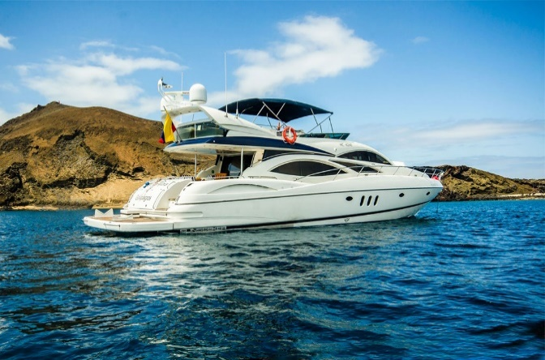
7. Tour aboard WindRose Yacht
After breakfast, you will head towards the Itabaca Channel to board the boat that will take you to visit several islands. The Windrose is a luxury yacht and the only one to visit two islands in one day. The itinerary varies depending on the day of the tour
- Monday and Friday: Seymour & Bachas
- Tuesday: Bartolome & Chinese Hat
- Wednesday: South Plaza and Santa Fe
- Thursday: Santa Fe and Plaza Sur
- Saturday: Bartholomew and Sullivan Bay
- Sunday: Chinese Hat & Dragon Hill

The tour on the Windrose will be an unforgettable experience in the Galapagos Islands. At the end of the day, we will return to Puerto Ayora. You will enjoy your last day in the Islands.

8.- Transfer From Hotel / Puerto Ayora – Airport In Baltra
After breakfast and at the indicated time, passengers will be picked up from their hotel to transfer to the airport to take their flight back to the continent Quito or Guayaquil.

PRICES PER PERSON
IN US DOLLARS

CATG | Hotels Quito | Hotels Galápagos | DBL | TPL | CUA
Tourist Sup | Hotel Finlandia | Mainao | 2349 | 2344 | 2223
First | Dann Carlton | Ikala | 2714 | 2709 | 2588
First Sup | Go Quito Hotel | Solymar | 2929 | 2924 | 2802
Rates apply throughout 2025

Continent Program Includes:
- Bilingual guide (Spanish and English) during transfers and excursions. Tours with 1-3 passengers are conducted with a driver-guide
- Accommodation at selected hotel
- Meals as detailed in the itinerary
- Visits as described in the itinerary
- Entrance fees to the visit sites detailed in the itinerary
- Taxes
- Travel assistance insurance

Galapagos Program Includes
- Shared transportation for transfers
- Ferry to Itabaca Channel
- Transportation for land excursions
- Bilingual naturalist guide during excursions
- 4 nights accommodation in selected hotel
- Meals detailed in the itinerary.
- Visits detailed in the itinerary
- Speedboats for navigation (shared service)
- Equipment for itinerary activities
- Taxes

Programs Do Not Include:
- Air ticket to/from Galapagos
- Galapagos National Park Entrance Fee
    - Ecuadorians USD 30
    - Merco Sur countries and Andean Pact USD 100
    - Rest of the World USD 200
    - Children (under 12 years old)
    - Ecuadorians: USD 15
    - Foreigners: USD 100
    - CAN/ MERCOSUR: USD 50
- Transit Control Card USD 20
- Isabela Entrance Tax USD 10
- Water taxis for embarkation and disembarkation of navigations
- Bus Lobitos / Public transport airport – Canal de Itabaca / direct payment USD 5 per person per way
- Personal expenses, tips
- Unspecified items

General Conditions
- All rates are in US dollars and per person.
- Rates apply throughout 2025 except on Ecuadorian holidays.
- Tours for 1 to 3 passengers are operated with a guide-driver; In the event that a different service is required, a supplement must be requested at an additional cost.
- Nights in the hotels indicated on the itineraries include breakfast and taxes.
- If local taxes change, rates will be updated.

Holidays
- April 18
- May 1-23
- August 11
- October 10
- November 3-4
- December 25

