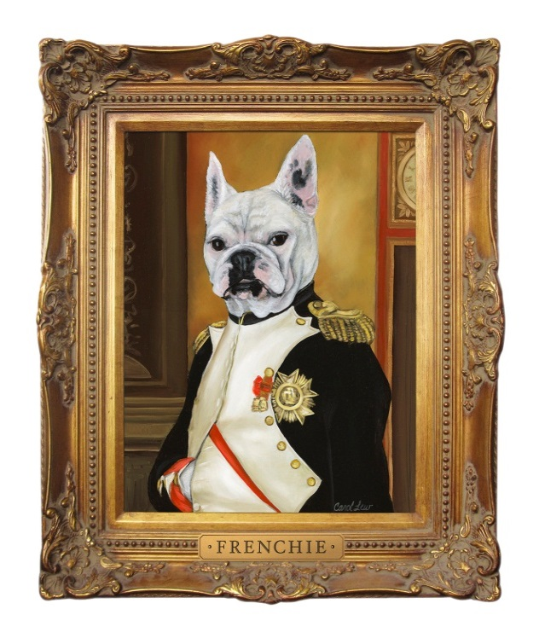
Frenchie
Proprietor Jean-Charles Boisset’s French Bulldog, Frenchie, represents the very essence of style, charisma and personality. With his stout stature and ability to steal everyone’s heart, he is definitely royalty around the winery. Although he may not go down in history as one of the greatest military leaders of all time, Frenchie will definitely go down in history as the greatest four-legged winemaker.

Napoleon’s Coronation
On Sunday, December 2, 1804, Napoleon Bonaparte was crowned as Emperor of France. Not wanting to be an old regime monarch, Napoleon explained that “to be king is to inherit old ideas and genealogy. I don’t want to descend from anyone… the title of Emperor is greater.” Napoleon has gone down in history as the greatest leader of France.

The Wine
The grapes for the 2015 vintage were sourced from a blend of 6 vineyards, but the majority of the Cabernet Sauvignon comes from St Helena to capture the riper flavors of the varietal. This is an enticing Cabernet Sauvignon with small amounts of Merlot from Oak Knoll, and Petit Sirah added to the final blend. Our wine was aged for 25 months in French oak barrels of which 15% is new oak.

Fragrant aromas of black currant and homemade plum sauce are accented by subtle notes of bergamot and cracked pepper. On the palate it has a soft entry with notes of pomegranate, dark jam with majestic tannins and a finish like French Royalty. This is surely a wine sure to make you drool.



2015 Cabernet Sauvignon
Napoleon

Appellation
Napa Valley

Alcohol
15%

pH
3.72

Titratable Acidity
6.2

Aged in Oak
French
25 months
15% New Oak

Frenchie, a dog like no other...

2007 Forgotten Vines

Zinfandel

t Vineyard
Pinot Noir

