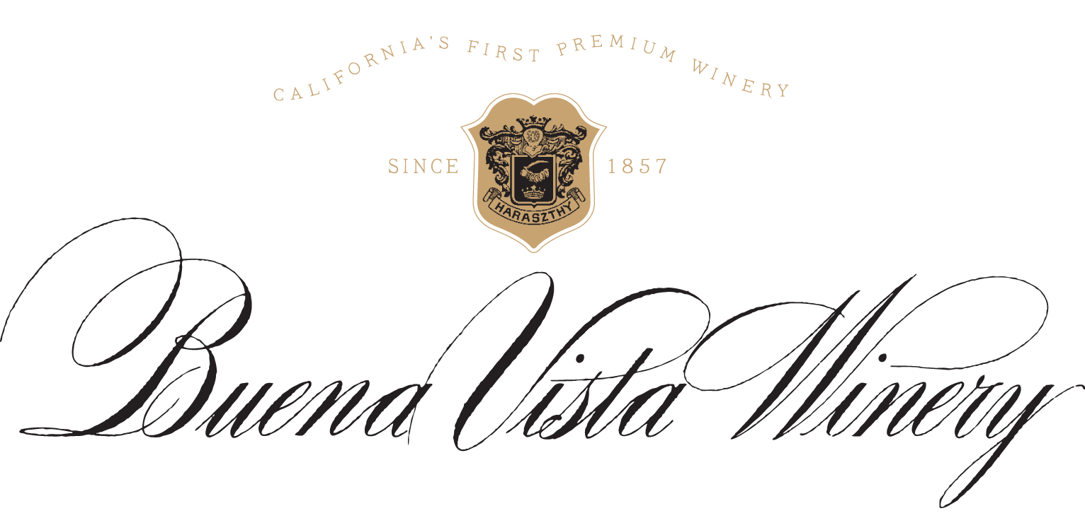

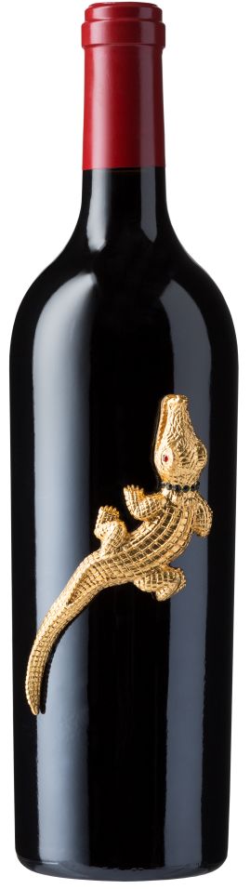
Alcohol: 15%
TA: 5.6 g/L
pH: 3.71
Aging: 100% French Oak for 20 months
Varietals: 51% Cabernet Sauvignon, 25% Syrah, 24% Cabernet Franc
Appellation: Napa Valley
The Revenge
2014
Napa Valley
Red Wine

The Revenge Red Wine 2014 from Buena Vista Winery avenges Count Agoston Haraszthy’s untimely death by crocodile in Nicaragua in 1869. After leaving Buena Vista in 1868, the Count traveled south to pursue an ambition for sugar growing for rum production. Less than a year after arriving, the brilliant, yet flamboyant life of The Count ended abruptly when he fell from a tree branch while crossing a crocodile-infested stream.

The Count has returned to Buena Vista and adorned this bottle with a gilded crocodile to show the passion of The Count can never be struck down! Revenge is his!

The Revenge is an unforgiving blend, bringing together Cabernet Sauvignon, Syrah and Cabernet Franc harvested from distinguished vineyards across the Napa Valley. From Oakville, Yountville and a hillside vineyard east of Oak Knoll, the fruit was hand harvested and then fermented with extended maceration. It was then aged for 20 months in 100% French oak before being bottled unfiltered.

Opening with bold aromas of violet, black cherry, and cocoa, this rich blend commands the senses. Succulent flavors of plum, raspberry and black cardamom lead to luscious, ripe tannins and a long, demanding finish.

