

Access low-cost credit when you need it!
We’re proud to introduce a new employee benefit program called Kashable.

Kashable offers low-cost loans via online application with quick decision and funds deposited directly to your bank account within 3 business days from approval.

These personal loans can be used for any purpose, and are a great resource for those looking to tackle high-interest debt or unexpected expenses during financial hardships.
- Loan amounts up to $20,000
- Interest rates starting as low as 6% APR*
- 6 to 24-month repayment terms**
- Repayment through payroll deduction
Kashable is a great alternative to:
- Borrowing from retirement savings
- Credit card cash advances
- Predatory lenders
*To qualify for the lowest rate, applicant must have a responsible credit history.
**A loan example: A $3000 loan with a finance charge of $267.02, and amount financed of $2,925, repayable in 26 bi-weekly installments, and an interest rate of 12.6% would have an APR of 17.84% and bi-weekly installments of $122.77.

Applying for a Kashable loan is easy.
Application is quick and easy. Employees can complete the entire process online in just a few minutes. Here’s how:
- Register & Verify Employment
Create an account at kashable.com and verify your personal mobile phone number, personal email address, and employment.
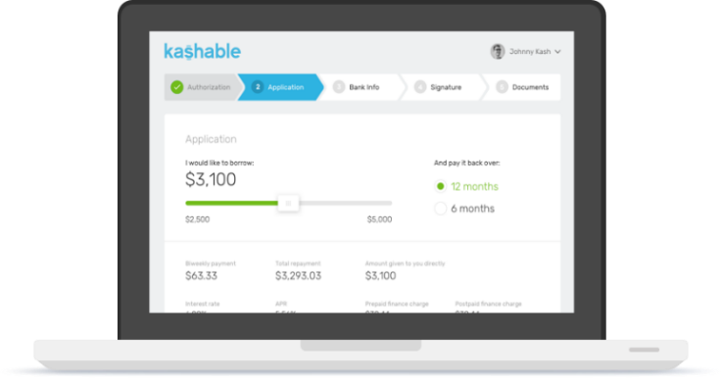
- Apply Online
Authorize Kashable to check your credit. Select your desired loan amount and
review the repayment amount and costs.

If you’re happy with your loan terms, provide your bank information so Kashable can deposit the loan amount. Then sign the agreements electronically.

- Set Up Repayments
Equal installment loan repayments are automatically deducted from your wages. You can also repay your loan early with no penalty. If on unpaid leave, you can reach out to Kashable to set up repayment outside of payroll deduction until you return to work.

- Receive Funds

Funds are disbursed electronically into your bank account within 3 business days.

Access Our Financial Education Library
Just register online at kashable.com and verify your employment to access personal finance tutorials, courses, calculators and more - no loan application required.
Apply whenever – there’s no open enrollment!
Learn more at:
www.kashable.com

Eligibility Requirements
[Your organization’s eligibility requirements]
Must have a personal checking account.

