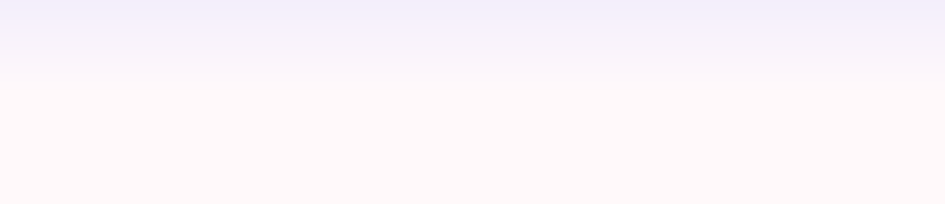
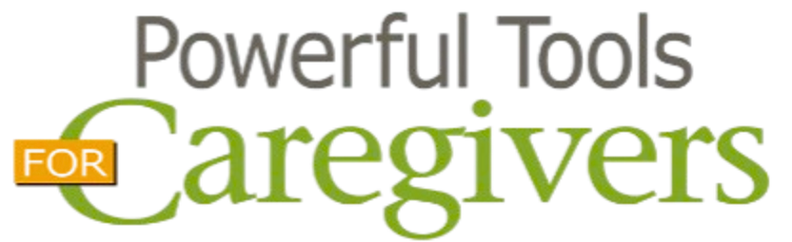
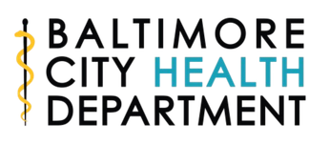




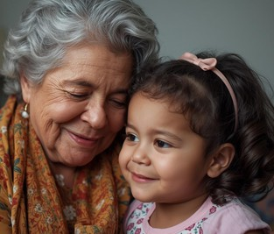

Are you caring for a loved one or know someone who is?
Join us for a 6-week evidence-based class series, where caregivers can explore topics on self-care including:
Taking Care of You Reducing Personal Stress
Communicating Effectively with Others Communicating Effectively in Challenging Situations Learning from Our Emotions
Making Tough Caregiving Decisions
Instruction, materials, and lunch provided. Space is limited!
Register by July 31st at https://tinyurl.com/2026-fall-ptc
When:
Fridays, 10AM - 12PM
Aug 7, 14, 21, 28 Sep 4, & 11


Where:
The Zeta Center
4501 Reisterstown Road, Baltimore, MD 21215
410-396-3535
Contact:

Baltimore City Family Caregivers Program
410-396-1337
linda.m.stewart@baltimorecitygov

