FY2026-2027 Cultural Spaces Capital Support Fund Application
  - Program Funding Guidelines and Application
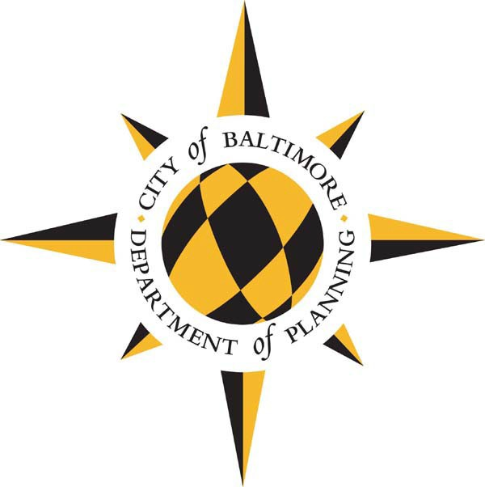

Release Date: Tuesday, February 18, 2025
Response Deadline: Wednesday, April 30, 2025
Please read these guidelines carefully before completing your application. Send application in Microsoft Word to Shakia Word at shakia.word@baltimorecity.gov.

Table of Contents
Overview 3
Important Dates 3
Eligible Applicants 3
Eligible Projects 5
Ineligible Uses of Grant Funds 5
Review Criteria 5
Administrative Information 6
Information Session 6
Award Amounts 6
Incurring Expenses 6
Project Scope Changes 6
Compliance with Law 7
Public Information Act Notice 7
Application Questions 8
General Information 8
Project Information 8
Capital Cost Estimate 8
Project Fund Sources 10
Proposed Project Schedule 10
Project Narrative 10
Facility Information 11
Financial Information 11
Population Served 11
Other Information 12

Overview
The City of Baltimore provides limited support to cultural organizations each fiscal year (FY) through the capital budget. Every two years, organizations can apply for General Obligation (G.O.) bonds for eligible capital improvements to their facilities.
Please note, Baltimore City’s fiscal year is July 1 – June 30 of each corresponding year. Therefore, FY 2026 begins on July 1, 2025, and ends on June 30, 2026.
Funds are intended to provide capital support for organizations that promote arts and culture in Baltimore City and contribute to the City’s unique identity, ensuring opportunities to experience arts and culture
In previous years, funds have supported:
- improvements to building systems, such as elevators and roofs
- improvements to public access, particularly for those with limited mobility
- building expansions or renovations
In FY2026 and FY2027, there is a total of $1 million per year available to support capital improvements at cultural institutions in Baltimore. Individual awards will not exceed $200,000 over two years. Typical awards will be between $50,000-$100,000 over a two-year period.
Please note that FY26 funds will not be available until July 1, 2025 and FY27 funds will not be available until July 1, 2026. If awarded, funds are provided on a reimbursement basis and expenses cannot be incurred until after final approval of the budget by City Council.

Important Dates
Grant Application Available | February 18, 2025
Information Sessions | Thursday, March 6, 2025, at 10:00 am  Tuesday, March 18, 2025 at 2:00 pm
Submission Deadline | Wednesday, April 30, 2025
Notification of Awards | Monday, June 23, 2025 (awards are contingent on approval of FY26 and FY27 capital budget)

Eligible Applicants
Applicants must meet all of the requirements below:
- The process is open to museums, galleries, and theaters, as well as all arts or cultural venues within designated arts and entertainment districts (click here for a map of these districts or visit the Maryland State Arts Council website to search by address).
- Any organization that wishes to apply must be a registered non-profit in good standing with the State Department of Assessment and Taxation.
- Organizations must have a physical location in Baltimore City.
- Must own the facility or have a minimum of a fifteen-year lease with responsibility for capital improvements.
- The facility must be open to the general public.

Eligible Projects
Funding can be used to fund a variety of capital projects. Eligible capital projects, as defined by Board of Estimates policy, are any physical betterment or improvement and any preliminary studies and surveys relative thereto, including, but not limited to, any property of a permanent nature, and equipment needed in connection with such improvement, when first erected or acquired. Projects should have a minimum 15-year service life.
Examples of projects funded in the past include upgrades to a plaza or entrance to accommodate customers with limited mobility, roof replacements, building envelope upgrades, elevator replacements, or museum/exhibit expansions.

Ineligible Uses of Grant Funds
- Projects or improvements costing less than $50,000
- Vehicular equipment
- Repair or maintenance items costing less than $100,000 or which are of an emergency nature
- Salaries other than those which are properly capitalized as part of the project cost
- Operating Support
- Relocation
- Repayment of existing loans or liens
- Projects that support specific religious or other affiliations, and/or that support political actions, causes, advocacy, or parties

Review Criteria
The Department of Planning uses similar criteria as the Planning Commission’s Capital Improvement Program to evaluate projects:
- Legal Mandate
- Equity. According to the City’s equity assessment program, equity means closing the gaps in policy, practice and allocation of resources so that race, gender, religion, sexual orientation and income do not predict one’s success, while also improving outcomes for all.
- Health and Safety
- Asset Condition
- Return on Investment
- Environmental Impact
- Efficiency and Effectiveness
The City may give additional consideration to projects that address the following:
- Project provides improvements to City owned assets
- Project provides access for Baltimore City Public School students
- Project enables organizations to build financial and organizational capacity
The City may also consider the organization’s capacity to execute the project and timely expenditure of previous allocations.
The City may consider previously approved city funds sources when determining eligibility and need when ranking applicants.

Administrative Information

Information Session
The Department of Planning will host two virtual information sessions:
- Thursday, March 6, 2025 at 10:00 am and
- Tuesday, March 18, 2025 at 2:00 pm
The Information Sessions will be held via WebEx. A link will be available on the City’s Cultural Spaces Capital Support webpage three days prior to each work session. If special accommodations are required, please email shakia.word@baltimorecity.gov at least three business days in advance.

Award Amounts
Final awards are made by the Director of Planning and must also be approved in the FY26 and FY27 capital budgets, which means there is a long lead time to receive these funds. The Department of Planning reserves the right to make an award of funds in an amount other than what is requested in the Grant Application.

Incurring Expenses
The City of Baltimore is not responsible for any cost incurred by any applicant in preparing and submitting this application or requested supplemental information in response to this application.

Project Scope Changes
The Department of Planning understands that project circumstances may necessitate scope changes that differ significantly from the original request. While we value adaptability, applicants should recognize that substantial modifications may require a comprehensive re-evaluation and could affect their award status.

Compliance with Law
By applying, organizations awarded funds agree that they will comply with all Federal, State and City laws, rules, and regulations and ordinances applicable to its activities and obligations under this program.

Public Information Act Notice
The Department of Planning commits to handling all information regarding financial assets in strictest confidence. Applicants should give specific attention to identifying any portions of their application that they deem to be confidential, proprietary or trade secrets and provide justification why such material should not be disclosed under the Maryland Public Information Act SS 1-601 et seq. of the State Government Article, Annotated Code of Maryland upon request by the public.

Application Questions

General Information
Name of Institution:
Contact Person:
Contact Title:
Contact Phone:
Contact Email:
Address:
Secondary Contact:
Secondary Contact Title:
Secondary Contact Phone:
Secondary Contact Email:
Secondary Contact Address:
Date:

Project Information
Project Name:
Project Address:
Short project description: (limit 50-60 words)
Total G.O. Bond Request (FY26 and FY27):

Grantee Information
Grantee Name as it appears in SDAT (or use the name of the fiscal sponsor, if relevant)
Grantee Name (Only if using a fiscal sponsor)

Finish this sentence- "The City hereby awards a grant of Grant Funds to Grantee to be used solely to..."

Grant Agreement Signatory Legal Name:

Signatory Title:
Signatory Email Address:

Eligibility
- Please indicate whether your organization is
- a museum
- a gallery
- a theater
- an arts or cultural venue within a designated arts and entertainment district

- Please attach a copy of your certificate of good standing with State Department of Assessment and Taxation.

- Please indicate whether your organization
- owns the facility used to provide services to the general public.
- has a lease of at least fifteen years with responsibility for capital improvements for a facility used to provide services to the general public.
- is located within a City owned facility used to provide services to the general public.
- does not provide services to the general public. If so, your organization is not eligible for these funds.
- does not have physical space in Baltimore City. If so, your organization is not eligible for these funds.

Capital Cost Estimate
Use whole dollars in estimates for each applicable phase in the project.
Design:
Site Acquisition:
Site Preparation:
Construction:
Equipment:
Inspection:
Contingency:
Insurance, Taxes, Assessments:
Total:

Project Fund Sources
Use whole dollar amounts for project funds.
Please provide specific information for any State, Federal, Private, or Other fund sources for the project. Add new rows to the table for each funding source. If City funding other than G.O. Bonds is involved, please specify. Include names of specific grant or agency budget programs, amounts committed, fiscal years of commitments, etc.
 | Previous Appropriations | FY 2026 | FY 2027 | Future Funds | Total
Total:
Please include specific information for private fundraising campaigns including overall goal, amount committed to date, and timeline for campaign completion.
Submit copies of commitment documents for all fund sources if available.

Proposed Project Schedule
Study | Start: |  | Complete:
Design | Start: |  | Complete:
Advertise for Bids | Start: |  | Complete:
Award Contract | Start: |  | Complete:
Construction | Start: |  | Complete:

Project Narrative
- Provide a detailed description of the project and how it enhances or improves your facility, including the public experience of your facility. You may submit any supporting materials that describe your project such as design/concept drawings, and scope of work.

- Provide a detailed explanation of the public benefit, expected outcomes from the project, and implications if the project is not funded.

- Please check which Planning Commission capital project review criteria apply and explain how your request meets the criteria,

Facility Information
- Are you applying for a capital improvement to a historic building? If the property is City owned or meets the criteria of landmark designation or contributing to a local historic district it will be reviewed by CHAP.

Financial Information
- Please provide financial statements and audits, if available, for the past three years.

- If you have previously received allocations of Baltimore City General Obligation Bonds, please describe how they were used and how the improvements impacted the organization.

- If you have previously received allocations of Baltimore City General Obligation Bonds that are currently unspent, please explain.

Population Served
- Please describe the population that visits and/or utilizes the subject facility, including any quantitative measures you may have of past attendance or participation (race, gender, age, zip code, etc.).
- Do you anticipate the proposed capital improvement will alter the make-up of the population that visits your site or utilizes your organization’s programs? If so, please describe.
- Does the organization have a focus on African American leadership, experiences and/or visitors or other historically disinvested communities and/or populations in Baltimore City? If so, please describe.

- What programs, if any, does the facility provide for Baltimore City Public School students? How many students participate annually and are there fees associated with student participation?

Other Information
- Explain how your organization will oversee this project. Describe your organization’s capacity to successfully manage this project, including partners that you will work and their respective roles.

- If there is any other pertinent information pertaining to this request not already covered by this application, please briefly describe below.

