PA-25-260 PUELCHE III
Price: 418.687 USD
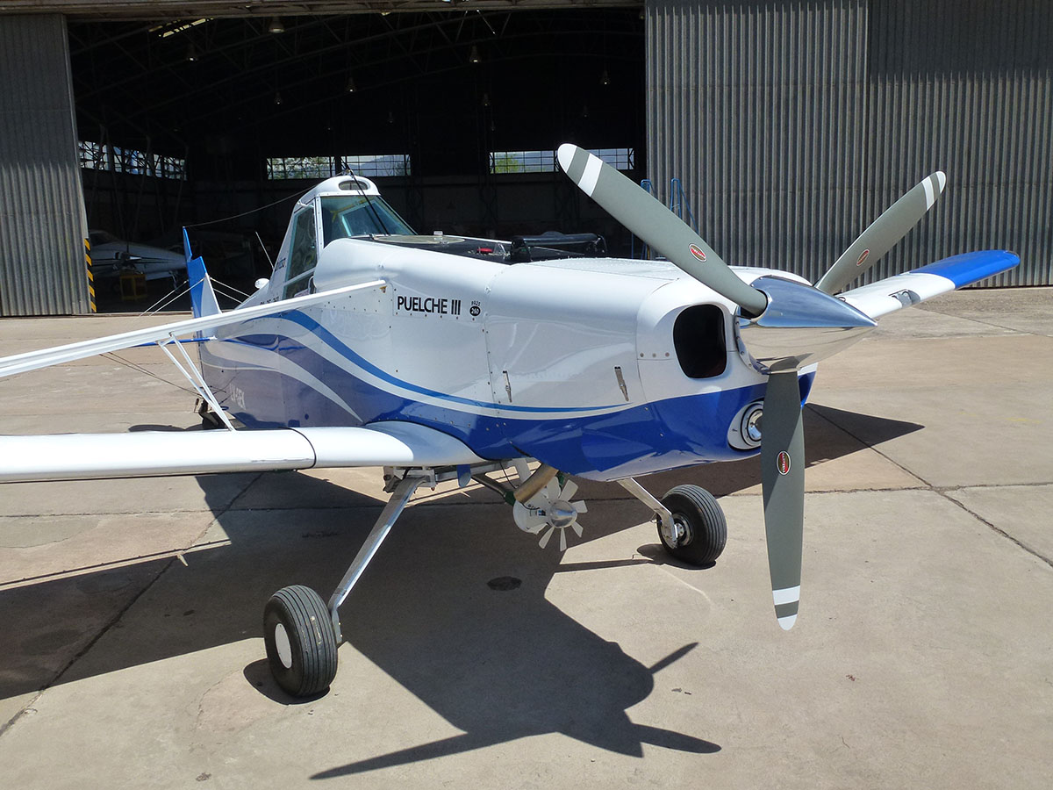
Engine: Lycoming injection. Model IO-540-D4A5 (260 HP-24 V)
Propeller: Hartzell three-blade. Model HC-C3YR-1RF/F8468A
Main Structure: Completely in 4130 steel tubes
Wingtips: Laviasa ND type.
Fuel tank: Central (53 gallons).
Product hopper: Capacity (180 gallons).
Laminar type landing gear (leaf spring)
Landing lights on leading edge of left semi-wing.
New instrument panel - optional.
New nozzles for spraying system - optional.
Incorporation of satellite marker and complementary - optional.
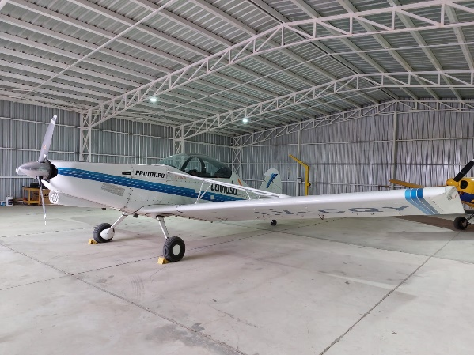

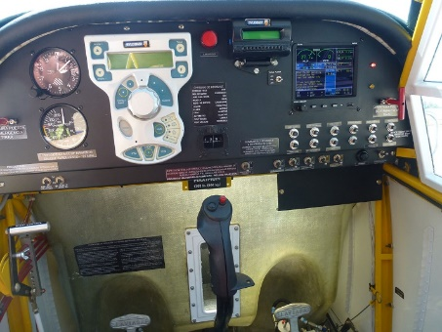
USES:
Spraying of liquids, fungicides and pesticides.
Spreading of fertilizers and sowing of seeds.
Detection and immediate actions in forest fires.
Towing of gliders and advertising banners.
Sowing of fry.
Leak detection in pipelines (oil and gas).
Police patrol.
Emergency assistance to isolated people.

