**Air! FIKI! SVT! ESP! Active Traffic (TAS)! TAWS-B! ADS-B Out!**

**2015 Cessna TTx T240 with G2000, GFC700, WAAS**

**N459JB Ser#T24002079**

**721 Total Time Since New**

**Avionics:**

GMA-36 Remote Digital Audio Panel w/Marker Beacon/Intercom

GTX-33ES Transponder-Mode S with ADS-B Out

GIA-63W NAV/COM/GPS/WAAS with Glideslope #1

GIA-63W NAV/COM/GPS/WAAS with Glideslope #2

GDU-1400 Primary Flight Display (PFD)

GDU-1400 Multi-Function Display (MFD)

GTC-570 Touch Screen Controller

GEA-71 Engine/Airframe Computer

GRS-77 Attitude & Heading Reference System (Dual) (AHRS)

GDC-74A Air Data Computer with OAT Probe

GMU-44 Magnetometer (Dual)

GCU-275 Primary Flight Display (PFD) Controller

GMC-720 Auto Flight Controller System (AFCS)

Garmin Terrain Awareness System (E-Prox+)

Garmin SafeTaxi & FliteCharts

ESI-1000 L-3 Trilogy (Backup Airspeed, Altimeter and Attitude (Electric) Indicator)

Electronic Checklist

GFC-700 Autopilot

* Go-Around Switch
* Electric Trim
* A/P Disconnect
* Control Stick Steering Button

Artex ELT-ME406 Emergency Locator Transmitter

Pitot System - Heated

Static System

Alternate Static Source

Dual 12-volt, 2-amp auxiliary power outlet

Lighted Entrance Step

Precise Flight Speed Brake System

Garmin SiriusXM Weather & Radio (GDL-69A)

**Additional Equipment:**

TKS De-Icing System (FIKI)

Air-Conditioning

Synthetic Vision Technology (SVT)

Electronic Stability Protection (ESP)

Garmin GTS-800 Traffic Advisory System (TAS)

Terrain Awareness and Warning Sys­tem (TAWS-B)

Oil Cooler Mod with New Vernatherm Winterization Kit

Oregon Aero Sport Seats

Tanis Engine Preheater

CO Detector/Pulse Oximeter

Rosen Sun Visors

Hot Prop

Built-In Oxygen

**Exterior:**

Apex Major- Matterhorn White with Arc Blue Pearl and Phantom Gray Pearl Stripes

**Interior:**

Blaze Leather: Dark Seat Option - Black Seat Surfaces with Crème Perforated Inserts

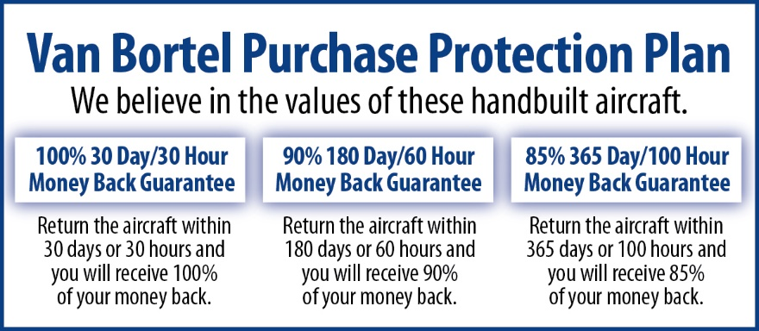

**We fly the aircraft to your ramp for inspection by you and your mechanic at no cost or obligation to you.**

**All Specifications Subject To Verification Upon Inspection**

**Trades Welcome • No Damage History • Always Hangared • No Corrosion**