**Air! TAWS-B! Active Traffic (TCAD)! Jepp Charts! ADS-B Out!**

**2006 Cessna 400 SL with G1000, GFC700**

**N225KW Ser#41671**

**1418 Total Time Since New**

**Avionics:**

GMA-1347 Digital Audio Panel with Marker Beacon/ Intercom

Garmin GTX-335R Transponder with ADS-B Out

GIA-63 NAV/COM/GPS with Glideslope #1

GIA-63 NAV/COM/GPS with Glideslope #2

GDU-1040 Primary Flight Display (PFD)

GDU-1044 Multi-Function Display (MFD)

Garmin Terrain Awareness System (E-Prox+)

Ryan 9900BX Traffic Collision Alert Device (TCAD)

Terrain Awareness and Warning Sys­tem (TAWS-B)

GFC700 Fully Integrated Two-Axis Autopilot

GCU 476 Keypad Controller

GMU-44 Magnetometer

GTP 59 OAT Probe

GEA-71 Engine/Airframe Computer

GRS-77 Attitude & Heading Reference System (AHRS)

GDC-74A Air Data Computer (ADC)

Artex ME200 Emergency Locator Transmitter

Garmin SafeTaxi & FliteCharts

Backup Airspeed, Altimeter and Attitude Indicator

Garmin SiriusXM Weather & Radio (GDL-69A)

**Equipment:**

Oregon Aero Sport Seats

Carbon Monoxide Detector

Rosen Sunvisors

Hot Prop

Built-In Oxygen

Climate Control (Digitally Controlled Air-Conditioning and Heating)

Precise Flight Speedbrake System

Pilot and Co-Pilot Brakes (Heavy-Duty, Vented for Cooling)

Sport Seats- Fully Articulating

4-Place Intercom System

Factory Tinted Cabin Window

Dual Independent Electrical Systems

Tuned Induction System

Utility Category Airframe

Dual 60 AMP Redundant Alternators

Carbon-Fiber Dual Wing-Spar construction

Jeppesen Chartview Card (Subscription)

Rear Seat Audio Controls

Alternate Static Air Source

Complete Surface Certified Lightning Protection

**Exterior:**

Matterhorn White with Glacier Blue, Pewter, and Black Stripes

**Interior:**

Leather: Tan Sidewalls, Center Console, Map Pockets and Armrests with Tan Leather Seat Surfaces

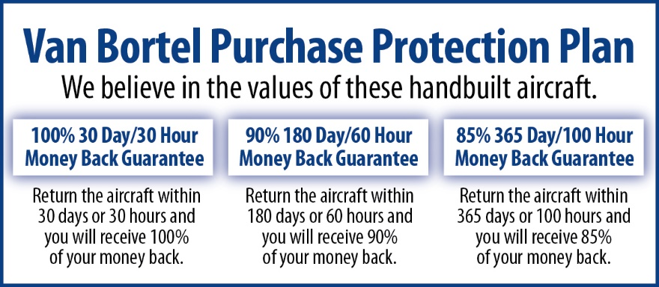

**We fly the aircraft to your ramp for inspection by you and your mechanic at no cost or obligation to you.**

**All Specifications Subject To Verification Upon Inspection**

**Trades Welcome • No Damage History • Always Hangared • No Corrosion**