1980 CESSNA CITATION II
Serial Number 550-0154
Registration N600TB
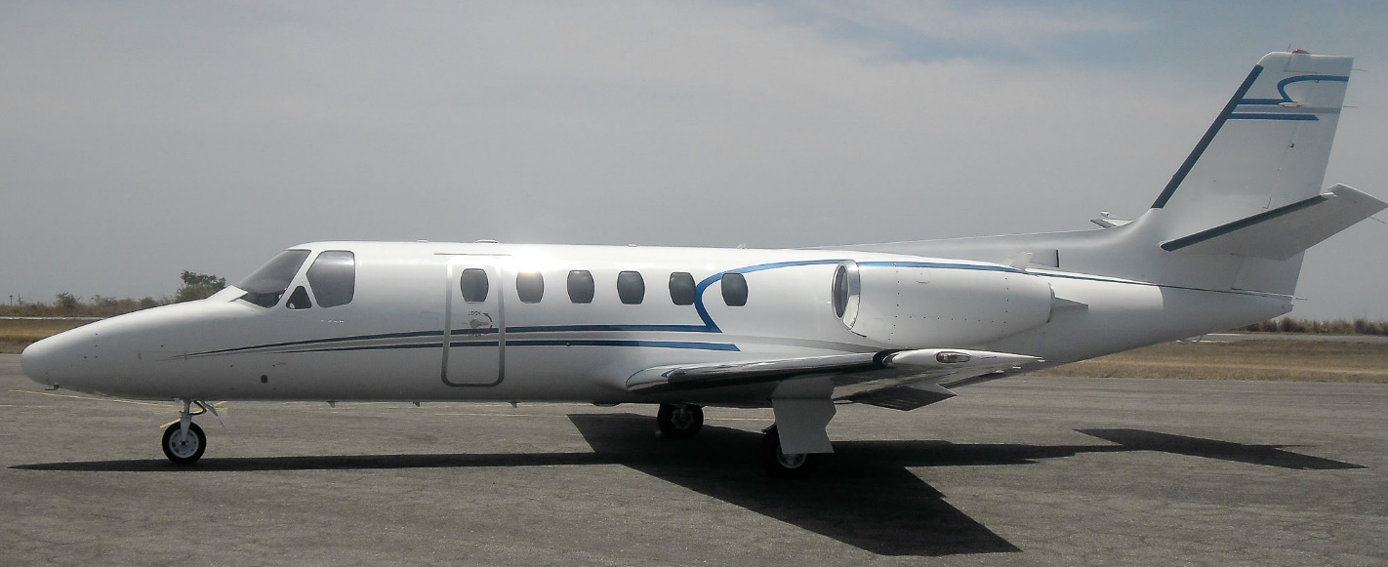

Airframe:
9124 Hours Since New 7962 Landings

Engines: Pratt & Whitney JT15-B TBO: 3500
Left: Serial Number N/A Right: Serial Number N/A
8095 Hours Since New 9533 Hours Since New
7859 Cycles Since New 7829 Cycles Since New
1803 Time Left to OH / HSI 1122 Time Left to OH / HSI

Avionics:
ADS-B Out
Comms: Dual Collins VHF-20A AHRS: Dual Collins AHC-85
Dual Collins VIR-30A Single Dittel FSG70
Collins ADF-60 Dual Collins DME-40
Sperry SPZ-500 Autopilot ART-2000 Weather Radar
Garmin GTN 625 Garmin GAD 42
Honeywell TCAS II Honeywell Mk VIII EGPWS
Dual Honeywell MST-67A Transponder King KMD 540/850 MFD
Annunciator Panel mounted on Glareshield

Avionics & Cockpit Options:
Engine Turbine Fan Synch Refreshment Center
Freon Air with Cool Sticks HF Provisions Only
Anti-Skid AFT Baggage Mod
Angle of Attack Currently operating RVSM
Tail Cone Mod

Interior:
8 Pax double club configuration, Belted Lav in the aft baggage area, Light Tan Leather seating.
Light Tan wool carpet, Beige headliner, Walnut hardwood dividers, Dual Walnut executive writing tables

Maintenance:
Phase I thru V completed September 2022
