**SVT! ADS-B Out!**

**2004 Cessna T182T Turbo Skylane with G1000**

**N1437R Ser#T18208345**

**1128 Total Time Since New**

**Avionics:**

GMA-1347 Digital Audio Panel with Marker Beacon/Intercom

Garmin GTX-335R Transponder with ADS-B Out

GIA-63 NAV/COM/GPS with Glideslope #1

GIA-63 NAV/COM/GPS with Glideslope #2

GDU-1040 Primary Flight Display (PFD)

GDU-1040 Multi-Function Display (MFD)

GEA-71 Engine/Airframe Computer

* CHT/EGT Sensors - All Cylinders
* Fuel Flow Meter
* TIT Sensor
* Manifold/Tachometer/Vacuum Sensors

GRS-77 Attitude & Heading Reference System (AHRS)

GDC-74 Air Data Computer with OAT Probe (ADC)

GMU-44 Magnetometer

KAP-140 Dual Axis Autopilot with Altitude Preselect/GPS Roll Steering

KCM-100 Configuration Module

KS-270C Pitch Axis Servo Actuator

KS-271C Roll Axis Servo Actuator

KS-272C Pitch Trim Servo Actuator

Pilot Control Wheel - Pitch Trim Switch / Autopilot Disconnect

3000-11 Emergency Locator Transmitter

Emergency Locator Transmitter Remote Mounted Switch

WX-500 Stormscope

Auxiliary Stereo Input Jack

Avionics Cooling Fans

LED Lighted Switch Panel

LED Light Circuit Breaker Panel

Backup Single Pump Vacuum System – Dry

Garmin SafeTaxi & FliteCharts

Garmin XM Weather & Radio (GDL-69A)

Additional Equipment:

Synthetic Vision Technology (SVT)

Tinted Windows

Rosen Sunvisors

Hot Prop

Built-In Oxygen

**Exterior:**

Matterhorn White with Khaki and Black Painted Stripes; Royal Blue Tail and Cowling

**Interior:**

Leather: Mink Leather Seat Surfaces with Perforated Mink Leather Insert / Mink Vinyl

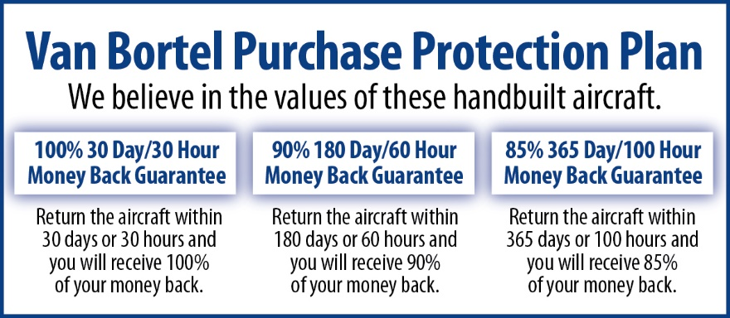

**We fly the aircraft to your ramp for inspection by you and your mechanic at no cost or obligation to you.**

**All Specifications Subject To Verification Upon Inspection**

**Trades Welcome • No Damage History • Always Hangared • No Corrosion**