**ADS-B Out!**

**2006 Cessna T182T Turbo Skylane with G1000**

**N781DK Ser#T18208597**

**789 Total Time Since New**

**Avionics:**

GDU-1040 Primary Flight Display (PFD)

GDU-1040 Multi-Function Display (MFD)

GMA-1347 Digital Audio Panel with Marker Beacon/Intercom

GIA-63 NAV/COM/GPS with Glideslope #1

GIA-63 NAV/COM/GPS with Glideslope #2

GTX-33 Transponder - Mode S with TIS

GEA-71 Engine/Airframe Computer

* CHT/EGT Sensors - All Cylinders
* Fuel Flow Meter
* Manifold/Tachometer/Vacuum Sensors

GRS-77 AHRS

GDC-74 Air Data Computer with OAT Probe

GMU-44 Magnetometer

KAP-140 Dual Axis Autopilot with Altitude Preselect

Artex ME406 Emergency Locator Transmitter

Emergency Locator Transmitter Remote Mounted Switch

WX-500 Stormscope

Auxiliary Stereo Input Jack

Avionics Circuit Breaker Panel

Single Engine Driven Vacuum Pump System

Magnetic Compass

Pitot System - Heated

Static System

Alternate Static Source

Audible Stall Warning System - Heated

Avionics Cooling Fans

Garmin SiriusXM Weather & Radio (GDL-69A)

AmSafe Inflatable Restraint System: All 4 Seats

Additional Equipment:

uAvionix Tail Beacon with ADS-B Out

Hot Prop

Built In Oxygen

**Exterior:**

Matterhorn White with Cayenne Red Pearl and Phantom Gray Metallic Painted Stripes

**Interior:**

Leather Seat Surfaces: Pebble Leather with Perforated Pebble Leather Insert / Pebble Vinyl

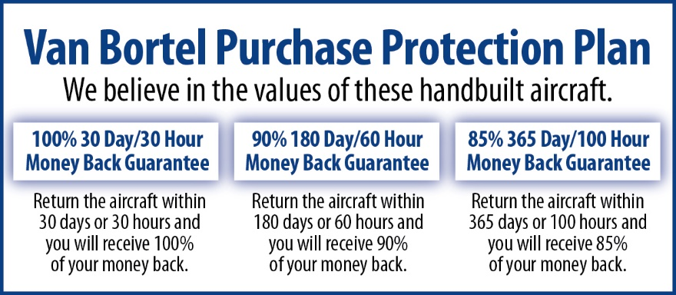

**We fly the aircraft to your ramp for inspection by you and your mechanic at no cost or obligation to you.**

**All Specifications Subject To Verification Upon Inspection**

**Trades Welcome • No Damage History • Always Hangared • No Corrosion**