**Air! WX500! SiriusXM! Oversized Wheels/Tires! ADS-B In/Out!**

**2004 Cessna T206H Turbo Stationair with G1000**

**N822HW Ser#T20608475**

**1360 Total Time Since New**

**Avionics:**

GMA-1347 Digital Audio Panel with Marker Beacon/Intercom

GTX-345R Transponder with ADS-B In/Out

GIA-63 NAV/COM/GPS with Glideslope #1

GIA-63 NAV/COM/GPS with Glideslope #2

GDU-1040 Primary Flight Display (PFD)

GDU-1040 Multi-function Display (MFD)

GEA-71 Engine/Airframe Computer

GRS-77 AHRS

GDC-74 Air Data Computer with OAT Probe

GMU-44 Magnetometer

KAP-140 Dual Axis Autopilot with Altitude Preselect

KCM-100 Configuration Module

KS-270C Pitch Axis Servo Actuator

KS-271C Roll Axis Servo Actuator

KS-272C Pitch Trim Servo Actuator

Pilot Control Wheel - Pitch Trim Switch / Autopilot Disconnect

3000-11 Emergency Locator Transmitter

Auxiliary Stereo Input Jack

Avionics Cooling Fans

Lighted Switch/Circuit Breaker (Pullable) Panel

Backup Single Pump Vacuum System - Dry

Standby Battery, 24 volt 8 AH

**Additional Equipment:**

Air-Conditioning

Oversized Wheels and Tires with Airglas Nosefork

WX-500 Stormscope

Garmin SiriusXM Weather & Radio (GDL-69A)

Stabilizer Abrasion Boots

Rosen Sunvisors

CO2 Guardian

**Exterior:**

Matterhorn White with Titanium Metallic Painted Stripes; Balboa Blue Painted Cowling and Tail Stripe.

**Interior:**

Beige Leather Seat Surfaces

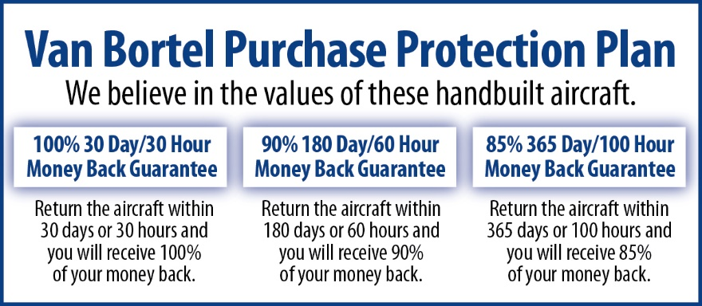

**We fly the aircraft to your ramp for inspection by you and your mechanic at no cost or obligation to you.**

**All Specifications Subject To Verification Upon Inspection**

**Minor Damage Right Elevator**

**Trades Welcome • Always Hangared • No Corrosion**