

1941 Boeing A75N1 (PT17) Stearman
N65502, SN:75-539
Aircraft has Experimental Airworthiness certificate

HIGHLIGHTS

1595.6 Hours Total Time Airframe.

2047 Engine Total Time. Under 50 Hours Since Engine Overhaul (Radial Engines LTD.)

0 Hours Since engine shop Visit and new Crankshaft Main bearings and Thrust bearings. (Radial Engines LTD.)

Fuel Injected Lycoming 300R 680E3B, Fresh overhaul on engine fuel pump.

Fresh Condition Inspection by Gosshawk Unlimited, Inc. Casa Grande, AZ. October 2025.

Completely Rebuilt / Restored finished in 2018. See more details on restorers at end of brochure.

Redline Brakes

Always Hangered Since Restoration

Records & logbooks digitized by Bluetail available online in addition to the hard copies

AVIONICS

GTX345 Transponder, ADSB in and out

Garmin Encoder

GTR225 Com

Flightcom 403 Panel Mount Intercom

ACK E-04-ELT

Engine monitoring system: JPI EDM900

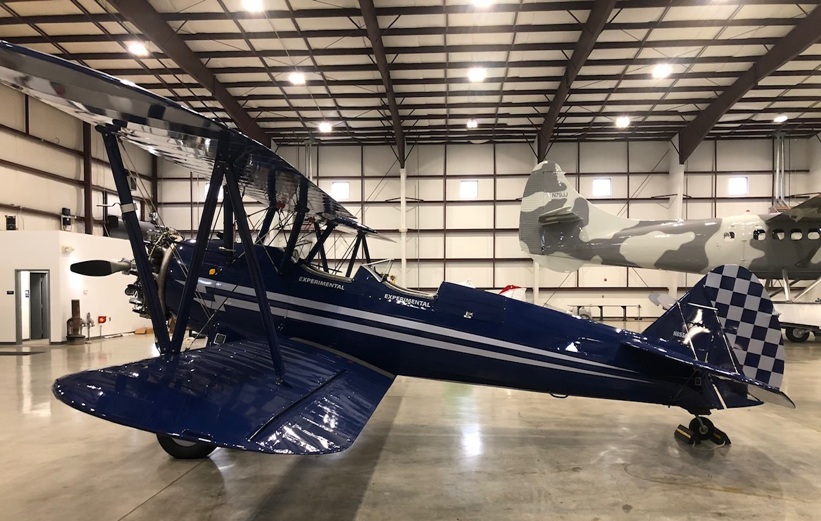

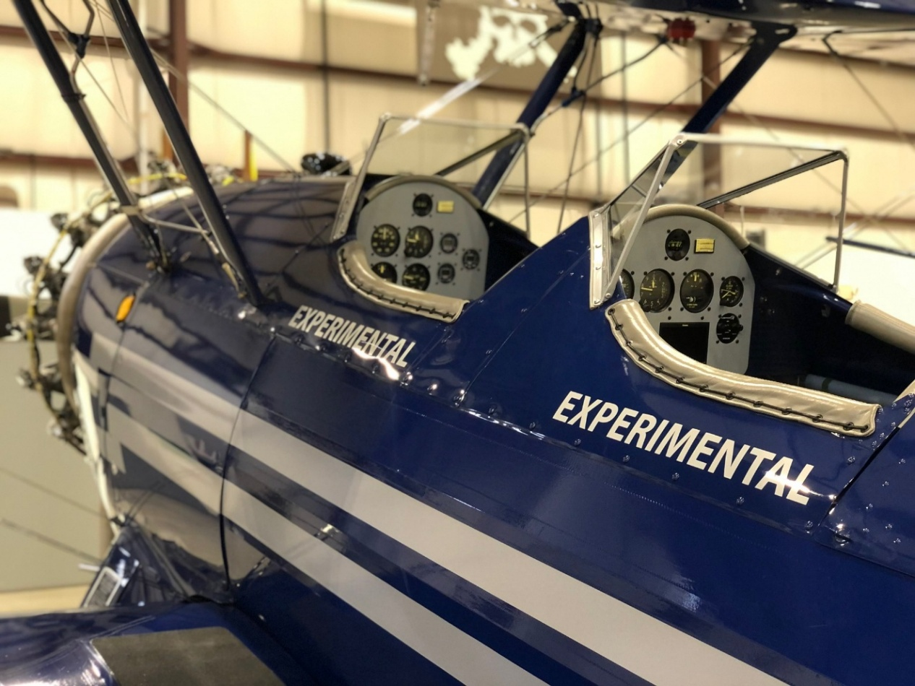

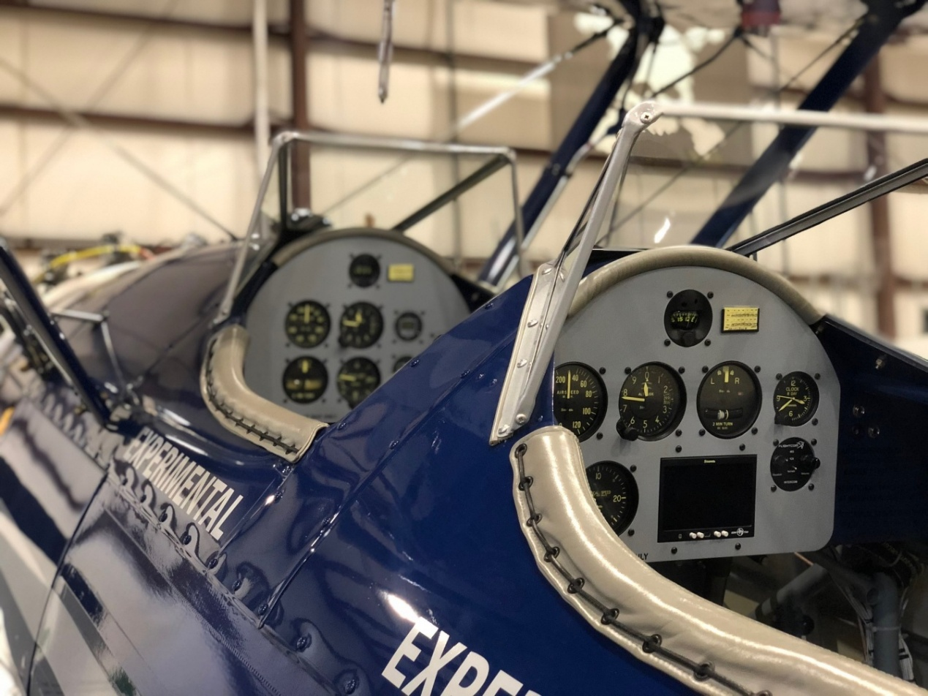

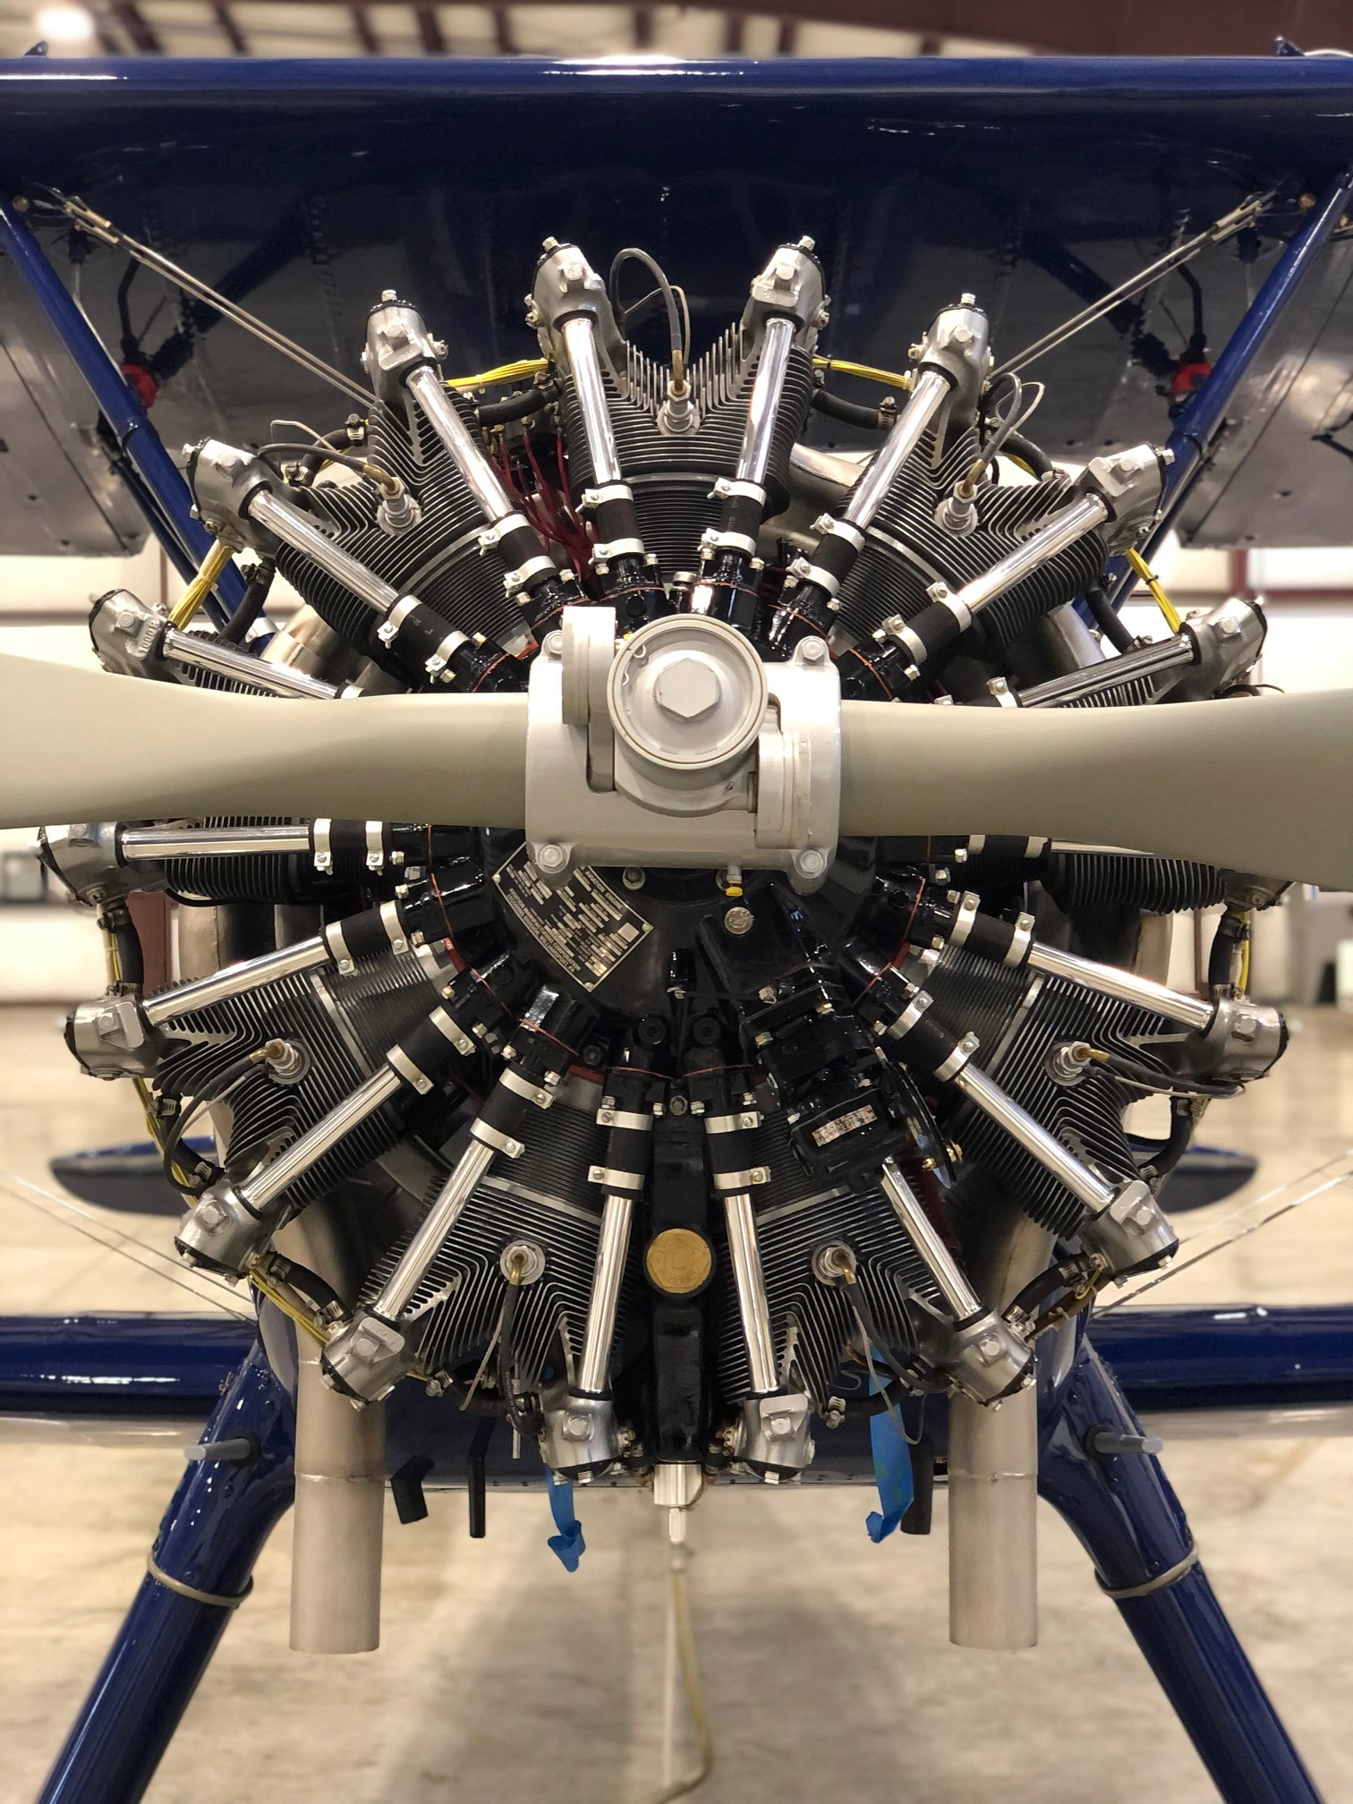

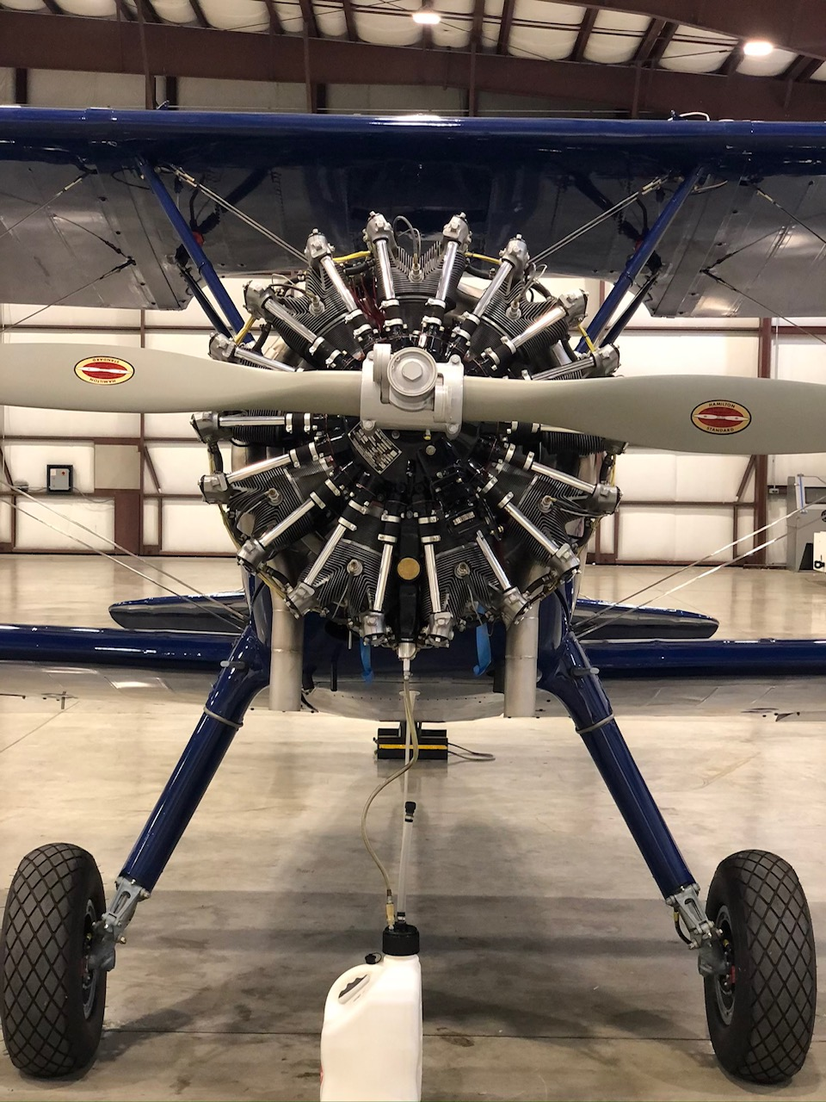

Restoration and rebuild by Carl Ott & Dennis Jensen

Carl Ott entered the US Navy in 1952 and served aboard the USS Sperry in both American and foreign waters until he was honorably discharged in 1956. After his naval service, he eventually settled in Napa, California Carl loved friends and flying and mixed the two as often as possible. Carl received his aviation maintenance education in Oakland, CA. He went on to work at Bridgeford Flying Service, Travis Air Force Base as a civilian, and eventually started his own business, North Bay Aviation. After receiving his teaching credential from the University of California Berkley Carl taught Airframe and Power plant at the College of Alameda in Oakland, CA. It was Carl's delight to be able to fly his family back to Union Star, Missouri every summer to see his folks and visit friends. Carl and his wife Kathleen returned to Union Star after his retirement from the Peralta School District, where he taught for more than 20 years. Upon returning to Union Star, he pursued his desire to resume farming. He actively farmed the home place where he was born, as well as an adjoining farm he purchased, for the rest of his life. Airplanes never left his life as he immediately built a runway on the farm, which he used as often as he could and many friends used it as well. He worked in his farm workshops not only on farm machinery, but continued to build, re-build, and maintain aircraft. This is where he took on the Starman rebuild and restoration. Carl used his extensive experience and expertise to bring the aircraft back structurally through fabric. After Carl’s health gave out and he passed his family sold the plane to family friend and aviator Dennis Jensen.

Dennis a professional pilot, aviation maintenance inspector (IA) and aircraft and powerplant mechanic(A&P) loved all things airplanes. Dennis grew up in Napa Valley, CA. Dennis had an extraordinary aviation career flying corporate aircraft for Mrs. Disney (Walt’s wife), Guess Jeans, and ultimately the founder of Oakley Sunglasses. Over his 33 years as Oakley’s Chief Pilot, he flew and helped maintain a diverse fleet that included three turbine Beavers—two on amphibious floats and one on wheels—along with two turbine Otters, also split between amphibious and wheeled configurations. He also operated a Helio Courier, a Helio Stallion, and, on the jet side, a Falcon 10, a Falcon 50, and one of the first Bombardier Global Express aircraft ever delivered. His personal aircraft collection included a Cessna 140, two Cessna 180s, and this Stearman, all of which he maintained himself using his A&P and IA certifications.

He furthered his passion of flying by building and restoring his own airplanes. He spent ten years restoring one of the Cessna 180s, replacing every rivet and hand-forming new skins using an English wheel. Most recently Dennis completed the restoration of this beautiful 1941 Stearman. Dennis obsessed over every detail which is evident when viewing this amazing plane. After its completion Dennis based the plane at his ranch in Hysham Montana until he passed in an automobile accident.

Richard Hodkinson - (775) 900-1000 - AeroAdvisors.com - 3535 Executive Terminal Drive, Suite 110, Henderson, NV 89052
Specifications and/or descriptions are provided as introductory information only and do not constitute representations or warranties.
Subject to verification by purchaser upon inspection.

